ACTIVE INITIATIVES  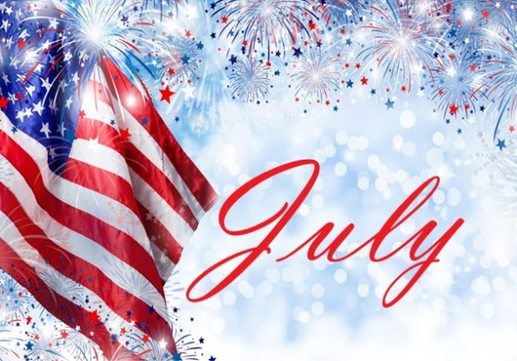  ACHIEVEMENT |  | CELEBRATING CAPTAIN HERLTH  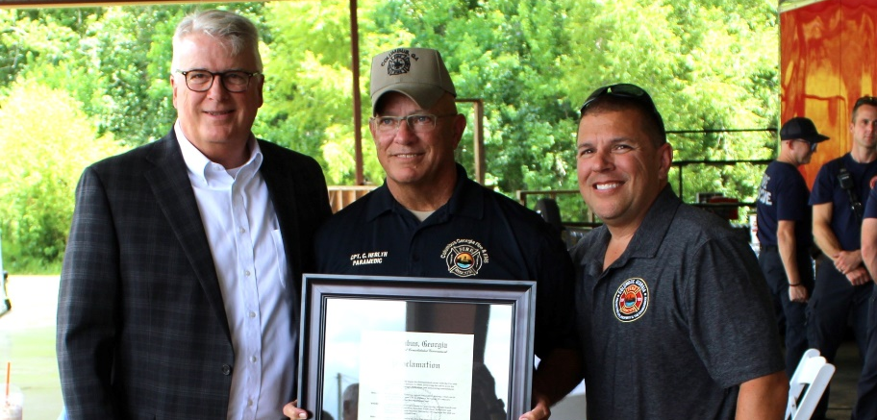
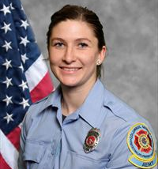  DOS: 02/01/2021 – 07/11/2025  NOTICE OF BEREAVEMENT  The Department of Columbus Fire and Emergency Medical Services mourns the passing of Firemedic Brittany Zerwick. FM Zerwick is the first active female firefighter to pass away as a member of CFEMS. She served the citizens of Columbus and the surrounding area for over 4 years. FM Zerwick will be truly missed. Our deepest and most heartfelt condolences to her family, friends, and department members who worked closely with her.  CONDOLENCE FROM THE FIELD  “She was more than just a Firemedic she was one of the best. Her heart, courage, and dedication to serving others set her apart…. She brought light and strength into every room, every scene, and every call. Brittany was a brave and beautiful soul, and her absence leaves a heavy weight on all of us who served beside her. Her impact on this department, and on the lives, she saved, will never be forgotten. May her memory continue to shine with the same fire she carried inside her. With the utmost respect and sympathy”  Lt. Dunham |  | On July 25th, Columbus Fire and Emergency Medical Services honored Captain Charles “Chuck” Herlth for his hard work, dedication, and service to the citizens of Columbus, Georgia. Thank you for your years of service and the impact you have had on us all. Congratulations!  EMPLOYEE OF THE QUARTER  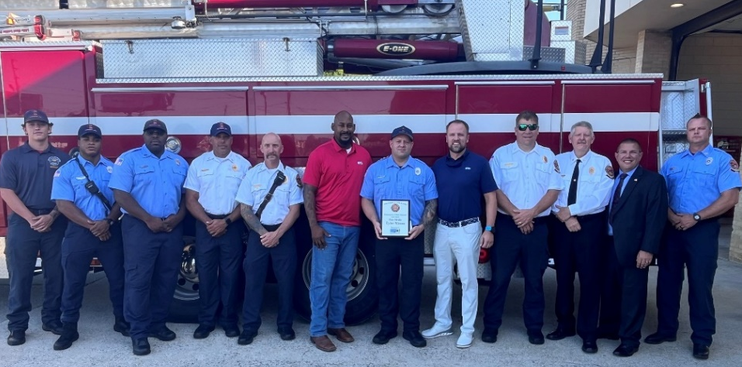Columbus Fire and Emergency Medical Services, Firemedic Tyler Mixon was awarded Employee of the Quarter. Congratulations on this well-deserved accomplishment.  BATTALON MEETINGS  Battalion meetings were conducted July 23 – 25. Field personnell were informed on accomplishment, challenages, short and long term projects. Personnell were also given the opporturntiy to ask questions, express concerns, and receive feedback from CFEMS Executive Staff. Also, several stations received commendation awards.  