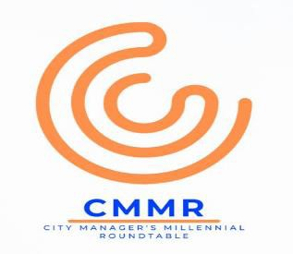
Applicant’s Information
Columbus Consolidated Government
CMMR/City Manager’s Millennials Roundtable
APPLICATION FORM Due: July 31, 2025

Last Name | First Name |  | Middle Name
Department | Division |  | Position
Years: Months: (current position) |  | Are you a regular full-time employee: Yes No (circle one)
How long have you been employed with the CCG? |  | Work Phone Number:
Gender: Male Female (circle one) |  | Cell Phone Number:
Employee / Applicants Signature Date

Division Chief / Supervisor Information

Last Name | First Name | Phone Number

I recommend for the City Manager’s Millennial Roundtable Yes No
Employee’s Name

Division Chief ‘s Signature | Date

To Be Completed by Department Director:

This serves as my approval for the applicant listed above to participate in the CMMR Program.

I understand that this is a two-year program and will require the applicant listed above to attend meetings. I understand that the CMMR Program will have limited interference with his/ her work requirements.

Director’s Signature | Date

In the space provided below, answer the following questions. If more space is needed, please attach additional sheets.

- What are you drawn to about this organization? How do you see this fitting into your career goals?

- If you were to leave the Columbus Consolidated Government today, what would you want your legacy to be?

- Please describe a project or initiative that you were proud to be a part of. What do you feel went well and what do you feel could have been executed better?

- Our organizational values are built upon community, inclusivity, collaboration, and innovation. How do you demonsrate these values in your personal or professional life?

- How would you describe yourself as a person? What skills do you posses that you think would be valuable to our organization?

- CMMR meets a minimum of 1 hour a month as a General Assembly on the second Wednesday.
It is also required that members complete a minimum of 4 volunteer hours (i.e. CMMR Projects, Career Fairs, Juneteenth, PSRW, and United Way) within the fiscal year. Would you be able to make this commitment?

Isaiah Hugley
City Manager / Columbus, Georgia

