Free and Discounted City Services!
Take advantage of these free or discounted City services offered to all City employees:
These services are subject to change without prior notice.

- City Hall Fitness Center! All city employees and retirees can use the Fitness Center with badge access!

• Ride a METRA Fixed Route bus for free to your next destination. Ride any 1 of the 9 routes at any time.

- Callaway Resort & Gardens offers CCG employees a special discount of 20% off the following memberships: Companion, Premium Companion, or Premium Family.
- Click on the Promo Code below to Access the link for more information.
- Promo Code: COLSGOVT20

• Get free mulch at Granite Bluff.

- LawnStarter Pest Control is offering $20 off your first service. Additionally, you can choose from 50+ outdoor services for your home.
- It's simple, plug in your address, tell us which date you want your service done, and we'll schedule you with a 5-star lawn care provider. There are no contracts, payments are all online, and you can manage your account from your phone. Lawn care, meet the 21st century.
- Use promo code GOV20 at the checkout.

- Acom Offers CCG Employees $5.00 off Monthly Monitoring & 10% off Equipment Purchasing C005 - Employee Discount program V3 - Sanford.pdf

• Free Drivers’ Training for employees and their dependents - Public Services Dept.

• Free home inspections on fire safety, Smoke Alarms, limited training in fire protection, and CPR provided by the Fire Department.

• Oxbow Golf Course offers employees w/City ID 9 holes of golf at $9 and 18 holes at $14 (Monday-Friday and after 12 on weekends & holidays).

- At Bull Creek, with a City ID, retired and current staff can play 9 holes for $16 and 18 holes for $22 on Monday through Friday and after 12:30 on weekends and holidays.

- Whit’s Frozen Custard offers a 20% discount to all city employees. Must show badge.

• Bruster’s Real Ice Cream offers a 10% discount to all employees with showing their city ID. This is not good with any other special offer or coupon. Also, currently only good at the 2 Columbus Locations: 3465-G Macon Rd, Columbus, GA 31907….1654 Whittlesey Rd. Columbus, GA 31904…

safety personnel/Uniforms Only (Sheriff, Marshal, Police and Fire) and get Three (3) sets Scrubs cleaned
for $10.00 w/City ID.

• CCG employees can launch $2.00 at Lake Oliver Marina. Just show your CCG ID badge.

• The Columbus Ice Rink offers a discount ticket of $5 for skating and rental of ice skates. Just show your
CCG ID badge.

- YMCA $5 Discount (Must Show Badge) 24 14th St, GA 31901

- CSU Active8 Kids Summer Camp: $50 off per year. Must be Full-Time & CCG health Benefits.

- Purchase discount movie tickets for AMC Theaters in Finance (City Hall, 1st floor).

- Chester’s Café (in the tower) offers a discount to all city employees with proof of City ID.

Discounts offered to city employees for cell phone services from carriers below:
- Verizon Wireless: http://www.verizonwireless.com/b2c/employee/eleuLanding.jsp
- AT&T:https://www.wireless.att.com/business/authenticate/?source=EC9S000ct0000000E&w
- Tmobile: http://explore.business.t-mobile.com/advantagerewards
- Sprint: https://businesssolutions.sprint.com/save/?ECID=vanity:save
- Any questions regarding discounts for Tmobile & Sprint, please contact Wilhelmina.Arceleta1@T-Mobile.com

Tickets at Work – For free access to 20-60% off on movies, hotels, theme parks & attractions, shows, concerts, sporting events, retail and more, create an account at https://www.ticketsatwork.com/tickets/

- How to get started: Visit the link, become a member, enter company code, or work email address to create an account
- Use Our Company Code: COLGA and start saving on:
- Work From Home Essentials
- Streaming Services: Disney+, Showtime and more
- Attractions, Shows, Sporting Events, and Concerts
- Hotels and rental cars
- Sam’s Club Memberships – over 40% off
- Education & Enrichment: Language Learning, Audiobooks and more
- Health & Wellness
- Home Office: Electronics, Laptops and more
- Insurance, Home Security and Protection Services
- Food & Wine
- Online Shopping: Walmart, Walgreens, Macy’s
- Financial Services
- Pet Supplies
- Entertainment
- And so much more!

Columbus GA-Fred's Tire Discounters Corporate Discount Program Is Live!

Tire Discounter, The Home of Free Alignment, is now offering Columbus GA employees exclusive discounts on Tires – 5%, Service – 10%, and Autoglass - $50 off. Plus $39.99 Oil Changes!

Scan the QR code to register and get valuable coupons.
Use employee code: 090-230207-CS-GA



Uptown Nutrition Discount!
10% discount for all employees with a valid CCG ID.

Also take advantage of the free customer VIP program. In the program you will be sent several coupons, promotions, and even chances to win free teas each week! There is also a birthday feature in the program that will provide qualifying members an opportunity to receive free loaded tea on their birthday!


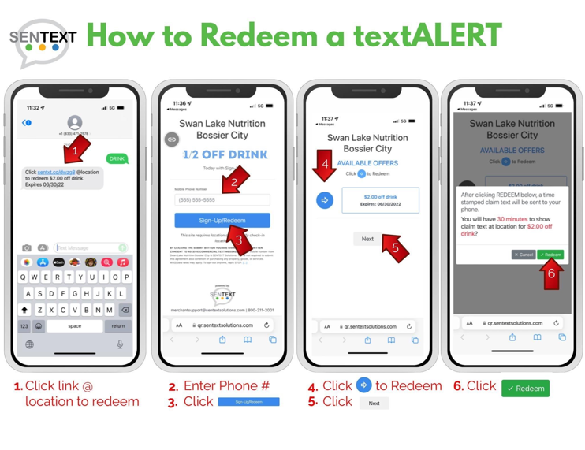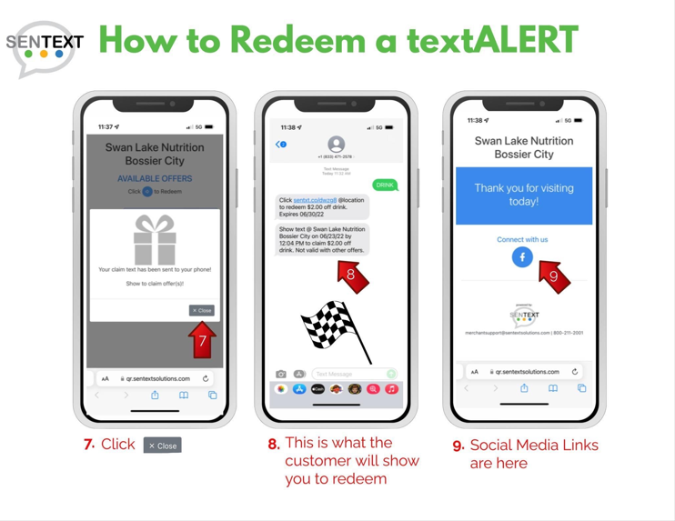
All Columbus Consolidate Employees have been added as a Preferred Employer at Prose Columbus Apartments. All employees will receive FREE application and FREE administration fees at the time that applications are submitted for being a preferred employer. Prose Columbus Apartments also have a current special that is being offered for a "limited time". Any applicant(s) that is approved, will receive 1 month's free rent and 3 months free Wi-Fi.

Hours of operation: Monday - Friday, 9:00 am-6:00 pm and Saturday 10:00 am-5:00 pm,
(available for in-person tours!)

Location: 6700 River Rd, Columbus, GA 31904.

You can also apply directly at: www.liveprosecolumbus.com
 | Prose Columbus is a pet-friendly apartment community in Columbus, GA  Prose Columbus in Columbus, GA offers 1, or 2 bedroom apartments for rent. Browse the gallery, explore the amenities, and get more information on availability today.  www.liveprosecolumbus.com

T-Mobile Work Perks for Columbus Consolidated Government Employees
- Work Perks: Save 15% on Go5G Plus and get premium Unlimited Talk, Text and Data!
  - Details and pricing: www.t-mobile.com/workperks
- Magenta 55+: Customers ages 55 and up get our best Unlimited plans.
  - Details and pricing: www.t-mobile.com/55
- First Responder & Military: Qualified first responders, veterans, and service members get 40% off family lines.
  - Military: www.t-mobile.com/military-discounts
  - First Responder: www.t-mobile.com/firstresponders
- To take advantage of any offer – Mention State of GA Local Government employee – perksGA1
  - New Customers:
    - Dedicated Perks Team: 855-570-9947
    - Local T-Mobile Store: www.t-mobile.com/store-locator
  - Existing Customers – for Work Perks eligibility questions/options:
    - Call (877) 334-7099
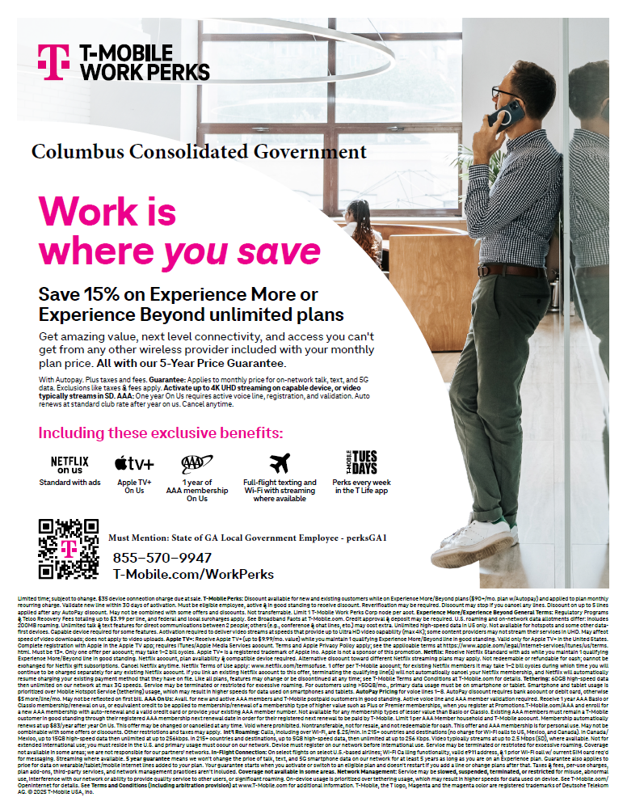



Whit's Frozen Custard is offering all city employees a 20% discount. Must show badge!
https://whitscustard.com/



Yooper Lube & Wash is now offering all City Employees 25% off any Duramax Brand oil change (synthetic blend, high mileage, and full synthetic only) for 1st time customers and 20% off after that, including a diesel oil change, and every oil change.

If any employee is current or former military, they offer 25% everyday.

(Must show your work badge for the discounts above!).

Yooper also offers fleet discounts for businesses (3 or more vehicles) of 25% for paying at the time of service and 20% for Net 30.

Also, no appointment needed for any oil change!

Located at 920 Veterans Pkwy, Columbus (Former Pennzoil Building)

