|  |  |  |
| --- | --- | --- |
| **ACTIVE INITIATIVES**  Sept. 11 memorial ceremonies  **ACHIEVEMENTS** |  | MARATHON PETROLEUM GRANT   |
| May be an image of 1 person and textNOTICE OF BEREAVEMENT *DOS: 01/11/2016 – 09/03/2025*  The Department of Columbus Fire and Emergency Medical Services mourns the passing of Firefighter Jakobe Smith. He served the citizens of Columbus and the surrounding area for over 9 years. We grieve together as a department during a difficult time for our entire fire service family. FireFighter Smith will definitely be missed. Our hearts go out to the family, friends, and loved ones affected by this heartbreaking loss.  **FAMILY MEMORIES-OBITUARY**  Jakobe lived a life of courage, service and pride in his community. He fulfilled his calling as a firefighter with the City of Columbus, where he served with honor and bravery. His dedication to protecting others was a reflection of his generous spirit and unwavering commitment to making a difference. |  | On September 9, 2025, Columbus Fire and Emergency Medical Services received a $4,700.00 grant from Marathon Petroleum. This grant will be used for fire rescue equipment. A group of men posing for a photo  AI-generated content may be incorrect.PIN GRANT CFEMS was awarded a  grant from Partnership for  Innovation in collaboration  with Georgia Tech to study  how A/I can help predict  wildfires. PUSH-N CEREMONY A group of people standing next to a fire truck  AI-generated content may be incorrect.  During the month of September, Columbus Department of Fire and Emergency Medical Services conducted a Push-In ceremony at station 10 as the crew received their new ladder unit. |

Columbus Fire and EMS is proud to be recognized as a Gold Helmet Department for having many of our firefighters enrolled in the National Firefighter Registry for Cancer. The NFR is the largest effort to understand and reduce cancer among U.S. firefighters. [**#NFRGoldHelmet**](https://www.facebook.com/hashtag/nfrgoldhelmet?__cft__%5b0%5d=AZUiXeNC82szkXYAMatqqXCSJsrtzzaeOMUhTXDvwc-JawEA4JezlkUQ9r5-jeI6lUdAimIEfhyLcZ4JU3CFBOnl3VkwWaArTHeyQQCt6eQbaztrUMNXCCT_Y5JgCMme7AVA3iNBbr2mC-105lFzxa_sgeVg4mxgmTqsTc0B-chTiby3w3WTfYinUjAOF58GBt4&__tn__=*NK-R)

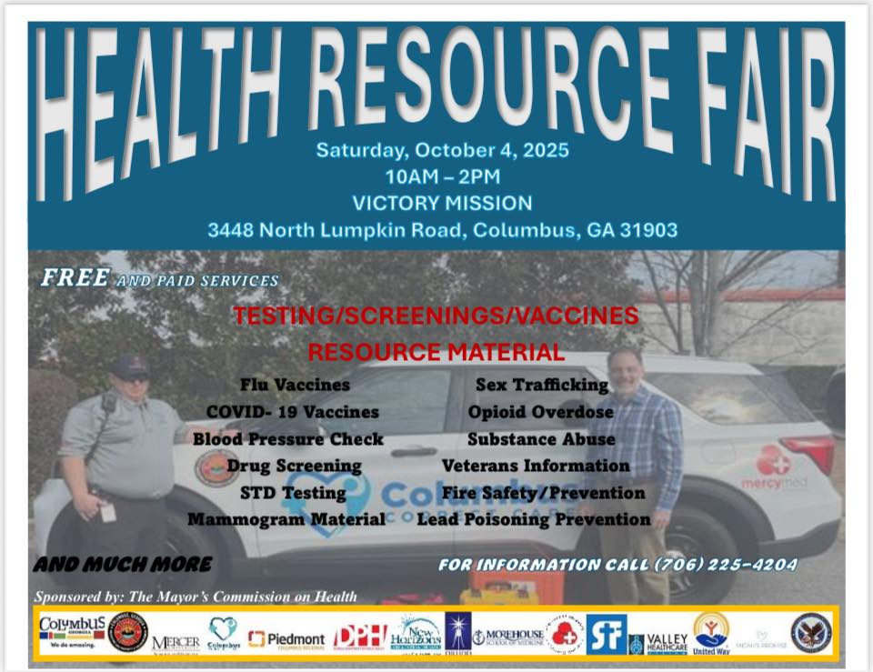Columbus Fire and EMS will be participating in this event.