Traversing the Peruvian Amazon
with International Expeditions

Being on this adventure treats you to seeing animals in their natural habitat, I got go see every animal that was on my list to see in the Amazon. In case I haven’t already said it, I have wanted to go to the Amazon since I was a child, I grew up reading National Geographic magazines.

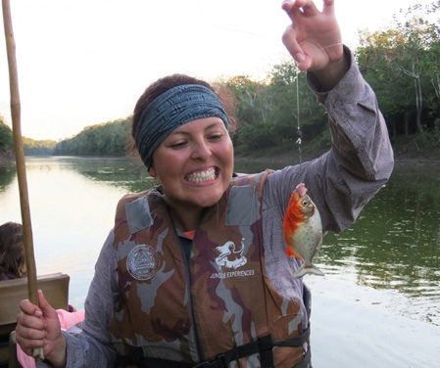
So, what were the animals I got to check off my list you ask? Poison dart frog, bird eating spider (only saw a baby and it was already too big for my arachnophobia ways), baby anaconda which we saw through a jungle walk with a man who knew the jungle like the back of his hand and knew exactly where to find these animals without disturbing them much. A caiman and capybara which we saw during a night excursion. Piranhas which we saw while fishing for them, and you will be happy to know piranhas aren’t as dangerous as most people think they are. Sure, they have extremely sharp teeth but they only go after raw meat so unless you’ve just injured yourself, you are safe swimming with them - which by the way I got to do! We also got to see pink dolphins, yes they are pink and you have to see them for yourself. I even saw animals I never even knew existed! For example this red snake that can swim and a bird called the patoo It was a blast trying to find this bird until your eyes hurt but so worth it once you see it. Not so fun was seeing that snake swim across the river.
On top of the amazing wildlife adventures, International Adventures has established relationships with local communities giving guests the opportunity visit Amazonian villages. You are welcomed into their homes, get to see how Amazonian beer is made. You will visit the school and meet with the kids. Bringing cash along so you don’t miss out on souvenirs because once you leave Iquitos there are no more ATMs for a week and your visits to the villages are a treat of handcrafts you won’t find in a store.
Being on this trip you get to see wildlife in their natural habitat, taste Peruvian cuisine while gliding along the Amazon river and share all these things with people who have a fervent love for their home and jobs. Traveling with International Expeditions means traveling with friends you never knew you had.
Thanks for reading,
Maria

