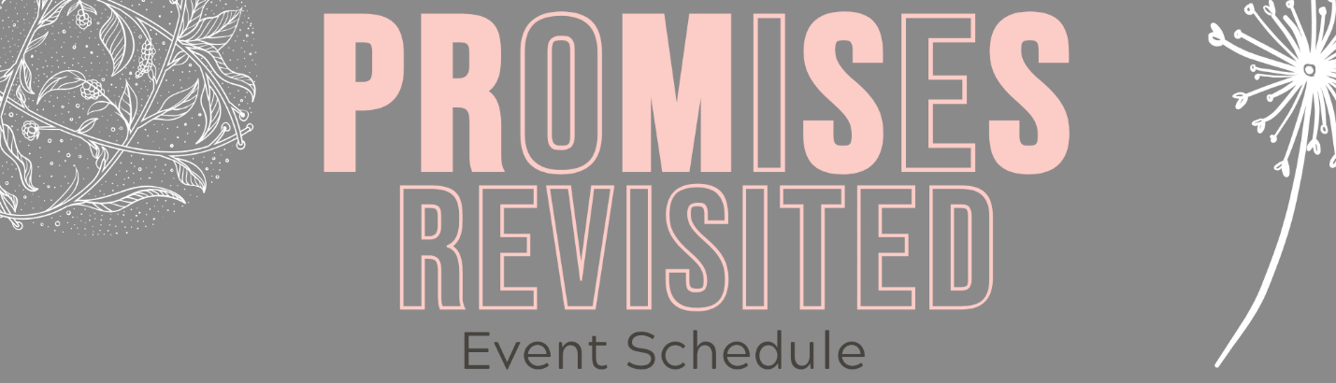
SATURDAY, AUGUST 1

8:30 Doors Open: Grab your Swag bag and color-coded bracelet at the
check-in table
9:00 Session One: The Promise, with Tonya and Mandy
10:30 Break – Beverages in TheCove. Snacks in your Swag bags.
11:00 Session Two: Walking in Your Inheritance, with Tonya and Mandy
12:00 Lunch, catered by Athena’s
1:00-4:50 AFTERNOON ACTIVITIES
- KICPOPS, Houston’s own award-winning ice pops available after lunch
- TheCove Coffee Bar: open all afternoon for conversations with friends, table games, comfy reading chairs, and other fun activities! Coffee, tea, and water will be served.
1:30 Mochas & Masterpieces (2hr. canvas painting class for those signed up)
1:30 Board Over Bored (2hr. wood sign making class for those signed up)
3:00 BINGO in TheCove - Prizes will be given for the winners!
4:00 Prophetic Ministry (for those who signed up)
4:00 Worship with the Word, in the Prayer Room with Mandy Rushing
5:00 Dinner & Comedy Show, catered by Carrabba's
6:30 Session Three: The Power of Your Words, with Tonya and Mandy
8:00 Ministry Time

