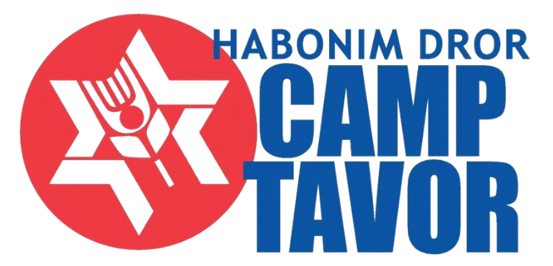

Gender Equality

Camp Tavor values the inclusion of all members of our community, including trans* and gender non-conforming chanichimot (campers) and madrichimot (staff). We strive to uphold practices that affirm all gender identities and sexualities and align with our values.

Tavor houses all chanichimot (campers) and madrichimot (counselors) in ohelim (tents) and tzrifim (cabins) according to their self-identified gender identity, including the gender identities of trans* chanichimot. We strive to create a safe and loving community for all within the living spaces and will make necessary accommodations to ensure everyone feels comfortable and respected at camp. In addition to gendered boys’ and girls’ bathrooms throughout camp, Tavor offers an all-gender bathroom for all chanichimot to use. All-gender restrooms provide access to safe bathrooms and changing areas for people of any gender identity and presentation.

Additionally, Tavor shares the practice of identifying the gender pronouns that each member of our community uses during introductions and as we get to know one another. By doing this we aim to create more comfort for community members of all gender identities. We invite you to learn more about terminology (including pronouns) from Keshet, a national organization that works full LGBTQ equality and inclusion in Jewish life.

