All Souls ECC Church
Reading, Pa
Established – April 2009
Ordinary Time

“Teacher, which commandment in the law is the greatest?”
October 25, 2026

As we enter the church, we enter a house of prayer and worship, a place of solace and grace, This is sacred space, so enter reverently, pray quietly, sing joyfully, listen attentively, give cheerfully and come back gladly.
+ The Entrance Rite +
At the sound of the bell, the people stand as they are able for the Processional.
Processional Hymn
Hymn #430 – Ubi Charitas – alternate Latin with English

The Opening Acclamation
Celebrant: |  | In the name of the Father +, Son and Holy Spirit.
People: |  | Amen.

The Greeting
Celebrant: |  | We have become imitators of the Lord and it was with the joy of the Spirit that we accepted the Gospel; we have become servants of the real, living God. May Jesus, the Lord we expect, be always with you.
People: |  | And also with you.

The Penitential Act
Celebrant: |  | It is difficult to love God in people. Let us ask the Lord and the people to forgive us where we have failed. (pause)  The child in the slums was you, Lord,  and we did not love you:  Lord, have mercy.
People: |  | Lord, have mercy.
Celebrant: |  | The shy alien living among us is you, Lord, and we have not learned to love you:  Christ, have mercy.
People: |  | Christ, have mercy.
Celebrant: |  | The family around the corner that has failed to repay its debts is you, Lord, and it is difficult to love them:  Lord, have mercy.
People: |  | Lord, have mercy.
Celebrant: |  | In your great mercy, forgive us, + Lord, and help us to love you in people.  Lead us to everlasting life.
People: |  | Amen.

Gloria

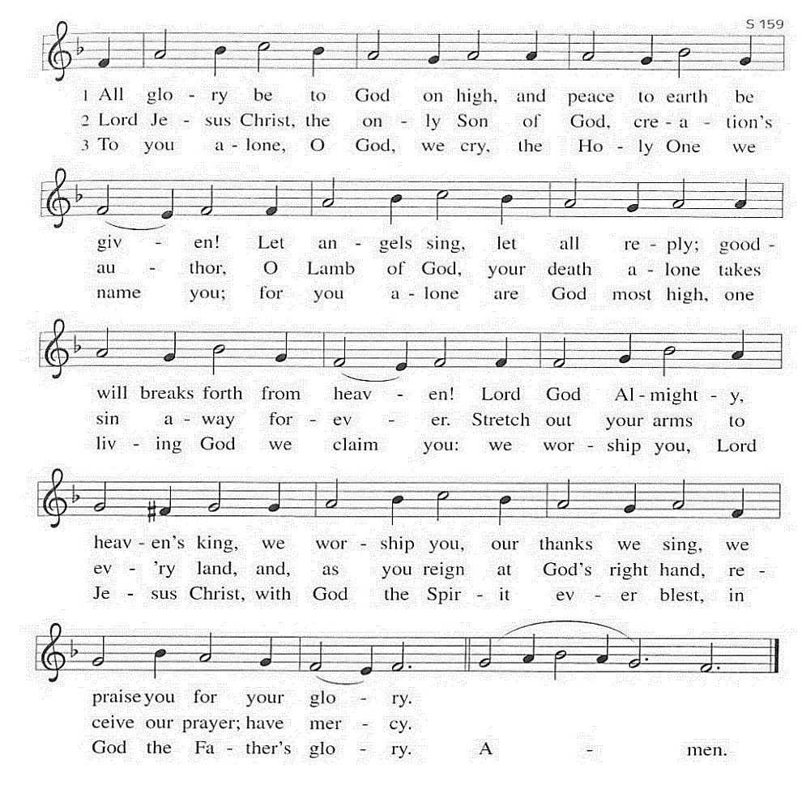

Opening Prayer
Celebrant: |  | Let us pray for the strength to do God’s will.  Almighty and ever-living God,  strengthen our faith, hope and love.  May we do with loving hearts  what you ask of us  and come to share the life you  promise.  We ask this through our Lord  Jesus Christ, your Son,  who lives and reigns with you and  the Holy Spirit,  one God, for ever and ever.
People: |  | Amen.
+ The Readings +
First Reading |  |  |  |  | Exodus 22:20-26
Lector: |  | Hear what the Spirit is saying to the People of God.
People: |  | Thanks be to God.

Psalm 18:2-3, 3-4, 47, 51
Response:
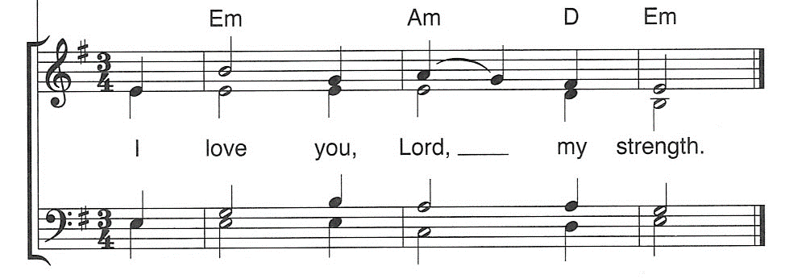

Second Reading |  |  |  |  |  |  | 1 Thessalonians 1:5c-10
Lector: |  | Hear what the Spirit is saying to the People of God.
People: |  | Thanks be to God.

Gospel Acclamation

The Gospel Acclamation will be sung twice prior to the reading of the Gospel and once after the proclamation of the Gospel.

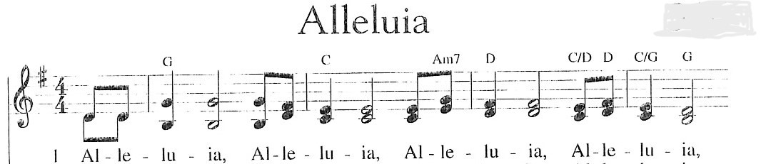

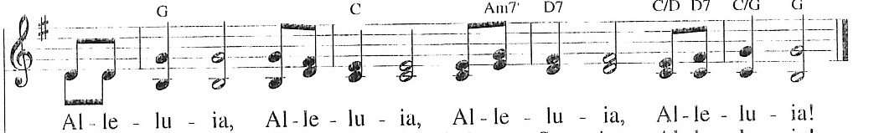
The Holy Gospel |  |  |  |  |  | Matthew 22:34-40
Celebrant: |  | The Holy Gospel of Our Lord Jesus Christ according to Matthew.
People: |  | Glory to you, Lord Christ.
Celebrant: |  | The Gospel of the Lord.
People: |  | Praise to you, Lord Christ.
The Homily
The Nicene Creed
We believe in one God,
the Father, the Almighty,
maker of heaven and earth,
of all that is, seen and unseen.

We believe in one Lord, Jesus Christ,
the only Son of God,
eternally begotten of the Father,
God from God, Light from Light,
true God from true God,
begotten not made,
of one Being with the Father;
through him all things were made.
For us and for our salvation
he came down from heaven,
was incarnate of the Holy Spirit and the Virgin Mary,
and became truly human.
For our sake he was crucified under Pontius Pilate;
he suffered death and was buried.
On the third day he rose again
in accordance with the Scriptures;
he ascended into heaven
and is seated at the right hand of the Father.
He will come again in glory to judge the living and the dead,
and his kingdom will have no end.

We believe in the Holy Spirit, the Lord, the giver of life,
who proceeds from the Father,
who with the Father and the Son is worshipped and glorified,
who has spoken through the Prophets.

We believe in one holy catholic and apostolic Church.
We acknowledge one baptism for the forgiveness of sins.
We look for the resurrection of the dead, +

and the life of the world to come. Amen.

The people remain standing for the Intercessions.

Intercessions
Celebrant: |  |  | Let us pray to our kind and merciful God that his love for us may animate all we do and that our love may become contagious.
The people’s response will be:
People: |  |  | Lord, make us instruments of your love.
Celebrant: |  |  | Our gentle God, help us to love you and one another with your measure, that is, without measure, in Christ Jesus our Lord.
People: |  |  | Amen.
The Peace
Celebrant: |  |  | May the peace of the Lord be with you all.
People: |  |  | And also with you.
Celebrant: |  |  | Everything else will pass away but love will remain forever. Let us give each other a sign of Christian love.
+ The Holy Eucharist +

Offertory Hymn
Hymn #429 – Jesu, Jesu

Presentation of the Gifts
Celebrant: |  | Blessed are you, God of all creation. Through your goodness we have this bread to offer, which earth has given and human hands have made. It will become for us the Bread of Life.
People: |  | Blessed be God forever.
Celebrant: |  | Blessed are you, God of all creation. Through your goodness we have this wine to offer, fruit of the vine and work of human hands. It will become our spiritual drink.
People: |  | Blessed be God forever.
Celebrant: |  | Blessed are you, God of all creation. Through your goodness we have these gifts of our time, talents and treasure to offer, gratefully given and the work of human hands. They will become instruments of your dominion.
People: |  | Blessed be God forever.
Celebrant: |  | Pray my sisters and brothers, that our sacrifice may be acceptable to God, the almighty Father.
People: |  | May God accept the sacrifice at your hands for the praise and glory of his name, for our good, and the good of all the Church.

Offering Prayer
Celebrant: |  | Lord God of power and might,  receive the gifts we offer  and let our service give you glory.  Grant this through Christ our Lord.
People: |  | Amen.

The Eucharistic Dialogue
Celebrant: |  | The Lord be with you.
People: |  | And also with you.
Celebrant: |  | Lift up your hearts.
People: |  | We lift them up to the Lord.
Celebrant: |  | Let us give thanks to the Lord our God.
People: |  | It is right to give him thanks and praise.
The Preface
The Preface is said by the Celebrant.
The Sanctus (Holy, Holy)

Sanctus #161

Eucharistic Prayer
The Eucharistic Prayer is said by the celebrant.
Celebrant: |  |  |  | Before he was given up to death, a death he freely accepted for love’s sake, he took bread and gave you thanks. He broke the bread, gave it to his disciples, and said:
People: |  |  |  | “Take this, all of you, and eat it: This is my body which will be given up for you.”
Celebrant: |  |  |  | When supper was ended, he took the cup. Again, he gave you thanks and praise, gave the cup to his disciples, and said:
People: |  |  |  | “Take this, all of you, and drink from it: This is the cup of my blood, the blood of the new and everlasting covenant. It will be shed for you and for all, so that sins may be forgiven. Do this in memory of me.”
Celebrant: |  |  |  | Let us proclaim the mystery of faith.
Memorial Acclamation
Memorial Acclamation #162
The Eucharistic Prayer is continued by the celebrant.
Doxology and Amen
Celebrant: |  |  |  | Through Him, with Him, in Him, in the unity of the Holy Spirit, all glory and honor is yours, almighty Father, for ever and ever.
The Great Amen
Amen #163

The Lord’s Prayer
Celebrant: |  | We know that the Father loves us and so we pray to him Jesus’ prayer of trust.
People: |  | Our Father, who art in heaven,  hallowed be thy Name,  thy kingdom come,  thy will be done,  on earth as it is in heaven.  Give us this day our daily bread.  And forgive us our trespasses,  as we forgive those who trespass against us.  And lead us not into temptation,  but deliver us from evil.
Celebrant: |  | Deliver us Lord from every evil, and grant us peace in our day. In your mercy keep us free from sin and protect us from all anxiety as we wait in joyful hope for the coming of our Savior Jesus Christ.
People: |  | For the kingdom, the power and the glory are yours, now and forever. Amen.
Breaking of Bread
The Celebrant breaks the consecrated Bread.
Celebrant: |  | Christ our Passover is sacrificed for us.
People: |  | Therefore let us keep the feast.
Lamb of God
Lamb of God #165

The Invitation to Communion
Celebrant: |  | This is Jesus the Lord, who said: Love the Lord your God  with your whole heart and soul; love one another as I have loved you. By this love people will know that you are my disciples.
People: |  | Lord, You have made me worthy to receive You, and by Your Word, I am healed.

The people stand as they are able for the Post-communion prayer.
Prayer after Communion
Celebrant: |  | Let us pray.
People: |  | Lord,  bring to perfection within us  the communion we share in this sacrament.  May our celebration have an effect in our lives.  We ask this in the name of Jesus the Lord. Amen.

+ The Blessing+
Celebrant: | In this Eucharist we have experienced God’s love for us.  Now that he has warmed us with his love, may we let its glow shine on those around us,  with the blessing of almighty God:  the Father, and the Son, + and the Holy Spirit.
People: | Amen.

Announcements

The Dismissal
Celebrant: |  | Go, and love one another as the Lord has loved you.
People: |  | Thanks be to God!

The Closing Hymn

Hymn #721 – Make Me a Channel of Your Peace

Hospitality:

October:
25th – All

November:
8th – A-P
22nd - Q-Z

December:
13th – A-P
27th – Q-Z

Sunday, November 1st, following Mass, we will hold our annual meeting in the Heritage Room. The meeting will start at 1:30. Light refreshments will be provided.

Eucharistic Adoration

The Missionary Franciscans of the Sacred Heart will be holding Eucharistic Adoration on the first Friday of each month at 7:30 in the chapel.

We will once again be collecting items for Berks Coalition to End Homelessness. For the month of October, we will be collecting the following items:

Shampoo (small and large-size bottles)
Conditioner
Men and Women’s Deodorant

Items can be placed in the collection box in the vestibule.

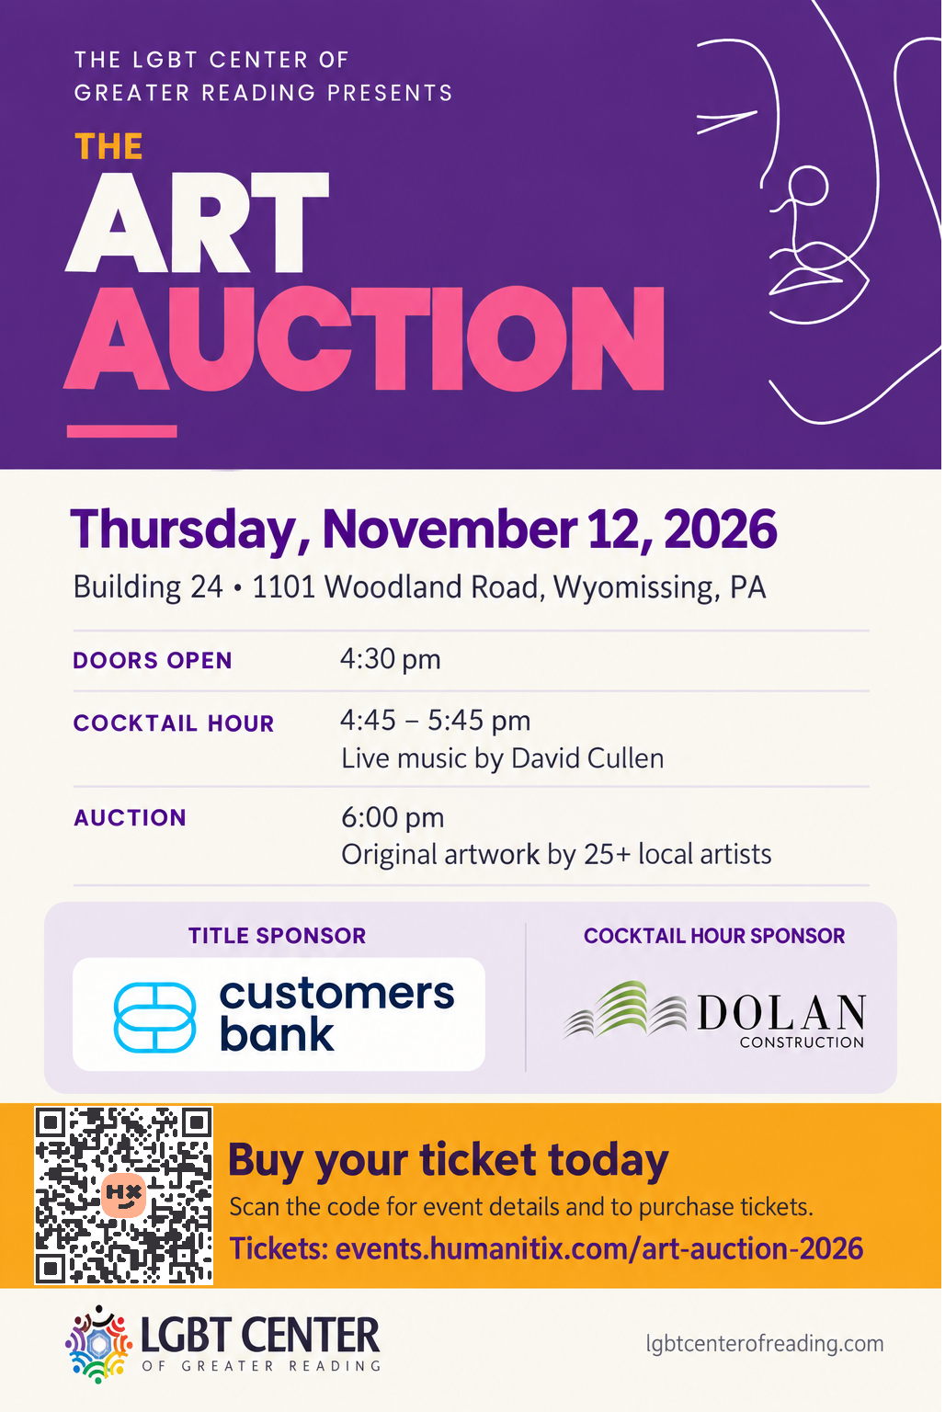

Parish Leadership
Clergy:
The Rev. Fr. Henry Pruski, Pastor
The Most Rev. Paul “Pablo” Burson, Presiding Bishop
Board of Directors:
Sr. Vice President: | Wendy Boyd
Jr. Vice President: | Joan Hanley
Treasurer: | Jerry Schearer
Assistant Treasurer: | Ben Renkus
Board Member: | Robert Waffle
Ministers:
All members are the ministers of this church
640 Centre Ave.
Reading, PA 19601
Phone: 610-621-1738
Email: allsoulsecc@gmail.com
Website: www.allsoulsecumenical.org
We’re on Facebook and Twitter!

