HANDY MIDDLE SCHOOL
Redesign Tour
OCTOBER 29TH
9:00 - 11:00 AM


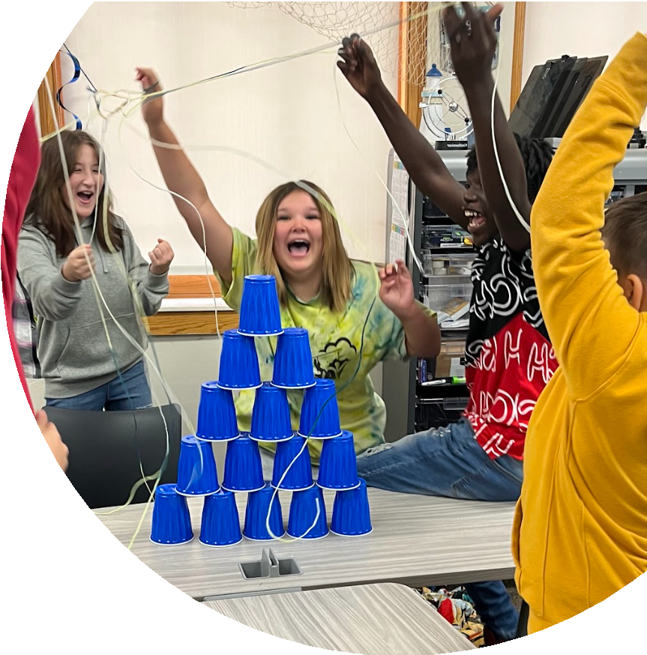

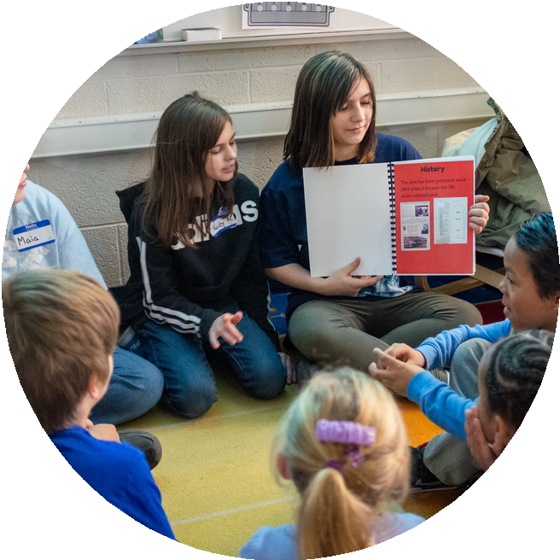


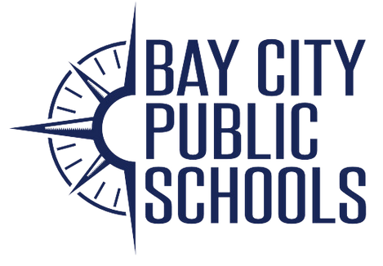

COME SEE THE POSITIVE CHANGES
Since 2022, Handy Middle School has embraced authentic learning by implementing Project Based Learning and creating a student-centered culture of belonging. In addition, interdisciplinary teaming fosters a small school feel, allowing teachers to collaborate closely for student success.
Handy Middle School was recently recognized nationally as a “Spotlight School” by the New Tech Network.

OUR VALUES
Teaching that Engages Culture that Empowers Technology that Enables

OUR INITIATIVES
Project Based Learning Crew
Interdisciplinary Teaming

TO RSVP:
989-671-8163
dillj@bcschools.net

