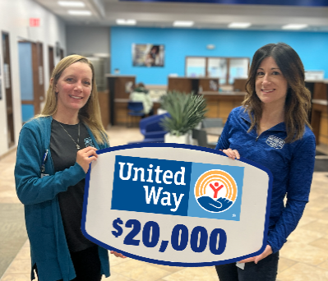
FOR IMMEDIATE PRESS RELEASE 1/7/2025
Contact
Rachel Hilbrandt
rhilbrandt@mfcu.net
989.513.7233
Members First Credit Union Donates $20K To United Way For Team Donation Match
MIDLAND, MICHIGAN—Members First Credit Union (M1) and its team members proudly participated in United Way’s annual charitable giving campaign, raising an impressive $20,000 to support its vital programs. More than 60 M1 team members demonstrated their commitment to uplifting local communities through their generous contributions.
“Our M1 team members generously pledged $9,143 to the United Way, and we’re proud to round up our total donation to $20,000,” said Kristen Williamson, Community Relations Leader at M1. “Members First values the important work our United Way organizations do within our communities, and this is just one way we can help make a meaningful impact.”
The donation benefits nine United Way organizations, including:
- Heart of West Michigan United Way
- United Way of Midland County
- United Way of Bay County
- United Way of Boone County
- United Way of Clare and Gladwin Counties
- United Way of Gratiot and Isabella Counties
- United Way of Saginaw County
- Mecosta-Osceola United Way
- United Way of Kent County
Additionally, four M1 team members who participated in the giving campaign were selected to have $250 donated on their behalf to organizations of their choice:
- Amy Garver – 1016 Recovery Network
- Becky Trombley – Community Cancer Services of Isabella County
- Lori Wagner – Humane Society of Saginaw County
- Katie Leppert – Grace's Table of Grand Rapids
About Members First Credit Union: At Members First, we believe joy and purpose go hand in hand. Since 1936, we've been here in Michigan serving our community with easy and affordable banking. With over 65,000 members and a team of 250+ dedicated employees, we are committed to being trustworthy, caring, and enthusiastic, supporting our members and communities every step of the way. Discover more at mfcu.net.
###

