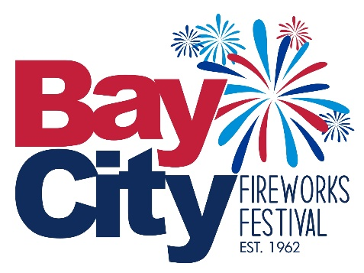
NEWS RELEASE

Bay City Fireworks Festival
2/24/2025

Bay City Fireworks Festival to hold Press Conference

Double Tree by Hilton Hotel Bay City Riverfront Friday March 14th, 2025
11 AM Room: Salon D

The Bay City Fireworks Festival will be holding a press conference on Friday March 14th, 2025, 11 AM Room at the Double Tree by Hilton Hotel Bay City Riverfront in the Salon D room. Officials will be on hand to discuss the upcoming festival for 2025 including sponsors, entertainment and acts along with information about this year’s show. This will include several big announcements.

About The Bay City Fireworks Festival
The Bay City is one of the largest fireworks displays in the Mid-West. Now in its 62nd year of bringing you family entertainment to Bay City’s riverfront in both Veterans and Wenona Park. The Bay City Fireworks Festival is Mid-Michigan’s premier destination for those looking to celebrate our nation’s Independence Day in the grandest fashion. People come from far and wide to enjoy our world class fireworks displays, but the fireworks are only a small part of what the festival has to offer. With so many events and activities available to participate in over our four-day event, you’re sure to find something for the whole family to enjoy!

Media Contact:
Earl Bovia
President
Earl_msu@yahoo.com
989-245-6376
Baycityfireworksfestival.com

