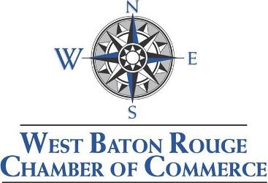

Annual Installation Dinner & Awards Banquet/Silent Auction

Tuesday, February 5, 2019
Addis Community Center
Social/Cash Bar and Silent Auction at 6:00 pm / Dinner and Program at 7:00 pm

Sponsorship Opportunities Available

Presenting $4,000
- Head table seating for your business’ representatives
- 10 minutes to present your company during Banquet
- 8 tickets at a preferred seating table
- Logo on FRONT PAGE of programs, reserved table signage, big screen rotator
- Listing in: press releases, website, e-mail & e-blast
- Contact information of all attendees

Gold: $1,000
- 8 tickets at a reserved table
- Listing in program, reserved table signage, big screen rotator
- Website, e-mail & e- blast

Silver: $500
- 4 tickets at a reserved table
- Listing in program, reserved table signage, big screen rotator
- Website, e-mail & e-blast

Silent Auction Items
Submit an item to be auctioned. Your company’s name will be on the item and mentioned during the program. Item must be received by Friday, February 1, 2019.

Ticket Sales
$50 each and can be purchased by calling the WBR Chamber office: 225-383-3140. Ticket sales and sponsorships will be available until Monday, January 28, 2019.

To sign up for a sponsorship call 225-383-3140

E-mail info@wbrchamber.org

Fax: 225/685-1044

COMPANY NAME: _

CONTACT PERSON:

E-MAIL: PHONE #:

SPONSORSHIP LEVEL: # OF TICKETS:

