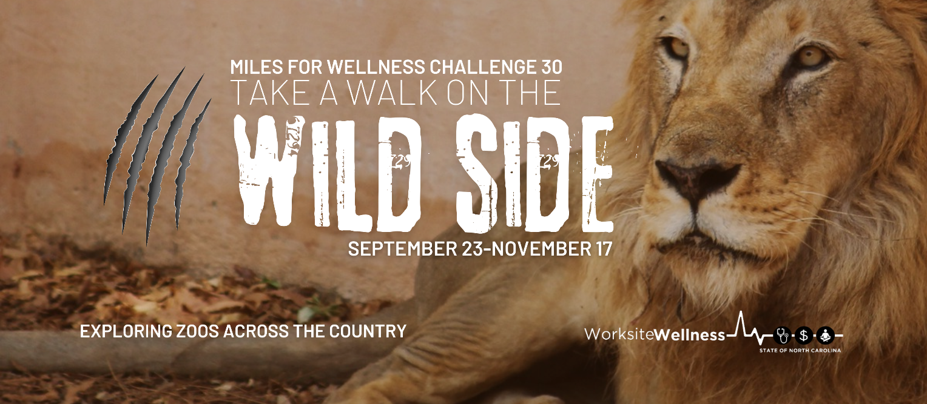
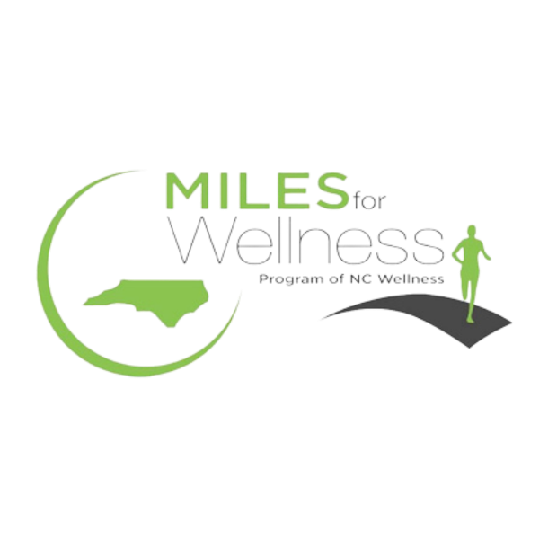
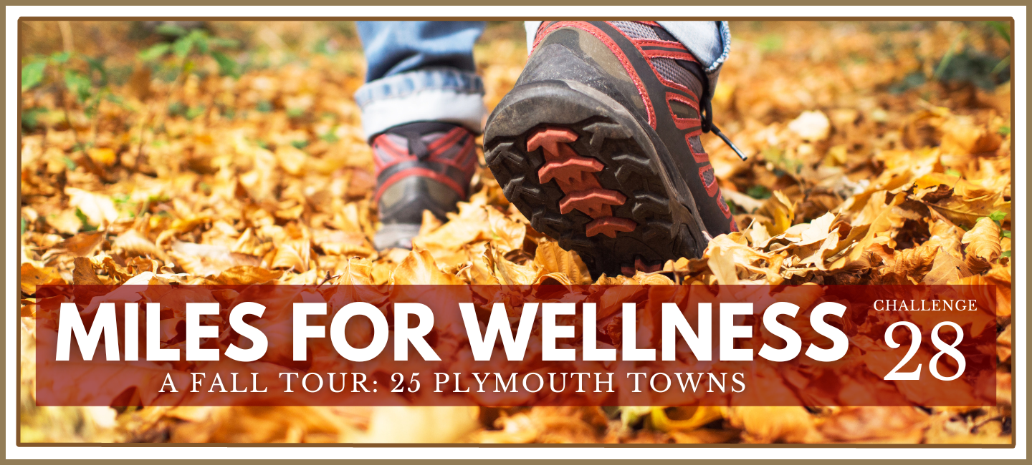

(Captain’s Name), Team Captain
(Team Name), (Agency/University)
Sponsored by NC OSHR Worksite Wellness
Fall 2024

for the participation and completion of
A Walk On The Wild Side
Miles for Wellness Challenge 30
(Number of Steps) steps
Congratulations
(Participant Name)

This certificate is presented to

