The Autism Society, Immunize .org, and Vaccinate Your Family release “The Facts About Autism and Vaccines” infographic
The Autism Society, Immunize .org, and Vaccinate Your Family partnered to create an infographic titled The Facts About Autism and Vaccines. This resource provides simple facts about common myths and misconceptions. This valuable tool emphasizes the scientific research showing no link between vaccines and autism. As the topic of vaccines and autism resurfaces widely online and in clinical offices in response to comments made by the HHS Secretary, this resource can help reassure and support families with facts.
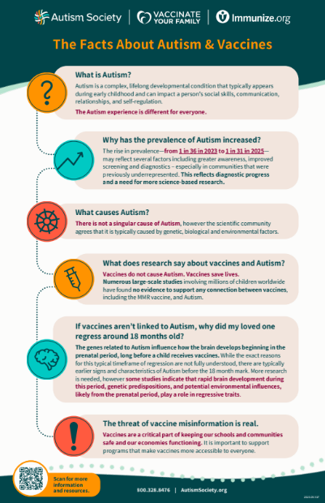
View the infographic.
Related Links
- Autism Society: Vaccine Education Initiative
- Autism Science Foundation and Vaccinate Your Family: The Truth About Autism and Vaccines (14-page PDF with 36 citations)
- Autism Science Foundation: Autism and Vaccines web page
- Children’s Hospital of Philadelphia Vaccine Education Center: Autism and Vaccines (PDF)
- Immunize .org: Autism: Resources & Information main page

