Voluntary Study on Workplace Sexual Harassment

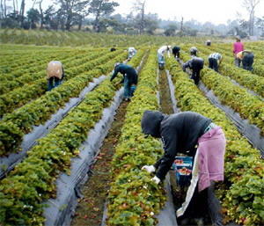
I am a student at John F. Kennedy University seeking voluntary participants for my dissertation study. This study will not collect identifying information. This study seeks to understand the experience of undocumented agriculture female workers facing sexual harassment. It is hoped that the information obtained from the study can be used by mental health professionals working with this population. In sum, the study seeks to shed some light on the experiences of sexual harassment among undocumented Latina agriculture workers. All participants will receive a $20 gift card.
To qualify for this study, you must be:
- Latina
- Between the ages of 18-50
- Have worked in agriculture for at least two years
- Has experienced workplace sexual harassment
- Undocumented

For more information, call Nicolasa Munoz at 925-290-8689

