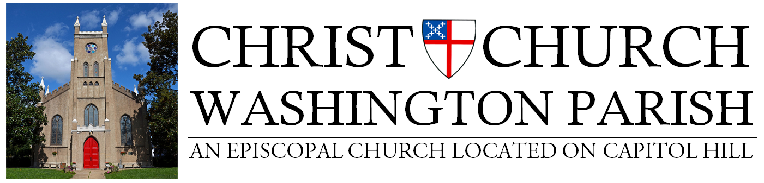
Covenant for Regathering in Worship
In response to the COVID-19 pandemic, I promise, with God’s help and to the best of my ability, to abide by the guidelines of the Diocese of Washington for participation in the life of Christ Church + Washington Parish according to the regathering phase in which my congregation is authorized to carry out its mission and ministry.

In fulfillment of our Baptismal Covenant, I will strive to:

Love my neighbor as myself
- Wear a mask or scarf over my nose and mouth at all times in church buildings, except momentarily to receive the sacrament or lead worship through an assigned speaking part.
- Only attend worship and receive communion if I am healthy and non-symptomatic with the novel coronavirus or any other transmittable disease that could compromise the health of another congregant.

Respect the dignity of every human being
- Make no physical contact with people beyond the members of my own household.
- Maintain a six foot or more distance from others in the congregation.
- Respect any requests for distance, masking, or cleaning, to ensure the safety and comfort level of others, even as restrictions are reduced.

Seek and serve Christ in all people
- Trust and support the decisions of our congregational leaders.
- Stay connected with others in my community by telephone, email, video chat, or mail.

Please sign and date this agreement and return it to Jennifer Baker Howard, Parish Life & Office Manager, via email (office@washingtonparish.org) or mail. All adult parishioners must have a signed letter on file with the Church Office BEFORE attending any services or gatherings inside the church complex (sanctuary, Parish Hall, etc).

______________________________________________________________ ____________________
Signature Date

______________________________________________________________
Print Name

