ASHI MEMBER SPOTLIGHT

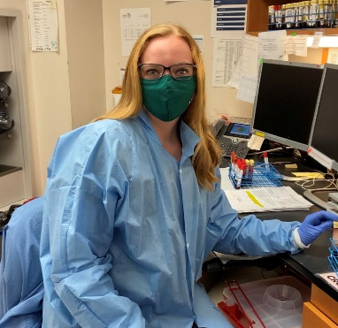
Brooke Banuelos, BS, CHT (ABHI)
Histocompatibility Technologist
UAB Hospital

Graduated from: University of Montevallo

How long have you been an ASHI member? 3 years

What made you decide to work in HLA? Working in the field of Histocompatibility allows me to make a positive impact in the lives of others. I am constantly learning new things which I greatly enjoy.

Most rewarding aspect: The most rewarding aspect of my work is getting to play a part in saving lives through transplantation. We get to see the amazing impact of organ donation.

Fun fact: I am a huge animal person! I met my husband while working in a pet store and we have two dogs and a cat.

