ASHI MEMBER SPOTLIGHTS
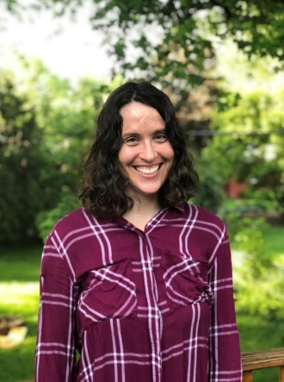
Miranda Bauer PhD
Senior Laboratory Services Scientist
Be The Match
Graduated from: University of Minnesota-Twin Cities
How long have you been an ASHI member? 3 years
Where was the ASHI meeting held the first time you attended? My first ASHI meeting was held in San Francisco in 2017. The ASHI QAS Committee had a dinner in the basement dining area of a cute little Italian restaurant. It was my first year on the committee and I had so much fun getting to know everyone.
What made you decide to work in HLA? I fell in love with genetics during my second rotation at the University of Minnesota as a first year PhD student. I used NGS technology to extend the known sequence of the major histocompatibility complex in a turkey. The gene's behavior, structure, and functionality absolutely fascinated me. When an opportunity came up to work with HLA at Be The Match 6 years ago, I jumped on it.
Most rewarding aspect: The most rewarding part of my job is converting labs to reporting HLA-CT results for patients and donors electronically, especially when we can get automated submissions set up for the lab. It improves the quality of data and reduces the time it takes for the results to get from the lab to NMDP. Working on a project where everyone wins at the end of the day is super rewarding.
Fun fact: I love animals and I professionally train dogs in my spare time. My favorite dog sport is agility, but I've also trained and competed in K9 Nose Work.

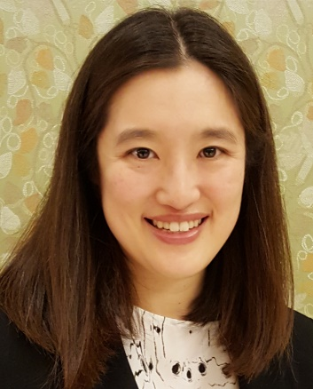
Deanna C. Fang, M.D.
HLA Director in Training
David Geffen School of Medicine at UCLA

Graduated from: Pomona College (B.A.), Saint Louis University School of Medicine (M.D.)

How long have you been an ASHI member? 5 years
Where was the ASHI meeting held the first time you attended? My first meeting was in Saint Louis, MO. It was somewhat nostalgic to return because I lived there for 6 years during my medical school years and my post-sophomore fellowship in Pathology. My hotel room had a great east-facing view of the Gateway Arch. It was a wonderful way to wake up.
What made you decide to work in HLA? I never considered training in HLA until I was in my transfusion medicine fellowship at University of Minnesota. That program has significant relationships with the solid organ and stem cell transplantation services and provided strong training in apheresis and in transfusion reaction and platelet refractoriness workups - subjects where HLA is featured prominently - and that inspired me to understand HLA better. I was so lucky that the HLA Director there, Dr. David Maurer, is such a great teacher (he has the gift of being able to explain anything) and that I had an example of the Blood Bank Director, Dr. Claudia Cohn, who was dual trained and opened my eyes to seeing how it was possible for a transfusion medicine physician to also cover the HLA lab service. They really changed the course of my life when I think about it.
Most rewarding aspect: For those who have never been to the ASHI Regional Education Workshop, it includes a session on “The Donor and Recipient Experience” where patients and/or family members of donors speak on their experience with the transplant process and the impact of the gift of donation. I don’t think anyone can go through that hour unaffected and it always brings me straight back to ground zero of why we do what we do and why it is important that we strive in our work to give these transplant recipients their best chance for a successful transplant.
Fun fact: I love walking and I was inspired by the example of one of my UCLA predecessors to live within walking distance of work. (It’s why I’m almost always in flat shoes instead of high heels nowadays.) Actually, it is still an adjustment for me to drive on the famous highways of the Los Angeles area, even after a year of being here. One time I checked the stats on my car and saw that there was even one month where I only drove 34 miles.
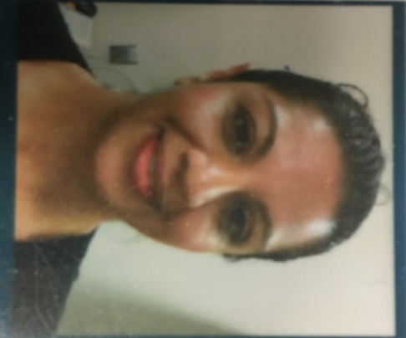
Aliya Merchant, MLT, BSc
Laboratory Manager - Core and HLA Laboratories
St. Joseph's Healthcare - Hamilton, Ontario, Canada

Graduated from: Cambrian College (Laboratory Technologist) and Laurentian University (BSc in Biomedical Science)

How long have you been an ASHI member? 2 years
Where was the ASHI meeting held the first time you attended? My first ASHI meeting is scheduled for this year in September where I hope to network with fellow colleagues, expand my technical knowledge, and participate in the 5K Tulip Run.
What made you decide to work in HLA? My new role as Laboratory Manager included Core Laboratory and two specimen collection centers. HLA was added to my portfolio to provide onsite support within a multi-site laboratory program.
Most rewarding aspect: The HLA laboratory has come full circle in my life. My father passed away with end stage renal failure and was not a candidate for transplant over 10 years ago. Today, I find myself managing staff and the operation of one of the five HLA labs in Ontario. I have been humbled to work with a dedicated team in supporting patients with life changing bone marrow and renal transplants.
Fun fact: I am an avid sports fan from football (NFL - Go Titans!), to basketball (Go Raptors! - the celebration parade was a lifetime experience), MLB (Go Jays!) to NHL (Go Leafs!).

