ASHI MEMBER SPOTLIGHTS
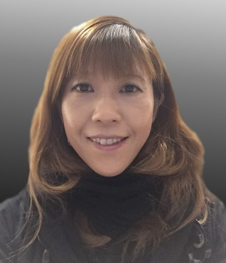
Michiko Taniguchi, M.Sc., PhD, D(ABHI)
Associate Director
City of Hope Medical Center
Graduated from: Kobe University (PhD), University of Southern California (MS), Royal Melbourne Institute of Technology
How long have you been an ASHI member? 3 years
Where was the ASHI meeting held the first time you attended? My first ASHI meeting was held in Hollywood, Florida over 10 years ago. It was also the first time I attended an academic meeting. Everything was very new to me and I felt overwhelmed with the presentations. I also took the CHT exam there.
What made you decide to work in HLA? My mentor Dr. Paul Terasaki hired me right after I graduated from USC despite the little job experience I had in HLA. I got into HLA as I joined his projects with his world-class research teams.
Most rewarding aspect: As a research scientist, the most rewarding aspect is discovering new facets of HLA that I didn’t know and having the opportunity to present to the HLA community. As an Associate Director, the most fulfilling moment is when engraftment in patients is achieved after the workup process and DSA monitoring.
Fun fact: I am a self-taught graphic designer and a visual thinker. I like to shape scientific data into visual objects. I have worked in various design projects including conferences and book promotions. One of the logos I designed is featured on a building in Westwood Village, Los Angeles. I created the ASHI Lab Week posters in 2017 and 2018. Also, I’m a car enthusiast and I like driving cars. I enjoy the freedom of exploring national parks in the American Southwest in my car.

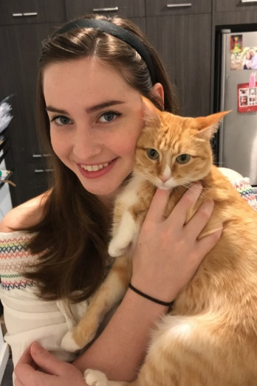
Brittney Howell, BS, CHT
HLA Technologist II
Bloodworks Northwest

Graduated from: Texas A&M University

How long have you been an ASHI member? 2 years
Where was the ASHI meeting held the first time you attended? My first ASHI meeting was in Las Vegas in 2018. A special memory was meeting and talking to technologists who worked in different labs across the US and realizing how different each lab really is.
What made you decide to work in HLA? I never heard of HLA until I applied for a position but I had a really great experience in my immunology class in college, so I searched for any job related to immunology and found an opening in Houston.
Most rewarding aspect: Aside from making a difference in people's lives, I love how challenging and fast paced this work can be because the science and the assays are always changing and there is always something new to learn.
Fun fact: I love cats, videogames and rainy weather.

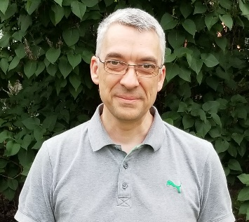
Eric Wagner, PhD, D(ABHI)
Lab Director
CHU de Québec-Université Laval

Graduated from: Université Laval, Quebec City, Canada

How long have you been an ASHI member? 11 years
Where was the ASHI meeting held the first time you attended? I attended my very first ASHI meeting in 1990 when I was just a young graduate student. The meeting was held in Los Angeles. I was presenting my work on the role of anti-HLA antibodies in human corneal allotransplantation. I still remember the stimulating discussions and exchange of ideas I had with society members. Unfortunately, I had to wait until 2008 for my next meeting which was held in Toronto. I was back in the field as a director-in training. I never missed a meeting since then.
What made you decide to work in HLA? HLA was always of great interest to me as I had the chance to do research as a graduate student in a clinical immunology and histocompatibility laboratory. In an ideal world, I wanted to be an HLA Lab Director but I had to be patient. After spending some time as a postdoctoral fellow at Duke doing research on the complement system and then as a clinical scientist in immunology and cellular therapy in Montreal, I was offered the chance to direct the ASHI-accredited HLA laboratory in Quebec City. My dream job was within reach and I certainly did not hesitate.
Most rewarding aspect: Working in HLA is unique as, in an era of moving toward personalized medicine, the HLA lab has already been involved in personalized laboratory testing for a long time. Contributing to a team effort alongside lab technologists, transplant physicians and nurses, and OPO coordinators is very rewarding as all our coordinated efforts, considering each patient individually in the tests we perform, benefit the patients directly. Also, volunteering on an ASHI committee (DTRC) and performing lab inspections brings me a lot of rewards as it allows me to work with great people and help the HLA community as much as I can.
Fun fact: I really like riding my bicycle to work every day. However, living in the cold Canadian climate (we, the north, go Raptors!), I still haven't found the courage to get my bicycle out in 3 feet of snow.

