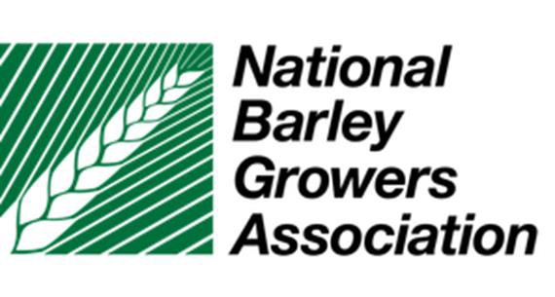
Summer
BOARD OF DIRECTORS MEETING

June 17-19, 2019
Snow King Resort
400 E Snow King Ave
Jackson Hole WY 83001

TABLE OF CONTENTS

Agenda – Attendees – Minutes
2—3 Agenda / Meeting Attendees
X—XX Minutes – Feb 6-8, 2019 Board Meeting – Washington DC

Financials

Resources
NBGA Board of Directors Roster; Industry & Associate Members

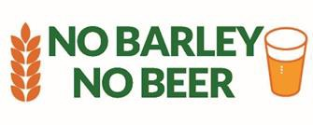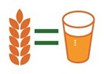

Agenda - NBGA 2019 Summer Meeting
Snow King Resort
400E Snow King Ave
Jackson Hole WY 83001

Monday, June 17, 2019

6 – 8 pm Welcome Reception Mountain View & Fireside

8:00 pm Executive Committee Meeting TBD

Tuesday, June 18, 2019

7:30 am Breakfast Grand View Pre-function

8:00 am Meeting Convenes Grand View A
Welcome / Introductions / State Crop Reports
Approval of Agenda / Previous Meeting Minutes / Anti-Trust Statement NBGA President Dwight Little

8:30 am Inside the Board Room – Board Training
Rick Waitley, Association Management Group (invited)

10:30 am Break

10:45 am NBGA Strategic Plan Implementation
Communication Contract Overview
Buzz Mattelin, Blair Elias, Dale Thorenson

11:15 am Financial Report / Proposed Budget for FY19/20

Dale Thorenson

Noon Lunch Grand View B

1:00 pm Panel on Beer Production, Consumption, and Outlook
Moderated by Laura Wilder, Idaho Barley Commission

2:00 pm Other Industry reports
Maltsters, Brewers, Crop Protection Companies

2:45 pm Break

3:00 pm Barley Export Marketing – Current Status and Outlook on Trade

U.S. Grains Council

4:00 pm DC Issues Update & Review of NBGA Policy Process
Tom Hance, Dale Thorenson

5:00 p.m. Adjourn for the Day

5:30 p.m. Board / Guest Dinner Mill Iron Ranch

Wednesday, June 19, 2019

7:30 am Breakfast

8:00 am AMBA Update
Scott Heisel

8:30 am Field to Market Update

Buzz Mattelin, Dale Thorenson

9:00 am Food Barley Situation and Outlook

9:30 am RMA - Quality Issues

10:15 am Break

10:30 am Craft Brewers Conference Report / NBGA Panel, Reception
Buzz Mattelin, Scott Brown, Greg Kessel, Blair Elias

11:00 am Discuss/Approve FY 19/20 Budget

Noon Adjourn

