Free Car Seat Inspection and
Installation Class
Please Call Laura Kent at 719-305-7233 for an appointment

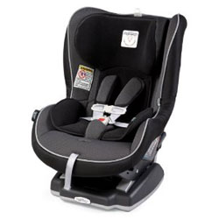
Family Name: ________________________

Address: ______________________________

Phone Number: ______________________________

Child 1: _______________________

Age______ Wt.: ______ Ht.: _______
Seat Size: ______________________Paid

Child 2: _______________________

Age______ Wt.: ______ Ht.: _______
Seat Size: ______________________Paid

$30.00 Convertible
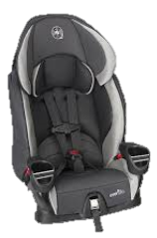
$40.00 High Rate Harness
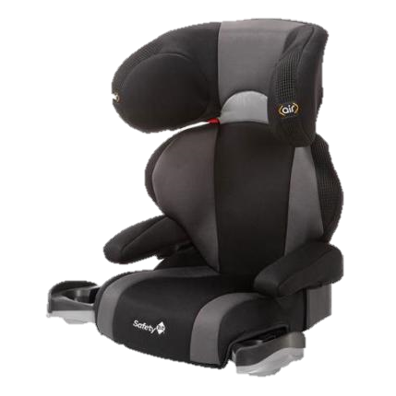
$20.00 Booster

