Press Release: October 20, 2022
Contact: Wouter Ketel at 252-342-5034

Cassett String Quartet Performs in Morehead City

The Cassatt String Quartet will perform in concert on January 7, 2023 at 7:00 PM at the First Presbyterian Church, 1604 Arendell Street, Morehead City, NC. Acclaimed as one of America’s outstanding ensembles, the Manhattan based Cassatt String Quartet has performed throughout North America, Europe, and the Far East. The Cassatt has recorded for the Koch, Naxos, New World, Point, CRI, Tzadik and Albany labels and is named for the celebrated American impressionist painter Mary Cassatt. Their program celebrates three women master-composers: Florence Price, Dorothy Rudd Moore, and Fanny Mendelssohn, presented here together with Mozart and his last string quartet.

“…an undulant, lyrical and insightful performance…” — New York Times

All AMF concerts are held at the First Presbyterian Church, located at 1604 Arendell Street, Morehead City, NC 28557. Parking is free. Tickets ($32.00) can be purchased at the door or on-line. Tickets for students or active –duty military ($16.00) are available at the door. Students 18 and under and one accompanying adult chaperone may reserve free tickets on-line. For more information: visit www.americanmusicfestival.org or call 252-342-5034.

COVID-19 Procedures in Effect
At the time of each concert, there will be masking and seating requirements based on CDC recommendations. Masks will be made available at the concerts.

Background

The American Music Festival (AMF) has been providing great music to Carteret County and Eastern North Carolina for the last 32 years. A portion of the ticket proceeds and donations to AMF go to provide music outreach programs for county school children.

The AMF is a local “not for profit” organization which receives support from the Arts Council of Carteret County, the NC Arts Council, and the National Endowment of the Arts, the Beaufort Ole Town Rotary and the Classical Voice of North Carolina.
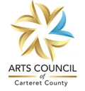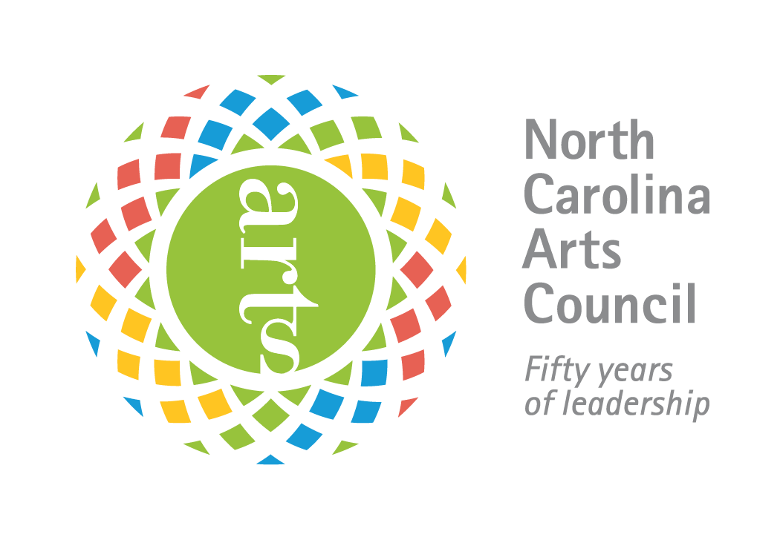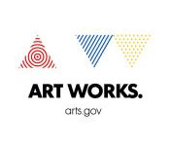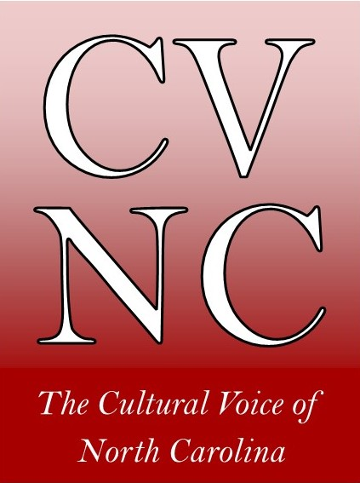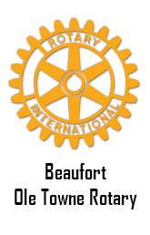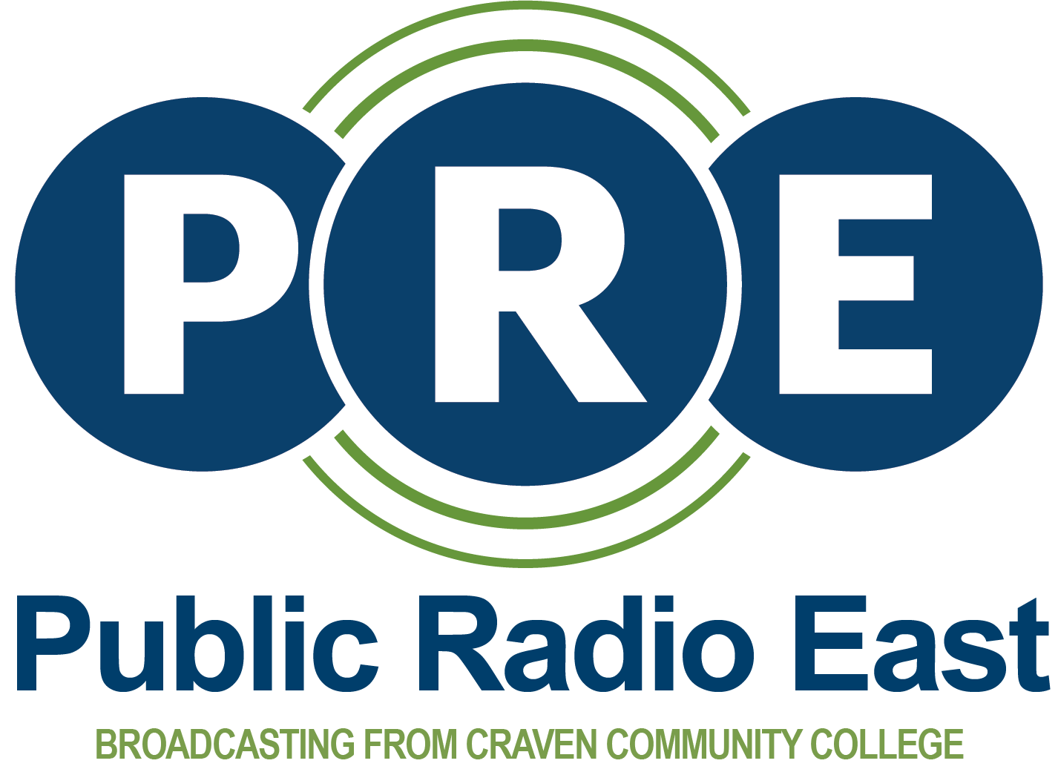

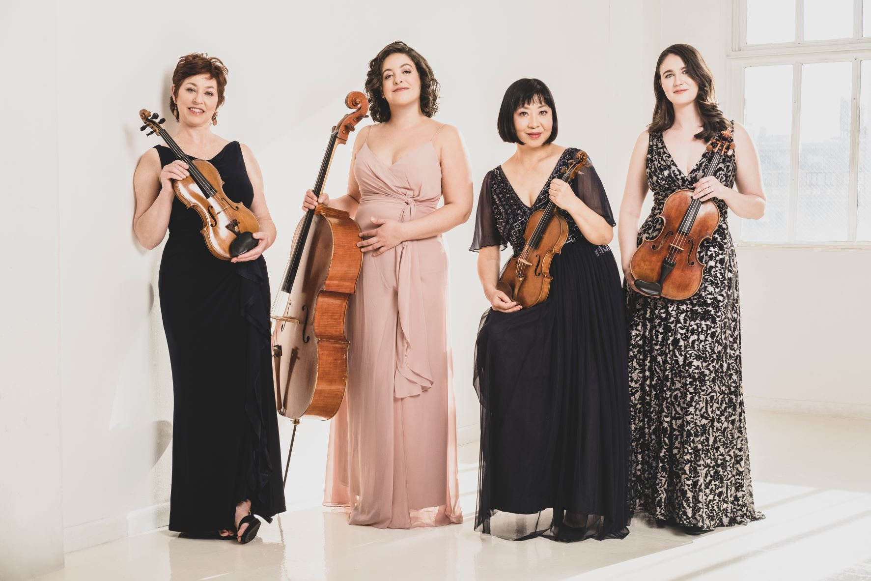

[Short Announcement]

The Cassatt String Quartet will perform in concert on January 7, 2023 at 7:00 PM at the First Presbyterian Church, 1604 Arendell Street, Morehead City, NC. The Cassatt String Quartet has performed throughout North America, Europe, and the Far East. Their program celebrates three women master-composers: Florence Price, Dorothy Rudd Moore, and Fanny Mendelssohn, presented here together with Mozart and his last string quartet.

Tickets ($32) are available online or at the door. Reduced price tickets ($16) are available for students and military at the door, and students 18 and under may reserve FREE tickets on-line. For tickets and information please visit http://www.americanmusicfestival.org/index.html.
For additional information please call 252-342-5034.

