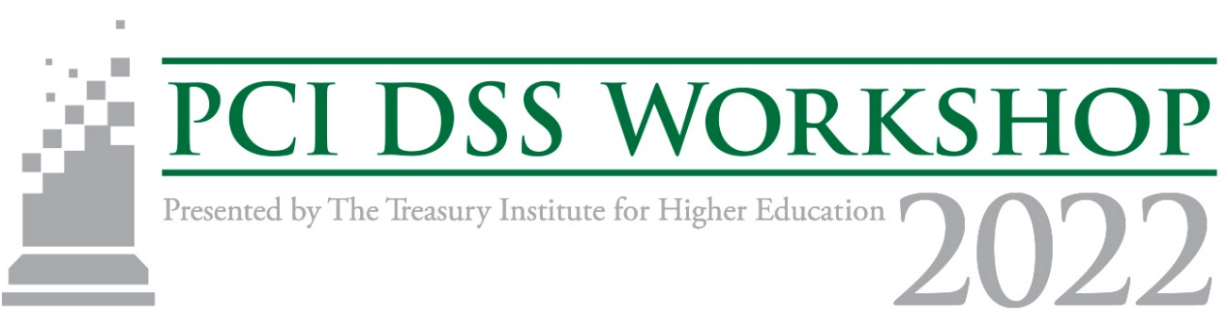
Managing Risk: Digital Payments, Cards, and Beyond Session Proposal Template
Session Proposals Due January 21, 2022:
Proposal Submission Link

Session Title
Presenter(s)
Job Title and Organization
Email
Work Number
Session Description
Audience Learning Objectives
Target Audience Experience Level
(Beginner, Intermediate, Advanced)
Presenter Bio (optional)

