International Women of Courage Alumni

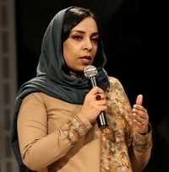
Roya Sadat (Afghanistan) - 2018
Using cinema and television as platforms for advocacy, Roya Sadat promotes positive change by telling the untold stories of Afghan women and girls. Throughout her career, Sadat has faced enormous risks and has overcome tremendous cultural, bureaucratic, and monetary barriers. At age 20, Sadat directed her first feature, Three Dots, which she secretly wrote during the Taliban era. Sadat took major risks to shoot the film in a rural village; at one point, she was chased away at gunpoint by villagers angry at her use of uncovered women actresses. In 2003, Sadat founded Roya Film House to tell compelling stories about Afghanistan. In 2013, she founded the Afghanistan International Women's Film Festival to promote women filmmakers and the empowerment of Afghan women through art. In the process of examining Afghanistan’s culture through cinema, Sadat is doing her part to make her country a better place for women and girls.

UPDATE 2022
Roya Sadat is an Afghan filmmaker & international women’s rights advocate. Named by the BBC as one of the 100 Most Inspiring & Influential Women in the World for 2021, she taught herself how to create visual stories during the Taliban regime.
Her film A Letter to the President was the Afghan submission for Best Foreign Language Film at the 2018 Oscars. The film follows Soraya, a low-level government official, who is imprisoned when she defends a woman from village lords. Behind bars, she writes the Afghan President for help. Variety Magazine says A Letter to the President is “A righteously compelling feminist drama from trailblazing director Roya Sadat.” Ms. Sadat is working with Studios Artistic Associate, Stephen Kitsakos and American composer Sheila Silver on the opera adaptation of Khaled Hosseini’s A Thousand Splendid Suns for the Seattle Opera’s February 2023 World Premiere.

When the Taliban took over Afghanistan in August 2021, Roya was forced to flee the country with her family to the United States where they have resettled. She plans to continue telling the story of Afghans through film in this critical period of the country’s history.

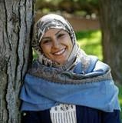
Fadia Najib Thabet (Yemen) - 2017
As a Child Protection Officer who reported on violations against children in conflict during the recent conflicts in southern Yemen, Fadia Najib Thabet faced death on a regular basis as she tried to protect the region's children from Al Qaeda and Houthi militias. Through her courageous work, she dissuaded young boys from joining Al Qaeda, exposed its Yemeni branch "Ansar al Sharia" as a recruiter of child soldiers, and documented for the United Nations Security Council cases of mining, abduction, rape, and other human rights violations by various armed groups. Thabet took the view that children recruited by extremists and militants were not criminals, but, victims. She worked with parents, schools, communities, the children themselves, and eventually the United Nations to develop an action plan in southern Yemen to save children from the war. Thabet continues to work on behalf of dispossessed and uprooted children with the American Refugee Committee.
UPDATE 2022
In 2019 Fadia Najib Thabet received her Master’s Degree from the SIT Graduate Institute in Vermont where she gave the student commencement speech at the graduation ceremony. In November 2020 she was recognized by SIA-Africa (Sustainable Initiatives for Africa) for her courage, leadership, and role in ensuring human rights and child development in Yemen and the Middle Africa’s. She plans to return to the region and continue her humanitarian work in war and post-war zones, but says she would also like to focus on engaging more women to participate in peace talks.

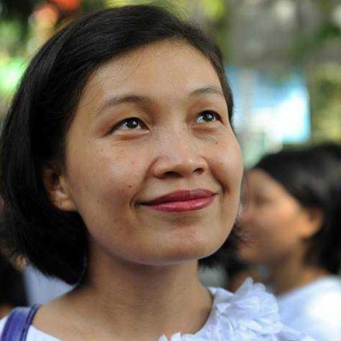
May Sabe Phyu (Burma) - 2015
The director of the Gender Equality Network, a coalition of more than 90 organizations collaborating to advocate for women’s rights, May Sabe Phyu is leading efforts to end discrimination against women and ethnic and religious minorities in Burma. She co-founded the Kachin Peace Network and Kachin Women Peace Network to prioritize the needs of ethnic minority women in Kachin State, who are disproportionately affected by the longstanding civil conflict between the government and ethnic armed groups in northern Burma. Her efforts to address gender-based violence and promote women’s involvement in the peace process have led to numerous legal charges, as well as harassment and threats from anonymous networks. Yet, May Sabe Phyu’s determination in the face of adversity, political opposition, widely held rigid views about women’s roles, and personal risk has inspired collective action to push for government policy changes and realize women’s rights in Burma.

UPDATE 2022
May Sabe Phyu has been listed by many local and international news media outlets as one of the inspiring women leaders who are changing Myanmar’s society. She has been recognized as a distinguished alumnus by the Asian Institute of Technology Alumni Association Thailand, where she received a Master’s degree in Gender and Development Studies. May Sabe Phyu is also an alumnus of the Mason Fellowship from Harvard University’s John F. Kennedy School of Government. In 2017 Georgetown University’s Institute for Women, Peace & Security presented her with the Global Trailblazer Award for her courage and commitment to inclusive peace building, and tireless work to advance women’s equality in the face of violent opposition. In 2019 she received the N Peace Award from the N Peace Network. She is currently a Dorethea S. Clarke Fellow at Cornell Law School in addition to her role as Director of the Gender Equality Network.

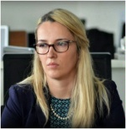
Arbana Xharra (Kosovo) - 2015
Arbana Xharra’s reporting contributes to the strengthening of Kosovo’s nascent democracy. Her early reporting on religious extremism and its impact on society shed light on a serious problem for Kosovo and the region. Ms. Xharra authored a series of investigative reports on extremists operating in Kosovo and uncovered financial and operational links with foreign terrorist organizations among local imams and NGOs. These efforts not only helped society understand the problem, but also bolstered government efforts to address the problem. Reactions to her reporting resulted in public attacks on her reputation and death threats to her and her family. Undeterred, Ms. Xharra continues to report on malfeasance in public institutions, including cases involving high-ranking officials. As editor-in-chief of one of Kosovo’s top daily newspapers, Ms. Xharra is galvanizing a new generation of journalists in search of, and dedicated to uncovering, the truth.
UPDATE 2022
On May 9th 2017 Arbana Xharra resigned from Zëri newspaper and became a member of the PDK - the largest political party in Kosovo. A few days later, she was attacked and severely beaten by unknown perpetrators in front of her home. Kosovo’s President Hashim Thaaci and Prime Minister Isa Mustaga, as well as media and civic society groups condemned the assault. She resigned from PDK in 2018. She is currently writing and researching with NYU professor Alon Ben-Meir on Turkey and radicalization in the Balkans.

