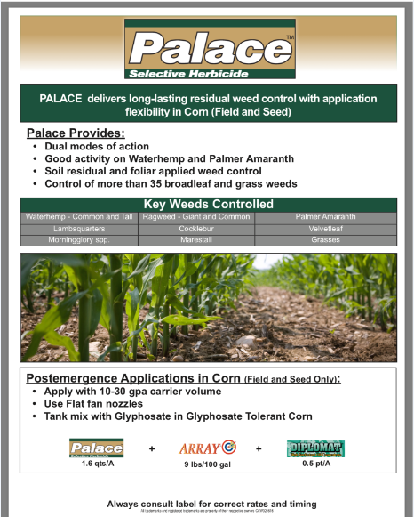
II
II
Palace II Callisto Dual II Mag 1.35 Qt. = 3.04 oz. 1.01 pt. 2.0 Qt. = 4.56 oz. 1.51 pt.
2.4 Qt. = 5.32 oz. 1.93 pt.

-TANK MIX WITH ATRAZINE IF POSSIBLE
-UP TO 30” TALL CORN
+Buccaneer Plus 1 Qt/ac
Tradition 93
1 Qt/ 100 water
1.35 Qt/ac

