Virginia Symphony Orchestra
Flute and Harp Recital
Saturday, October 7, 2017
2:00 p.m.
Ark and Dove Presbyterian Church
$20/$25 in Advance
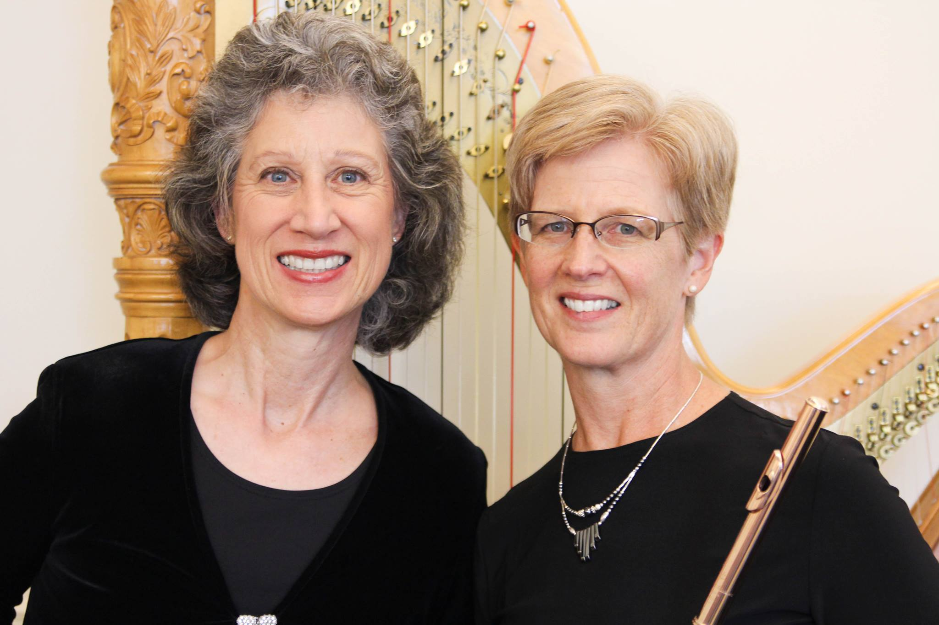
Debra Wendells Cross, Flute
Barbara Chapman, Harp

