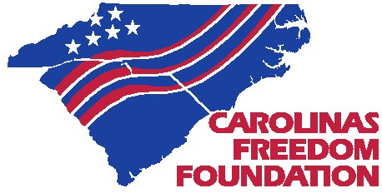

***Annual***

**FREEDOM BREAKFAST &**

**SALUTE TO VETERANS PARADE**

**2019**

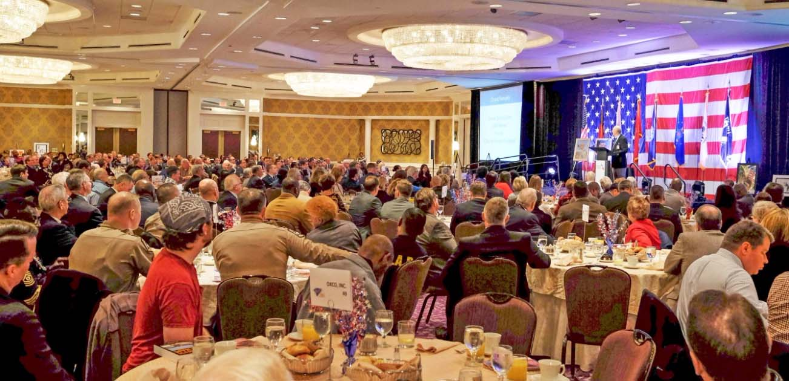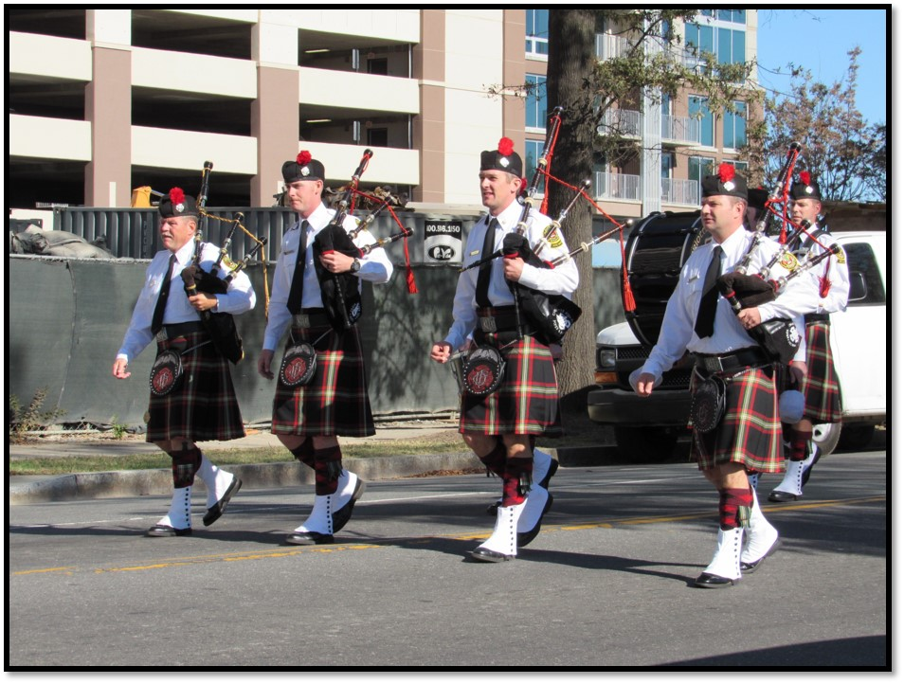

**DATE: Saturday, November 9th, 2019**

**START TIME: 11:00 AM**

**LOCATION START:**

**700 North Tryon St. Parking Lot**

**LOCATION END:**

**Between 3rd St. E. MLK St.**

**If you are a company or an organization that would like to participate in the parade, please go to the link below to register.**

[**https://www.carolinasfreedomfoundation.org/veterans-parade/**](https://www.carolinasfreedomfoundation.org/veterans-parade/)

**DATE: Friday,**

**November 8th, 2019**

**TIME: 7:30 AM-9:00 AM**

**LOCATION:**

**Charlotte Convention Center, 501 South College Street, Charlotte, NC 28202**

**COST: Individual tickets- $80/Tables of 10- $1,000 Sponsorships available**

**REGISTER AT:**

[**https://www.carolinasfreedomfoundation.org/events/C591166A-23D2-4FA0-AF17-EC274D349566**](https://www.carolinasfreedomfoundation.org/events/C591166A-23D2-4FA0-AF17-EC274D349566)