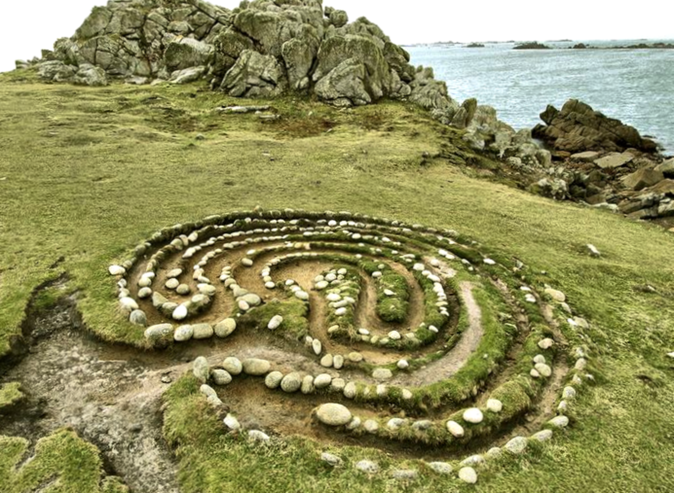

‘Make everything in you an ear and you will hear at every moment what the Source is whispering to you… You are-we are all- the beloved of the Beloved. And in every moment of life, the Beloved is whispering to you exactly what you need to hear and know. Who can explain this miracle? Listen and you will discover it every passing moment. Listen, and your whole life will become a conversation and act between you and Him now and always…’ by Rumi

‘Spiritual Direction is a window to your soul’

Rev Kai Millar, Pastor Northern Lights Metropolitan Community Church Newcastle



East Window at St. Martin-in-the-Felds church, London, UK. Created by Shirazeh Houshiary

SPIRITUAL DIRECTION ACCOMPANIMENT with INCLUSIVE HEART CONNECTION

‘Spiritual direction is like panning for gold… we dip into the stream of their life and pull up all kind of things.’ Dr. Janet Ruffing

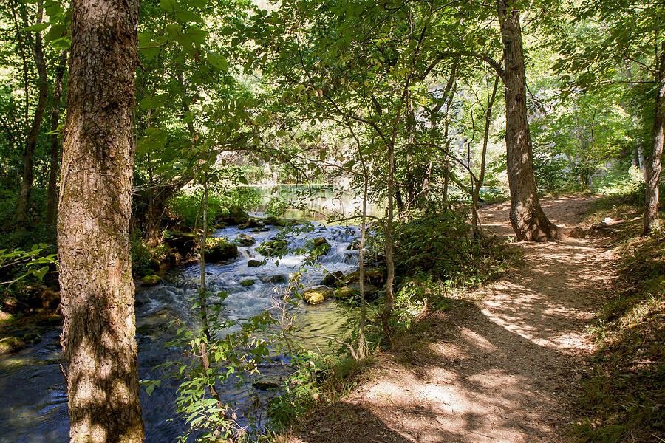

Spiritual Direction helps ‘to hear the voice of God in life’s experience and to discover God’s plan as it unfolds’ through accompanying ‘another on the ongoing journey of faith as a fellow traveller. .’- Northumbria Community

What is Spiritual Direction?
Spiritual direction is an ancient practice where a ‘director’ walks alongside their’ ‘directee’, to help you reflect on and discover where God is in your life, what God’s direction is for you; to explore, nourish and to develop in your faith life, to get ever closer to God, to become who you are truly created to be.
Spiritual accompaniment is a more contemporary term and is a professional relationship journey about accompanying, listening, being with, affirming and acknowledging, to help you explore find the answers yourself towards wholeness. This is your sacred journey. You will not be told what you should do. Accompaniment offers support, inviting God’s presence into the sessions.
Spiritual accompaniment is for all parts of your life, where you can bring whatever is on your heart, to reflect on where you are, where you are with God on your journey. People often find this particularly useful in times of changes and transitions, in difficult times, or if you are feeling alone from God. Accompaniment is helpful and healing.
Spiritual accompaniment helps you to find your sacred journey and how to move forward in your life and community.
What will it look like?
This is an opportunity for you to share in a warm, accepting, non-judgemental, open and confidential space.
Sessions last for 50 minutes, every 4 to 6 weeks.
At present, sessions occur virtually, online and there is no fee.
This is a sacred space. The space is yours to bring yourself just as you are. You are free to bring anything. We will reflect on where God is, what’s God invitation is to you, and how you would like to move forward with God until the next session and life chapter. We can explore different prayer and faith practices to support you.
If you wish, you can connect with creativity, your drawings, writing, music if that helps you.
If you would like the opportunity to share and discover yourself and your sacred journey with God more, please email me, Jack Helena Knight at inclusiveheartconnection@gmail.com
Who Am I?
I am a trainee spiritual accompanier, on my last year of The Encounters Course at the London Centre for Spiritual Direction
I have a diverse faith background and identify as a liberal Christian with an open radically inclusive perspective.
I am a Christian and am part of Nazareth Community from St. Martin-in-the-Fields and follow a contemplative, intentional and reflective way of life. I also am part of the Metropolitan Community Church, an ecumenical church affirming and welcoming all people, sexualities, and genders with social justice at its heart. As part of the LGBTQI+ community, radical inclusivity, connecting to the heart of God and living compassionately are central to my faith.
I have previously worshiped at a range of denominations including the United Reformed Church, Oasis Church Waterloo, Unitarians, Church of England, Quakers, Baptist, and I have a background in God conscious meditation and mindfulness.
My faith is all about heart, intention and growing in connection with God, to embrace and become the person God created you to be whilst living with love and compassion for all people and in unity. God needs us to be still and present to be open to be changed and transformed so that we can bring love and service into the world.
I am open and welcome learning from other cultures, traditions and wisdoms. I am inspired and spiritually nourished by being present in nature, with art, music and poetry and by writings, from Richard Rohr, Julian of Norwich, The Dalai Lama, Celtic Christianity and ‘Thay’.
I am a parent and have worked in disability in the NHS for 27 + years in diverse communities. I welcome all, particularly for those who feel on the edge or excluded, those who may not be part of or feel safe in church, whatever your background, faith or no faith. I welcome people with disabilities, neurodiversity, PTSD, people of colour, all ages, LGBTQI+, with whatever background or stories you bring.

