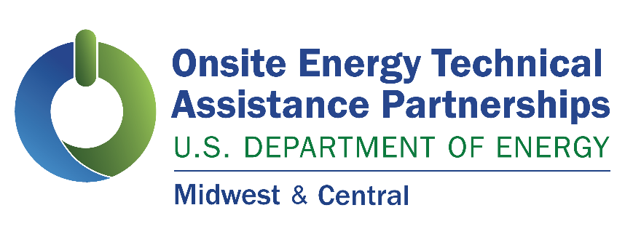
Technical Assistance Now Available to Midwest & Central Facilities Interested in Onsite Energy

Industrial facilities and other large energy users interested in exploring ways to deploy onsite clean energy technologies are encouraged to request technical assistance through the U.S. Department of Energy’s Onsite Energy Technical Assistance Partnerships! The University of Illinois Chicago’s Energy Resources Center operates the Midwest & Central Technical Assistance Partnership. It can help industrial facilities and other large energy users transition to onsite clean energy while lowering costs, reducing emissions, and contributing to a clean energy economy. We can screen your site for opportunities and help you craft an onsite energy strategy to maximize economic impact, reduce risk, and minimize operations and maintenance costs. Contact us today to get started.

Cliff Haefke,
Director, U.S. DOE Central, and Midwest On-site Energy TAPs,
chaefk1@uic.edu

Ben Campbell,
Assistant Director, U.S. DOE Central On-site Energy TAP,
bcampb24@uic.edu

Graeme Miller,
Assistant Director, U.S. DOE Midwest On-site Energy TAP,
gmille7@uic.edu

DOE Announcement
Embargoed until 1 p.m. on Jan. 10, 2024

Calling All Manufacturers: Get Support to Adopt Clean Energy Solutions with DOE’s Onsite Energy Technical Assistance Partnerships
Are you a manufacturer or other large energy user looking to integrate new clean energy technologies at your facility?
The U.S. Department of Energy’s (DOE) new Onsite Energy Technical Assistance Partnerships (TAPs) can help industrial and other large energy users transition to clean energy, lower costs, reduce emissions, and increase resilience.

The Onsite Energy TAPs will help facilities across the nation integrate the latest onsite energy technologies by providing region-specific, specialized services, including:
• Technical Assistance: Screen sites for opportunities to implement onsite energy technologies and provide advanced services to maximize economic impact and reduce risk from initial screening to installation to operation and maintenance.
• End User Engagement: Partner with organizations representing end-users to advance onsite energy as a cost-effective way to transition to a clean energy economy.
• Stakeholder Engagement: Engage with strategic stakeholders, including utilities and policymakers, to identify and reduce barriers to onsite energy through fact-based, unbiased education.

The TAPs have the expertise to advise on a wide variety of distributed technologies, including battery storage, combined heat and power (CHP), district energy, fuel cells, geothermal, industrial heat pumps, renewable fuels, solar photovoltaics, solar thermal, thermal storage, and wind power.
By generating and storing electricity and heat directly at their facilities, manufacturers can improve their resilience, be more flexible, and reduce operating costs. When facilities increase their onsite energy, they reduce their dependence on energy utilities and can better manage outages and other reliability issues. With onsite energy, facilities can also decide to generate or purchase energy when it is most economical.
DOE’s 10 Regional TAPs cover all 50 states, Guam, Puerto Rico and the U.S. Virgin Islands.
For more information visit the Onsite Energy website or download this fact sheet.
The Onsite Energy Program is overseen and funded by DOE’s Industrial Efficiency and Decarbonization Office. The TAPs are also supported by a trio of DOE national laboratories (the 5 National Renewable Energy Laboratory, Oak Ridge National Laboratory, and Pacific Northwest National Laboratory) with subject-matter expertise in onsite energy deployment.

