Congregational Toolkit for a
Bilingual Way of the Cross/Via Crucis

Introduction
The Episcopal Church in the United States of America as well as many other denominations celebrate the Way of the Cross as a Lenten tradition especially on Good Fridays. Many Episcopal Churches have artistic depictions of the fourteen Stations of the Cross around their sanctuary, and have services built around walking a pilgrimage devotion from station to station. Historically the service grew from the Christian tradition to make a pilgrimage to Jerusalem and walk the actual Via Dolorosa on Good Friday.

Via Crucis remains a strong tradition in Latin America. Via Crucis Viviente, a living reenactment of the Passion, with actors playing Christ, Pilate, Simon of Cirene, Mary, and the others, remains popular in Spain and the Mediterranean, as well as in Spanish- and Portuguese-speaking countries in the Americas as well as in Latinx/Hispanic parts of the US. This type of service speaks to the Catholic in the AngloCatholic nature of the Anglican Communion, but such a pageant is not considered here. What is considered here is a bilingual Way of the Cross/Via Crucis either live or put out via Zoom and/or Facebook Live.

Reasons for a Bilingual Crucis
Why mount a bilingual version of an obscure and depressing service that seems to wallow in the agony of Christ? The simple answer is that the pain of the Passion is central to an emotional, spiritual and intellectual understanding of the Christian faith. It drives home the emotional weight of the sacrifice of Christ. We can see the pain and uncertainty that affected the human part of Christ and strive for the divine strength, love and dignity that Christ displayed especially in the Via Dolorosa. It is a powerful way to contemplate, and enter into, the mystery of Jesus' gift of himself to us. Saying the simple potent liturgy in a language in which you normally pray gets at the Christian emphasis of honoring those from different cultures and it puts participants into the heart and not just the intellectual appreciation of the Passion. Doing the service bilingually, not repeating each part but switching from Spanish to English, station by station, allows both English and Spanish speakers to feel the tension of incomplete comprehension, and experience the alienation and otherness of another language. While we hope the pandemic restrictions will be over by Lent of 2022, this time of daily death counts recalls suffering and the image of bearing a cross. The Via Crucis is especially moving to Latinx/Hispanics because like Jesus, they are intimately acquainted with unwarranted suffering, and unjustly accused of being criminals. For Anglos a bilingual Way/Crucis has the benefit of being a familiar Lenten practice for Anglicans, and not quite the cultural stretch of Dia De Los Muertos.

Congregational Toolkit
The Service for Way of the Cross is in The Book of Occasional Services, starting on page 46. A Spanish version is in the translation Libro de Ritos Ocasionales, beginning on page 50. Both of these printed books are also available as downloadable pdf’s, and the online versions can be copied.
Book of Occasional Services: https://www.episcopalchurch.org/wp-content/uploads/sites/2/2021/01/lm_book_of_occasional_services_2018.pdf
Libro de Ritos Ocasionales: https://extranet.generalconvention.org/staff/files/download/21367
Materials for the Service
In Person Service
The sparseness and simplicity of the Way of the Cross/Vis Crucis service makes it relatively easy to produce in a live setting. For an in-person service, you need only have a bilingual service booklet and a lay leader or clergy, and some plan to get the word out to the parish community. It helps to have the Stations of the Cross arrayed around the church walls, and many in the Diocese do.

Bilingual Booklets for In-Person Service Booklet Links
There are several examples of service booklets with facing page English and Spanish text of the liturgy for Way of the Cross/Via Crucis t

hat can used or adapted for a local church. Here are two nice examples. Christ Church Cathedral, Springfield, MA, service booklet:
https://www.diocesewma.org/wp-content/uploads/2014/05/Way-of-the-Cross-Jersusalem-BILINGUAL.pdf
This service book expands on the text of the Book of Occasional Services and offers an example of further creativity.
St Stephen & The Incarnation Episcopal Church, Washington, DC
https://www.ecfvp.org/uploads/tools/files/Via_Crucis_bilingue1.pdf

Experience of Incarnation Santa Rosa &
Slides for the Zoom/Facebook sharing
In the pandemic-bound Lent of 2021, the Church of the Incarnation in Santa Rosa mounted a Zoom and Facebook Live broadcast of a bilingual Way of the Cross/Via Crucis. The church had done an all-English service on Good Friday in years past at Incarnation. The idea for a bilingual celebration grew from the bilingual tradition at St. Paul’s Episcopal Church’s Spanish congregation. There, in pre-Pandemic times, celebrants were able to physically gather and process around the stations on the wall of the church. Booklets with the liturgy of the Way/Crucis were distributed and a lay leader asked if a person would read the service in the language comfortable for him or her. Incarnation in 2021 set out to have a service every Friday in Lent, and do it bilingually. We alternated parts of the opening and closing devotions in English and Spanish, and did odd stations in Spanish and even stations in English. We had two lay readers, one reading parts of the service English and the other in Spanish, and readers did the liturgical verse and responses for each other. Linelle Lane of the Church of the Incarnation created slides using Adobe Dreamweaver website software to create the slides, exporting the slides as a .pdf. Linelle laid out the slides from text in both languages copied and pasted pieces of the service from the online Book of Occasional Services and Libro de Ritos Ocasionales. Linelle and others found some copyright-free art for the slides and also from photos of the carved wooden Stations of the Cross that adorn the sanctuary of the Church of the Incarnation in Santa Rosa. Linelle used a program called Adobe Dreamweaver to create the slides and exported the slides as pdf’s. These .pdfs were able to be used with Zoom to broadcast the services. Similar slides could be created and exported as pdf’s using Microsoft Office PowerPoint. She sought to find copyright-free art to accompany the text. These slides are included with this report.

Church of the Incarnation mounted also mounted A Soldier’s Stations of the Cross. David Jasper, a layman, had written a meditation on the stations from the point of view of the Roman soldier who accompanies Christ on the Via Dolorosa. This service was inspired by the carved wooden stations in the church. We did this one Friday in English with David Jasper reading, and once in Spanish with Bo Simons reading.
Music for the Way of the Cross/Via Crucis
The Way of the Cross/Via Crucis is a spare service, but some solemn music enhances the service. Here following is whole of the music suggested in the Book of Occasional Services:

The hymn Stabat Mater (“At the cross her vigil keeping” Hymnal 1982, 158) has frequently been associated with this service, but is not an integral part of it. Selected stanzas of this hymn may appropriately be sung at the entrance of the ministers, and (after the opening devotions before the Altar) as the procession approaches the first station.

In the form which follows, the Trisagion (“Holy God”) is the chant recommended as the procession goes from station to station. Alternatively, the Trisagion may be used to conclude each station, and stanzas of appropriate hymns sung asthe procession moves. It is appropriate that all present take part in the procession.

At Incarnation we used Stabat Mater wholly in English as a final hymn at the end of the service. It was sung beautifully by our choir director. 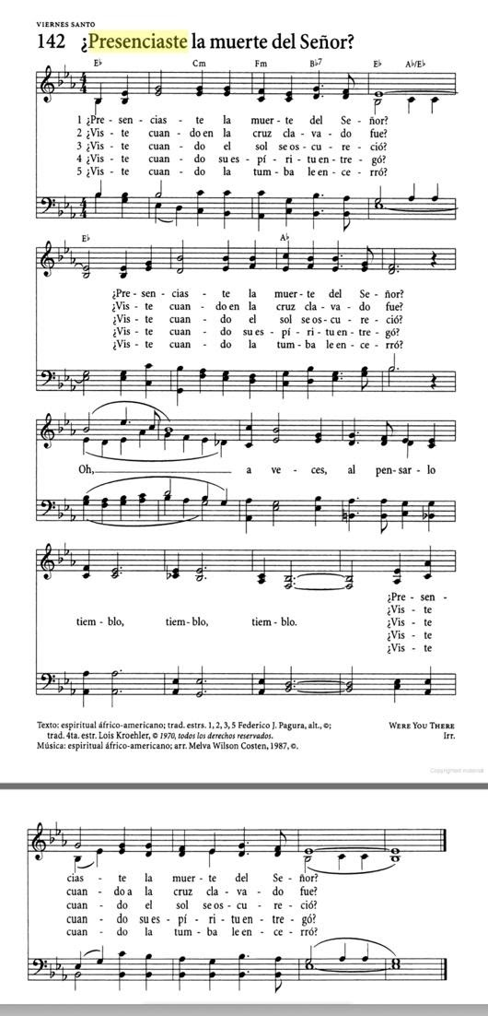

We used the Trisagion after each station. We recorded it sung acapella in both English and Spanish, sung by our Rector Stephen Shaver. We alternated each station in a different language. At Incarnation we were blessed with having a rector and his wife with excellent voices and a reading and speaking and singing.

Both the Stabat Mater, in English, and the Trisagion, in both Spanish and English, were prerecorded as sound files and the technical director played them at the appropriate times. It is possible we could share the sound files with any church interested in mounting a bilingual Way/Crucis.

The only music used for the Soldier’s Way was the hymn, Were You There When They Crucified My Lord? (Hymnal 1982. 172). This hymn has been translated variously into Spanish, and the most singable version is ¿Presenciaste la Muerte del Señor? Julia Shaver, our Rector’s wife, sung both the English and the Spanish versions. We think the screenshot at right, taken unattributed from the Web, is from El Himnario, the out-of-print Episcopal Spanish Hymnal. The only in-print Himnario version is the shortened and lyrics-only El Himnario Seleciones. Unfortunately, the Spanish version we used, ¿Presenciaste la Muerte del Señor? , is not in this in-print version. We can share a fullsize version of the image at right.

Planning and Preparation Timeline
Summer
- Decide whether you wish to mount a bilingual Way of the Cross/Via Crucis.
- Decide whether it can be done in person at your church, or remotely with either Facebook live or Zoom.
- Decide whether you are going do a single Way of the Cross/Crucis (Good Friday?) or multiple ones (every Friday in Lent? Or selected Fridays in Lent?).
- Prepare to decide music: Trisagion between stations, and Closing Hymn, Stabat Mater (“At the cross her vigil keeping” Hymnal 1982, 159): Himno de clausura. Stabat Mater (“En la cruz, su vigilia” Hymnal 1982, 159). We have some beautiful recordings acapella of the Trisagion in both English and Spanish by Father Stephen Shaver from Incarnation we might be able to share.
- Decide whether to go through the service twice, that is, once in English once in Spanish, switching every so often, or to the do the service once, switching back and forth from English to Spanish, but not repeating.
- Select a team to produce the service. Select clergy or a lay leader if it is to be live, and readers for both Spanish and English parts. involve the tech support people if it is to be Zoomed and/or Facebooklive.
- Notify the Diocese and get on the Diocesan calendar.

September
- Coordinate dates with the Diocese.
- Decide on music, who will perform it live or recorded.
- Prepare booklets if you are mounting a live service.
- Prepare slides for the liturgy and decide what if any music will be used.

October
- Continue to prepare booklets or slides.
- Plan publicity.
- Rehearse and record music.

November and December
- Concentrate on Advent and Christmas.

January, 2022
- Rehearse.
- Publicize to congregation.
- Publicize to the Diocese through the Latino Hispanic Committee.
- Publicize to Latino Community.

Friday, first Friday of Lent, through Good Friday
- Perform Via Crucis
- Be prepared for technical glitches if you are Zooming or going Facebook Live

