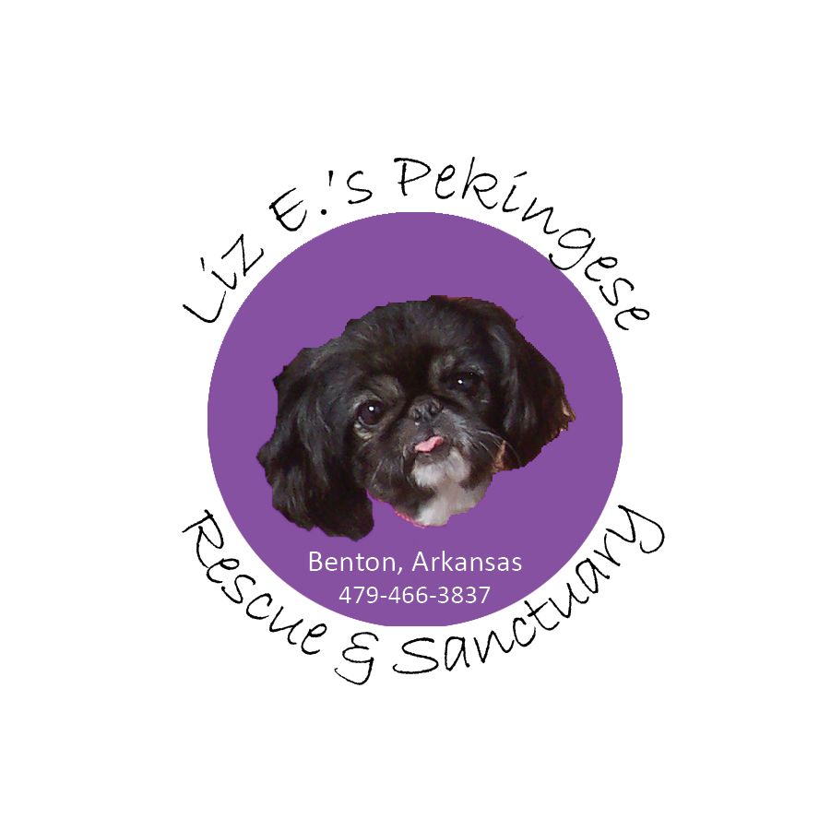
Adoption Application
Name of dog(s) you are interested in: ___________________________________________
Name:__ ___ ___________________________
Address:_ _______________________________
City:_____ ________________________ State: _ ____ Zip:________
Phone # Home: _________________ Work phone:___________________
Cell:__________________________
Email address:________________________________
What is your age? ___________________
Who resides in your home ? __________________________
Who is in your home on a regular basis? Please list names and ages of friends, relatives, caretakers, etc.__________________, age__________
______________________________, age__________
______________________________, age__________
______________________________,age___________
______________________________, age__________

Add additional names at end of application if needed.

Number of children:________ Ages:________________________
Is everyone on board about adopting a Pekingese? ____________
Are you familiar with common problems a Pekingese can have in its lifetime? _____ ______
Employer name, address and phone #: ____________________________________
Current work hours: __ ____ _
Are other household members employed outside the home? __ ___
How many hours would dog be alone in a typical day? _______
Are you in the Military? __ ____
What would you do with your dog if you were transferred? _________ ___
Do you own your home? _ _________ Rent? __ _____
Do you live in a house/apartment/condo? _____ _______
If you rent, do you have landlord approval to adopt a dog? (We do confirm)__ __ _
Do you have a fenced yard? _ _ ___
Is the fencing adequate to contain the dog you are planning to adopt? ____________________________________________________________________
What is the fence made of?__ _____ What is the height of the fence?________
Where will your dog be kept when you’re not home?_ ____________________
Where will he/she sleep_ ___________________________________________
What are your thoughts on crating a dog?_ _______________
Will he/she have the run of the house or be confined to a specific area? ___________________________________________________
Is anyone in your family allergic to pet hair? ______________
Do you expect that this dog will shed hair?_____________
If something should happen to you where you can no longer care for the dog, what is your plan for the dog? ___________________________________________________________________
Do you travel ? ____________
Where will your pet stay when you travel? ________________________________
Do you have or have you had other pets in the past? ______
If you have or have had other pets (now or in the past), please list:
(Please copy/paste and add additional lines as needed)
Breed:_______________
Spayed/Neutered? __________________
How long you have had (or had) the pet: ________________
If deceased, age of death and reason of death or circumstances surrounding: ________________________________________________________________________________________________________________________________________
Breed:_______________
Spayed/Neutered? __________________
How long you have had (or had) the pet: ________________
If deceased, age of death and reason of death or circumstances surrounding: ________________________________________________________________________________________________________________________________________
Breed:_______________
Spayed/Neutered? __________________
How long you have had (or had) the pet: ________________
If deceased, age of death and reason of death or circumstances surrounding: ________________________________________________________________________________________________________________________________________

Up to date on shots? _____ _
What is your opinion on heartworm preventative?________________________
What is your opinion on flea preventative?______________________________
Do you have a preference for a male_____ female _____________age: _________
Would you consider a special needs dog? _______
Do you have any experience with a rescue pet? If so, please explain:_____________________________________________________________________

Has anyone in your family or living with you ever been convicted of or charged with animal cruelty___ _______
If you move, what will you do with your dog? _ _________________________
Rescues need extra patience due to their prior circumstances. Are you willing to allow the dog 2-4 weeks to settle in and understand its new home?____________
Do you currently have a veterinarian? ______________
Vet’s Name _____ ________________________
Vet’s Address________________________________________
Vet’s Ph # ( )_____________
Please list 3 references: people who are unrelated to you who are familiar with you and your current or previous pets

Name Address Ph# Relationship to you
1.
2.
3.
Please e-mail to: Liz E.’s Pekingese Rescue and Sanctuary at lizethedog@yahoo.com.

**Thank you for applying and for your interest in a rescue dog! Please only submit if you are serious about adopting and willing to commit to your Pekingese for a LIFETIME. Submission of this application to Liz E.’s Pekingese Rescue must be initiated by a person at least 21 years of age or older. Applicants certify that they will have sole responsibility in the care and well-being of the adopted Pekingese. Any misrepresentation with this adoption application will invalidate the agreement. The dog will be reclaimed by Liz E.’s Pekingese Rescue and no refund will be given for the adoption fees. ALL DOGS ADOPTED THROUGH Liz E.’s Pekingese Rescue and Sanctuary ARE SPAYED OR NEUTERED PRIOR TO ADOPTION. NO INTACT DOGS WILL LEAVE THE PREMISES FOR ANY REASON.

