January, 2019

Dear Parents and USAFA Parent Clubs:

The Eastern Massachusetts USAFA Families Club, Inc. is proud to again offer our Keepsake Collection to the families of our soon to be Recognized ‘Doolies’ and our soon-to-be USAFA graduates.

For Class of 2022 Parents:
Our Recognition Keepsake is beautifully framed and matted with a photograph of your 4th Degree with their soon-to-be-earned prop and wings and ‘Doolie’ squadron pin. This Keepsake will forever provide a fond memory of their first year at USAFA and the friends they made in their first squadron.
In addition, this is a great Keepsake for you and a thoughtful gift for other family members; quantity discounts are available. If you do not have your cadet photo at time of the order, we can send along simple directions with your frame so you can install it yourself.
If you have any questions, please email us at keepsake.usafaema@gmail.com. You can order online and pay via PayPal or use mail-in order form. Both accessible via our website http://www.usafaema.org/recognition-keepsake.html. Available for a limited time, the deadline for ordering the Keepsake is February 22nd to ensure delivery for Recognition.
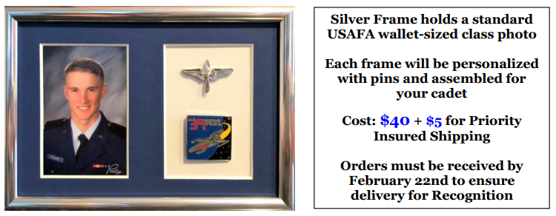

For Class of 2019 Parents:
Our Commissioning Keepsake is beautifully framed and matted with a photograph of your graduating Cadet alongside their 2nd Lieutenant bar engraved with his/her graduation date, above a pin with the seal of the United States Air Force. If you provide a wallet-sized photo at the time of order, we will also insert it for you. Otherwise, we will provide you simple instructions on how to insert the photo yourself upon receipt of the Keepsake frame.
This is a great keepsake for you and a thoughtful gift for other family members that may, or sadly may not, be able to attend Graduation. Looking for the perfect sponsor family thank-you? The Commissioning Keepsake is a perfect gift for them to remember your cadet. Parent Clubs: These make great gifts for your graduating parents. Please see the instructions on the order form if you want to place a group order.
If you have any questions, please email us at keepsake.usafaema@gmail.com. You can find mail-in and online order forms at our website http://www.usafaema.org/commissioning-keepsake.html. Available for a limited time, the deadline for ordering the Keepsake is May 10 to ensure delivery for Graduation.
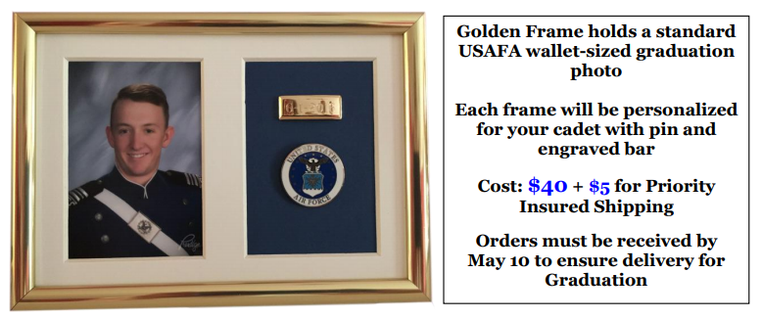

We look forward to hearing from you and appreciate the opportunity to commemorate these important milestones.
Best Regards,
Andrew Borodenko, Fundraising Chair
Eastern MA USAFA Families Club, Inc.

