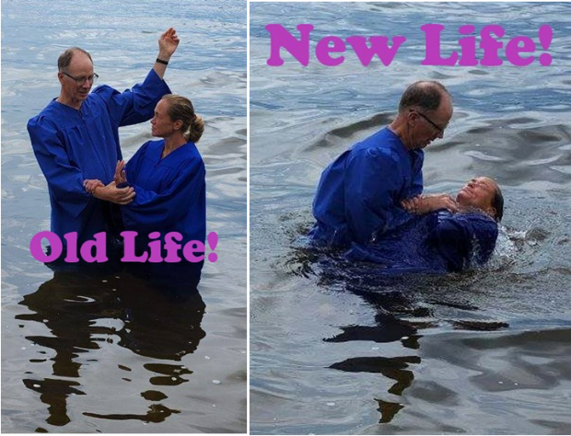  Baptism Joey Retsema  Photo source: Pastor Bob Benson  Joey's STR Testimony 2  Joey completes her STR testimony this Sunday at 3:30 am, Monday at 4 pm, Wednesday at 9 pm, and Thursday at 1 pm.  Order Your Seeds!  Enjoy the Garden Guy's Chinese Vegetable Quiz and seed ordering prompts this Sunday at 5 pm, Monday at 10 am, and Wednesday at midnight.  Camp Devotions Resume  Blind camp devotions resume this Friday at 1:00 pm and Sunday at 5 pm.  Point, click, and give!  ﻿Give to Strong Tower Radio via the STR.fm giving page with your smartphone or by mailing a check to  P.O. Box 567, Cadillac, MI 49601  ﻿  On-air, via Apple & Android apps, & STR.fm |  | Baptism Joey Retsema  Photo source: Pastor Bob Benson  Joey's STR Testimony 2  Joey completes her STR testimony this Sunday at 3:30 am, Monday at 4 pm, Wednesday at 9 pm, and Thursday at 1 pm.  Order Your Seeds!  Enjoy the Garden Guy's Chinese Vegetable Quiz and seed ordering prompts this Sunday at 5 pm, Monday at 10 am, and Wednesday at midnight.  Camp Devotions Resume  Blind camp devotions resume this Friday at 1:00 pm and Sunday at 5 pm.  Point, click, and give!  ﻿Give to Strong Tower Radio via the STR.fm giving page with your smartphone or by mailing a check to  P.O. Box 567, Cadillac, MI 49601  ﻿  On-air, via Apple & Android apps, & STR.fm

