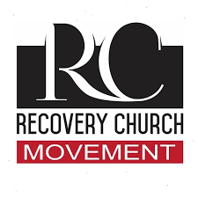  Recovery Church Movement  Photo credit: Recovery Church Movement  Addictions Recovery Movement  How does the church help addicts? Hear the answer Sunday at 3:30 am, and again on Monday at 4 pm, Wednesday at 9 pm, and Thursday at 1 pm.  Work for the Disabled  A blind listener produced a program on job training and employment for people with disabilities. Listen this Sunday at 5 pm, Monday at  10 am, and Wednesday at midnight.  Galatians with Gallimore  Enjoy the debut of Pastor Jay Gallimore's Galatians series Friday at 1:00 pm and Saturday at 5 pm.  Point, click, and give!  ﻿Give to Strong Tower Radio via the STR.fm giving page with your smartphone or by mailing a check to  P.O. Box 567, Cadillac, MI 49601  ﻿  On-air, via Apple & Android apps, & STR.fm |  | Recovery Church Movement  Photo credit: Recovery Church Movement  Addictions Recovery Movement  How does the church help addicts? Hear the answer Sunday at 3:30 am, and again on Monday at 4 pm, Wednesday at 9 pm, and Thursday at 1 pm.  Work for the Disabled  A blind listener produced a program on job training and employment for people with disabilities. Listen this Sunday at 5 pm, Monday at  10 am, and Wednesday at midnight.  Galatians with Gallimore  Enjoy the debut of Pastor Jay Gallimore's Galatians series Friday at 1:00 pm and Saturday at 5 pm.  Point, click, and give!  ﻿Give to Strong Tower Radio via the STR.fm giving page with your smartphone or by mailing a check to  P.O. Box 567, Cadillac, MI 49601  ﻿  On-air, via Apple & Android apps, & STR.fm

