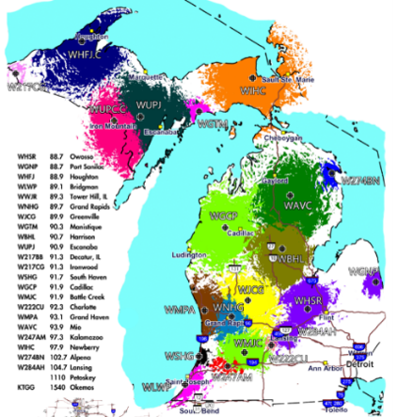  Strong Tower Radio’s 23 Michigan Stations  Photo credit: STR  Radio Ministries Offering  The Michigan Conference of SDA's will take up an offering for Michigan-based radio ministries on October 10. Strong Tower Radio appreciates your support through this offering.  STR October Preview  Get the big picture on what will airing on Strong Tower Radio in October. Tune in this Sunday at 5 pm, Monday at 10 am, and Wednesday at midnight.  Animal Husbandry Program  Join Creation Animal Care's visit the Andrews University Animal Husbandry program. Airing this Sunday at 3:30 am, Monday at 4 pm, Wednesday at 9 pm, and again on Thursday at 1 pm.  STR Protestant Reformation Month  October 1-31  Grow your faith and knowledge with the STR Protestant Reformation sermons, panels, and dramas airing October 1 to 31 at 6 am and  6 pm.  Point, click, and give!  ﻿Give to Strong Tower Radio via the STR.fm giving page with your smartphone or by mailing a check to  P.O. Box 567, Cadillac, MI 49601  ﻿  On-air, via Apple & Android apps, & STR.fm |  | Strong Tower Radio’s 23 Michigan Stations  Photo credit: STR  Radio Ministries Offering  The Michigan Conference of SDA's will take up an offering for Michigan-based radio ministries on October 10. Strong Tower Radio appreciates your support through this offering.  STR October Preview  Get the big picture on what will airing on Strong Tower Radio in October. Tune in this Sunday at 5 pm, Monday at 10 am, and Wednesday at midnight.  Animal Husbandry Program  Join Creation Animal Care's visit the Andrews University Animal Husbandry program. Airing this Sunday at 3:30 am, Monday at 4 pm, Wednesday at 9 pm, and again on Thursday at 1 pm.  STR Protestant Reformation Month  October 1-31  Grow your faith and knowledge with the STR Protestant Reformation sermons, panels, and dramas airing October 1 to 31 at 6 am and  6 pm.  Point, click, and give!  ﻿Give to Strong Tower Radio via the STR.fm giving page with your smartphone or by mailing a check to  P.O. Box 567, Cadillac, MI 49601  ﻿  On-air, via Apple & Android apps, & STR.fm

