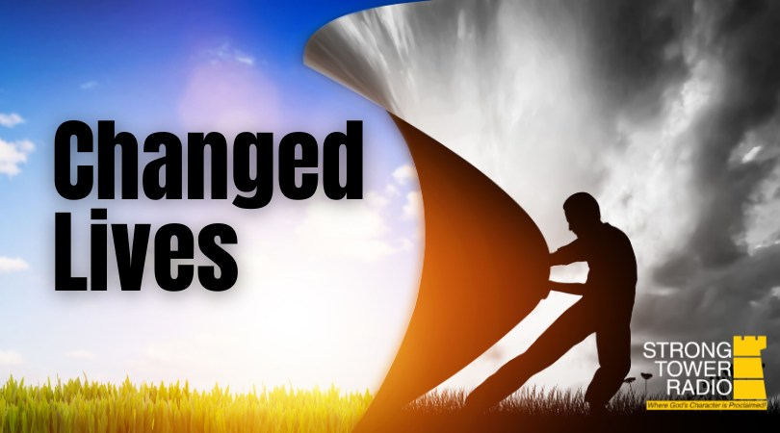  Changed Lives  Photo credit: Strong Tower Radio  John Partridge  Hear another story of how listening to Strong Tower Radio changes lives this Sunday at 3:30 am, and again on Monday at 4 pm, Wednesday at 9 pm, and Thursday at 1 pm.  Garden Guy's Root Quiz  This week the Strong Tower Radio Garden Guy conducts a root crop quiz and reveals the latest All-American plant winners this Sunday at 5 pm, Monday at 10 am, and Wednesday at 12 am.  Blind Camp Devotionals Continue  Strong Tower Radio has preserved Pastor Fred's past blind camp devotions. One of them is airing Fridays at 1 pm and Saturdays at 5 pm.  Point, click, and give!  ﻿Give to Strong Tower Radio via the STR.fm giving page with your smartphone or by mailing a check to  P.O. Box 567, Cadillac, MI 49601  ﻿  On-air, via Apple & Android apps, & STR.fm |  | Changed Lives  Photo credit: Strong Tower Radio  John Partridge  Hear another story of how listening to Strong Tower Radio changes lives this Sunday at 3:30 am, and again on Monday at 4 pm, Wednesday at 9 pm, and Thursday at 1 pm.  Garden Guy's Root Quiz  This week the Strong Tower Radio Garden Guy conducts a root crop quiz and reveals the latest All-American plant winners this Sunday at 5 pm, Monday at 10 am, and Wednesday at 12 am.  Blind Camp Devotionals Continue  Strong Tower Radio has preserved Pastor Fred's past blind camp devotions. One of them is airing Fridays at 1 pm and Saturdays at 5 pm.  Point, click, and give!  ﻿Give to Strong Tower Radio via the STR.fm giving page with your smartphone or by mailing a check to  P.O. Box 567, Cadillac, MI 49601  ﻿  On-air, via Apple & Android apps, & STR.fm

