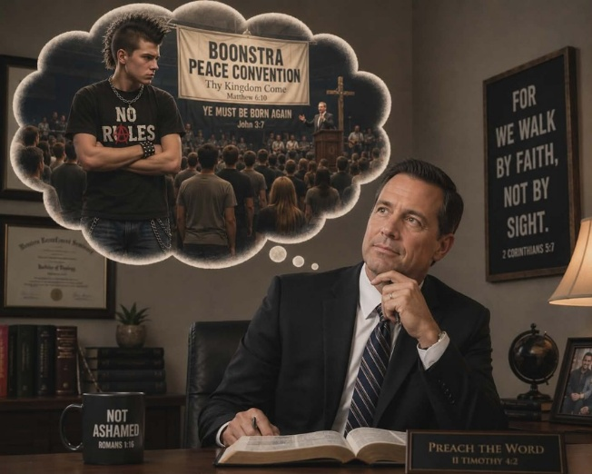  The Rest of the Story - Shawn Boonstra and Nick Wanovic  Photo credit: Jessica Taylor  The Rest of the Story!  Hear the rest of the story of a young rebellious youth attending Pastor Boonstra's meetings. Airing this Sunday at 3:30 am, and again on Monday at 4 pm, Wednesday at 9 pm, and Thursday at 1 pm.  The Narrow Way  Northview Adventist School presents The Narrow Way to Heaven this Friday at 1 pm and Saturday at 5 pm.  3ABN Camp Meeting Finale  3ABN's Summer Camp Meeting concludes with sessions at 3, 4, 7, and 8 pm.  Point, click, and give!  ﻿Give to Strong Tower Radio via the STR.fm giving page with your smartphone or by mailing a check to  P.O. Box 567, Cadillac, MI 49601  ﻿  On-air, via Apple & Android apps, & STR.fm |  | The Rest of the Story - Shawn Boonstra and Nick Wanovic  Photo credit: Jessica Taylor  The Rest of the Story!  Hear the rest of the story of a young rebellious youth attending Pastor Boonstra's meetings. Airing this Sunday at 3:30 am, and again on Monday at 4 pm, Wednesday at 9 pm, and Thursday at 1 pm.  The Narrow Way  Northview Adventist School presents The Narrow Way to Heaven this Friday at 1 pm and Saturday at 5 pm.  3ABN Camp Meeting Finale  3ABN's Summer Camp Meeting concludes with sessions at 3, 4, 7, and 8 pm.  Point, click, and give!  ﻿Give to Strong Tower Radio via the STR.fm giving page with your smartphone or by mailing a check to  P.O. Box 567, Cadillac, MI 49601  ﻿  On-air, via Apple & Android apps, & STR.fm

