﻿﻿  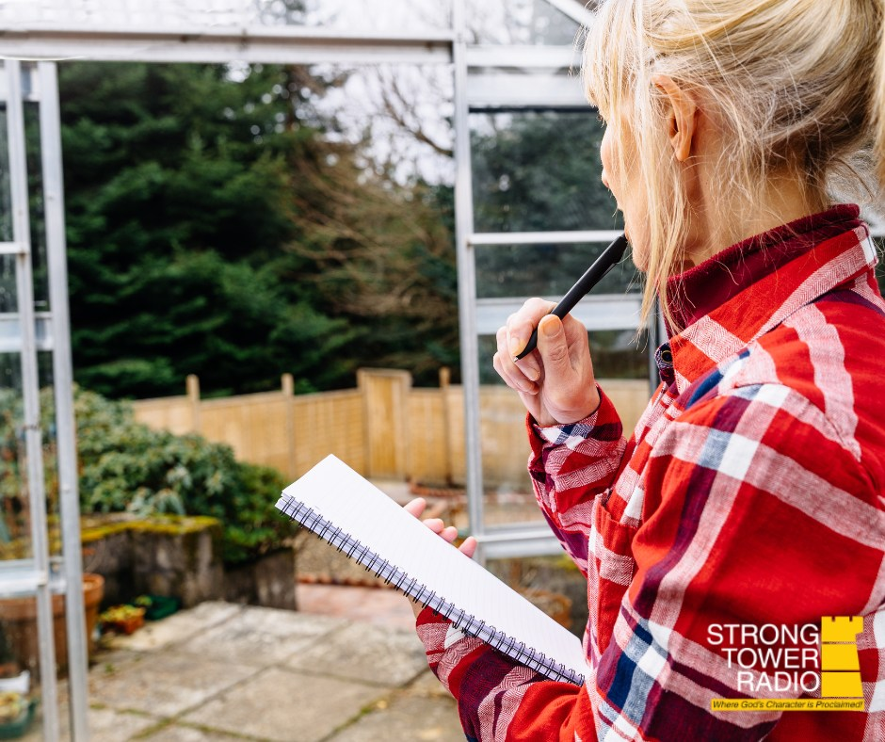  STR Good Gardening Planning.  Photo credit: Jennifer Brooks  May Gardening  Strong Tower Radio's garden guy talks about apricots, asparagus, rhubarb, and May planting on Sunday at 5 pm, Monday at 10 am, and Wednesday at midnight, only on STR stations, STR apps, or STR.fm.  Soil is the Foundation  Soil testing is not optional for the serious gardener. Find out why on Sunday at 3:30 am, Monday at 4 pm, Wednesday at 9 pm, and Thursday at 1 pm.  Pastor's Prayer Seminar  Pastor Darrell Le Roux's camp meeting prayer seminar started yesterday. It will continue on Fridays at 1 pm and Saturdays at 5 p.m. until the June camp meeting.  Point, click, and give!  ﻿Give to Strong Tower Radio via the STR.fm giving page with your smartphone or by mailing a check to  P.O. Box 567, Cadillac, MI 49601  ﻿  On-air, via Apple & Android apps, & STR.fm |  | ﻿﻿  STR Good Gardening Planning.  Photo credit: Jennifer Brooks  May Gardening  Strong Tower Radio's garden guy talks about apricots, asparagus, rhubarb, and May planting on Sunday at 5 pm, Monday at 10 am, and Wednesday at midnight, only on STR stations, STR apps, or STR.fm.  Soil is the Foundation  Soil testing is not optional for the serious gardener. Find out why on Sunday at 3:30 am, Monday at 4 pm, Wednesday at 9 pm, and Thursday at 1 pm.  Pastor's Prayer Seminar  Pastor Darrell Le Roux's camp meeting prayer seminar started yesterday. It will continue on Fridays at 1 pm and Saturdays at 5 p.m. until the June camp meeting.  Point, click, and give!  ﻿Give to Strong Tower Radio via the STR.fm giving page with your smartphone or by mailing a check to  P.O. Box 567, Cadillac, MI 49601  ﻿  On-air, via Apple & Android apps, & STR.fm

