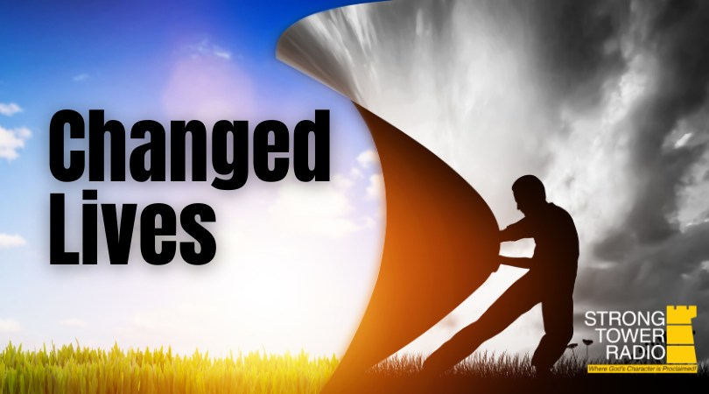  Photo credit: Strong Tower Radio  STR Changed Lives Stories  Strong Tower Radio listener is delivered from Satanism, drugs, and alcohol. Hear this on Sunday at 3:30 pm, Monday at 4 pm, Wednesday at 9 pm, and Thursday at 1 pm. on STR stations, STR apps, or at STR.fm.  December Gardening  Learn about natural Christmas trees, seasonal safety, and the gardener's wish list this Sunday at 5 pm, Monday at 10 am, and Wednesday at midnight only on STR stations, STR apps, or STR.fm.  Christmas Variety Hour Classics  Classic Christmas Strong Tower Radio Variety Hour performances through the years air Fridays at 1 pm and Saturdays at 5 pm in December. Available only on STR stations, STR apps, or STR.fm.  Point, click, and give!  ﻿Give to Strong Tower Radio via the STR.fm giving page with your smartphone or by mailing a check to  P.O. Box 567, Cadillac, MI 49601  ﻿  On-air, via Apple & Android apps, & STR.fm |  | Photo credit: Strong Tower Radio  STR Changed Lives Stories  Strong Tower Radio listener is delivered from Satanism, drugs, and alcohol. Hear this on Sunday at 3:30 pm, Monday at 4 pm, Wednesday at 9 pm, and Thursday at 1 pm. on STR stations, STR apps, or at STR.fm.  December Gardening  Learn about natural Christmas trees, seasonal safety, and the gardener's wish list this Sunday at 5 pm, Monday at 10 am, and Wednesday at midnight only on STR stations, STR apps, or STR.fm.  Christmas Variety Hour Classics  Classic Christmas Strong Tower Radio Variety Hour performances through the years air Fridays at 1 pm and Saturdays at 5 pm in December. Available only on STR stations, STR apps, or STR.fm.  Point, click, and give!  ﻿Give to Strong Tower Radio via the STR.fm giving page with your smartphone or by mailing a check to  P.O. Box 567, Cadillac, MI 49601  ﻿  On-air, via Apple & Android apps, & STR.fm

