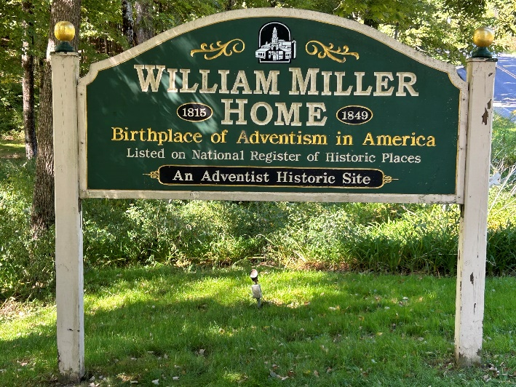  ﻿Pioneer William Miller's home sign  Photo credit: Tom Mejeur  Joseph Bates & William Miller  New England Adventist Pioneer Tour features Joseph Bates and William Miller, narrated by Dr. Brian Strayer, on Friday, August 8 at  1 pm and again on Saturday, August 9 at 5 pm only on STR.  Sabbath School Prep  Prepare for your adult Sabbath School lesson each Friday from  9-11 pm and Saturday from 9-11 am only on STR stations or STR.fm.  Healing Pre-school Families  STR visited Healing Roots, a program that helps struggling families thrive. Airing on Sunday at 3:30 am, Monday at 4 pm, Wednesday at 9 pm, and Thursday at 1 pm, only on STR stations.  "Why Love Never Ends"  STR Relationship CPR host explains his "Why Love Never Ends" lead article this Sunday at 5 pm, Monday at 10 am, and Wednesday at midnight only on STR stations, or STR.fm.  Point, click, and give!  ﻿Give to Strong Tower Radio via the STR.fm giving page with your smartphone or by mailing a check to  P.O. Box 567, Cadillac, MI 49601  ﻿  On-air, via Apple & Android apps, & STR.fm |  | ﻿Pioneer William Miller's home sign  Photo credit: Tom Mejeur  Joseph Bates & William Miller  New England Adventist Pioneer Tour features Joseph Bates and William Miller, narrated by Dr. Brian Strayer, on Friday, August 8 at  1 pm and again on Saturday, August 9 at 5 pm only on STR.  Sabbath School Prep  Prepare for your adult Sabbath School lesson each Friday from  9-11 pm and Saturday from 9-11 am only on STR stations or STR.fm.  Healing Pre-school Families  STR visited Healing Roots, a program that helps struggling families thrive. Airing on Sunday at 3:30 am, Monday at 4 pm, Wednesday at 9 pm, and Thursday at 1 pm, only on STR stations.  "Why Love Never Ends"  STR Relationship CPR host explains his "Why Love Never Ends" lead article this Sunday at 5 pm, Monday at 10 am, and Wednesday at midnight only on STR stations, or STR.fm.  Point, click, and give!  ﻿Give to Strong Tower Radio via the STR.fm giving page with your smartphone or by mailing a check to  P.O. Box 567, Cadillac, MI 49601  ﻿  On-air, via Apple & Android apps, & STR.fm

