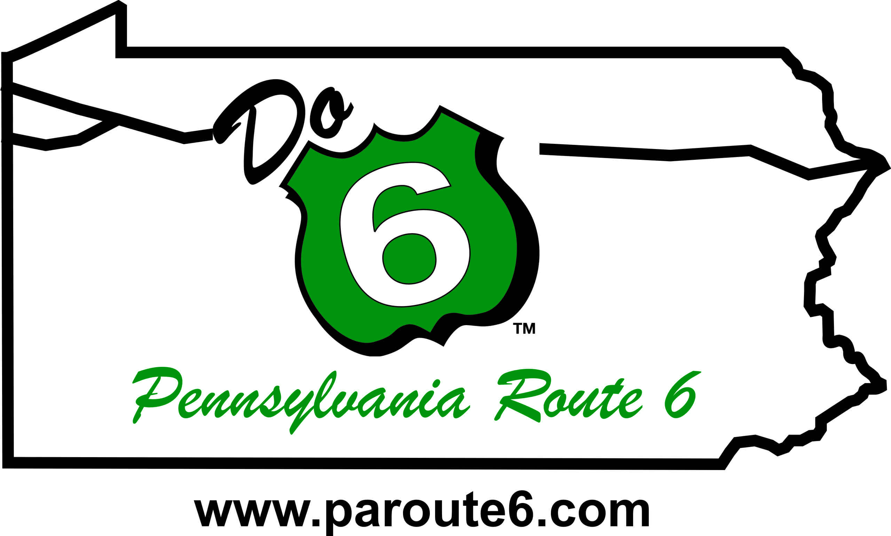
FOR IMMEDIATE RELEASE:
February 12, 2025

PA Route 6 Alliance
814-435-7706
info@paroute6.com

PA Route 6 Alliance Accepting Nominations for 2025 “Do 6” Awards
Recognizing outstanding persons, groups, and communities along PA Route 6!

The PA Route 6 Alliance is requesting nominations for their 15th Annual “Do 6” Awards, which recognize individuals, groups, projects, and communities that exemplify and advance the Alliance’s mission of protecting, preserving, and promoting the scenic, cultural, historic, and recreational resources across the 11-county corridor of PA Route 6.

Candace Hillyard, Executive Director of the PA Route 6 Alliance, shared, “Our “Do 6” Awards are a wonderful opportunity to celebrate those who are making a difference in the PA Route 6 Heritage Corridor. Whether through protecting our history, enhancing tourism, or fostering a love for our communities, these awards shine a light on the efforts that help preserve the beauty and culture of this special corridor. We encourage everyone to submit nominations and help us honor the individuals, groups, and projects that are truly making a positive impact along PA Route 6.”

Nominations may be submitted until May 2, 2025, through the online form at https://paroute6.com/do-6-awards-nomination/. Award winners will be notified upon selection, and awards will be presented during the PA Route 6 Educational Workshop, Annual Meeting and “Do 6” Awards Program on September 10th and 11th in Kane, PA.

Nominations can be made in six categories:

LIFETIME ACHIEVEMENT AWARD - Presented to a person or agency who exemplifies outstanding leadership and advances our mission through heritage development.

HERITAGE PARTNERSHIP AWARD - Presented to a group, person or organization that has demonstrated excellence in historic preservation, cultural preservation, interpretation, and/or education through cross-corridor thinking and interagency cooperation.

HERITAGE TOURISM AWARD - Presented to a business or project that furthers economic and tourism development while respecting the heritage and cultural resources of the PA Route 6 Corridor.

ARTISAN OF THE YEAR AWARD - Presented to an artist or artisan group that exemplifies the goals of the PA Route 6 Artisan Trail program showing regional thinking and cooperation while promoting the arts along the corridor.

HERITAGE LEADERSHIP AWARD - Presented to a person(s), business or organization for meaningful contributions and/or through partnerships, by enriching our communities through landscape initiatives or historic preservation.

HERITAGE COMMUNITY OF THE YEAR - Presented to the designated Heritage Community, who are embracing their Heritage Tourism Work Plans and implementing worthwhile projects and showing impacts and results.

The 2024 award winners included Fort LeBoeuf Historical Society in Waterford (Heritage Partnership); Milford Hospitality Group in Pike County (Heritage Tourism); Jane Varcoe in Wayne County (Heritage Leadership); Kane, PA (Heritage Community of the Year); Pop’s Culture Shoppe in Wellsboro (Artisan of the Year); and Jason Krise of PA Route 6 Alliance Board (Lifetime Achievement).

For more information on the “Do 6” Awards Program and the 2025 PA Route 6 Educational Workshop & Annual Meeting, visit https://paroute6.com/2025-educational-workshop-annual-meeting-do-6-awards/ or contact the Alliance at info@paroute6.com or 814-435-7706.

The PA Route 6 Alliance, a 501(c3) corporation, was established in 2003 to manage the PA Route 6 Heritage Corridor and to implement branding and marketing plans, community development programs and other planning efforts along the corridor. The Alliance includes representatives from all 11 counties, 9 convention and visitor bureaus, 4 heritage areas, local development districts, local business owners, Chambers of Commerce, and other interested parties along the corridor. The PA Route 6 Heritage Communities program is a program of PA Route 6 Alliance and PA Route 6 Heritage Corridor funded by the PA Heritage Area Program under the Pennsylvania Department of Conservation and Natural Resources.
--End--

