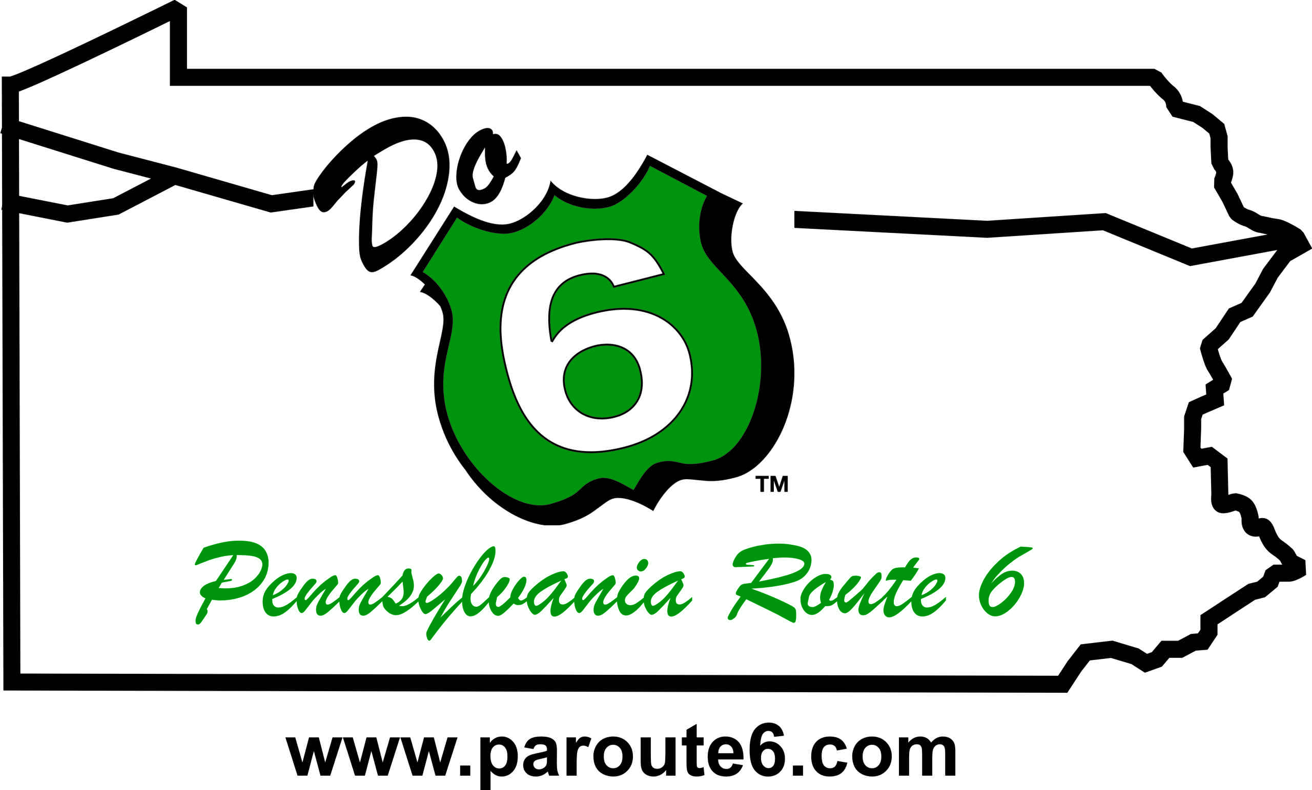
FOR IMMEDIATE RELEASE:
April 17, 2025

Candace Hillyard, Executive Director
PA Route 6 Alliance
814-435-7706
info@paroute6.com

PA Route 6 Alliance celebrates $100k in Façade Improvements in the Pocono Mountains Region in Wayne and Pike Counties.
PA Route 6 Façade Program in the Northeastern PA a Success
The PA Route 6 Alliance has announced the award recipients for the PA Route 6 Façade Program in Wayne and Pike Counties. To date, the program is supporting 20 projects in these counties, representing more than $200,000 in façade improvements. The success of this year’s program reflects strong partnerships between the PA Route 6 Alliance, Pocono Forests and Waters Landscape Area, Pennsylvania Environmental Council, Pocono Mountains Visitors Bureau, and the Greater Honesdale Partnership.
This initiative was made possible through a $100,000 Keystone Communities Grant from the Pennsylvania Department of Community and Economic Development (DCED), additional support from the Pennsylvania Department of Conservation and Natural Resources (DCNR), and matching funds from local businesses and organizations. The program is part of a broader PA Route 6 Alliance strategy to stimulate economic development by enhancing the visual appeal of small towns across the 11-county PA Route 6 Heritage Corridor.
Following public informational meetings in March 2024, businesses and organizations in Wayne and Pike Counties were invited to apply for matching grants of up to $5,000 to support physical improvements to their buildings. The response was strong—46 applications were received, highlighting significant local interest in revitalizing and enhancing community spaces.
All funded projects utilize local contractors, suppliers, and resources—providing an economic boost that often exceeds the value of the individual grant awards. The Alliance also hopes that applicants who did not receive grant funding will still be inspired to pursue their improvement projects, continuing the positive momentum throughout the community.
"The PA Route 6 Façade Program is a powerful example of how strategic partnerships and community-driven investment can support the revitalization of our small towns and historic corridors," said Candace Hillyard, Executive Director of the PA Route 6 Alliance. "In the Pocono Mountains Region, we’re seeing firsthand how even modest improvements can spark pride, attract new visitors, and strengthen local economies. We’re especially excited that five additional projects totaling $25,045 in improvements were referred to The Greater Honesdale Partnership (GHP), which was able to leverage its own façade funding to support even more local businesses. Collaborations like these amplify the impact of our efforts and demonstrate the strength of community partnerships along the Route 6 corridor."
One such recipient was the Pike County Historical Society & Museum.
"The Pocono Mountains façade grant allowed for a fresh coat of paint to our façade, which included all railings and columns on the front of the building and new stain on our front doors," said Lori Strelecki of the Museum. "Our building is three stories high with balustrades and porches on each floor, so it is no easy task keeping the Pike County Historical Society & Museum freshly painted and looking spiffy. Many thanks to the PA Route 6 Alliance and to the Historic Preservation Trust of Pike County for the grant and matching funds to complete this job."
The Pocono Mountains Region marks the fifth implementation of the PA Route 6 Façade Program. Previous programs have been held in the PA Wilds, Endless Mountains, Great Lakes Region, and Lackawanna County. Across the 11-county corridor, 159 businesses and organizations have received façade funding, with the program’s total economic impact now exceeding $1.6 million.
For more information about the program or to see the complete list of award recipients, visit the PA Route 6 Alliance website at http://www.paroute6.com/pocono-mountains-facade-program or contact the Alliance at info@paroute6.com or 814-435-7706.

The PA Route 6 Alliance, a 501(c3) corporation, was established in 2003 to manage the PA Route 6 Heritage Corridor and to implement branding and marketing plans, community development programs and other planning efforts along the corridor. The Alliance includes representatives from all 11 counties, 9 convention and visitor bureaus, 4 heritage areas, local development districts, local business owners, Chambers of Commerce, and other interested parties along the corridor.
The PA Route 6 Heritage Communities program is a program of PA Route 6 Alliance and PA Route 6 Heritage Corridor funded by the PA Heritage Area Program under the Pennsylvania Department of Conservation and Natural Resources.
--End—

