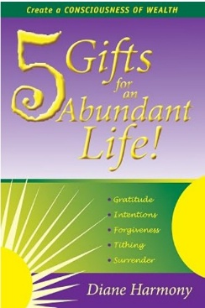
THE 5 GIFTS OF PROSPERITY
A Five-Week Journey into Spiritual Abundance
Inspired by 5 Gifts for an Abundant Life by Diane Harmony

WEEK THREE: FORGIVENESS
Clearing the channel
What We’re Exploring
Forgiveness dissolves the blocks that constrict prosperity: resentment, regret, self-judgment, and old wounds.

Key Teachings
- Forgiveness restores wholeness.
- Prosperity thrives in freedom.
- Forgiveness is for liberation, not approval.

Daily Affirmations (7 Days)
Monday: Forgiveness clears the channel through which my good flows.
Tuesday: I release resentment and reclaim my energy.
Wednesday: I forgive myself for forgetting my worth.
Thursday: I let go of old hurts and open to new blessings.
Friday: Forgiveness is freedom.
Saturday: I choose peace over punishment.
Sunday: My heart is clear, my spirit open, abundance flows easily.
Reflection Questions
Who or what needs compassion from me?

What am I ready to stop carrying?

How does forgiveness expand my prosperity?

Practice of the Week: The Heart Clearing
Place your hand on your heart each morning and say: I free myself today.
Meditation: Clearing the Channel
Imagine your heart as a flowing stream. Choose one stone representing an old hurt. Thank it for what it taught you. Place it in the stream. Watch it dissolve. Feel your heart lighten.
Closing Intention
This week, I free myself and open fully to abundance.

