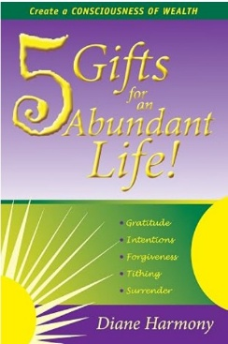
THE 5 GIFTS OF PROSPERITY
A Five‑Week Journey into Spiritual Abundance
Inspired by 5 Gifts for an Abundant Life by Diane Harmony

WEEK TWO: INTENTION

Aiming Your Energy Toward Prosperity

What We’re Exploring
Intention is the quiet power that shapes our prosperity. It is the inner
decision that directs our energy, focuses our awareness, and signals to the Universe what we are ready to experience. Intention is not a wish — it is a direction. When we choose consciously, life responds clearly.
Intention is the steering wheel of consciousness. Where we aim our energy, abundance follows.

Key Teachings
- Intention focuses consciousness and organizes experience.
- Prosperity begins with a clear inner “yes.”
- What we choose deliberately becomes the pattern our life follows.
- Intention is the first act of creation. It is the seed of manifestation.
- When intention is aligned with love, flow becomes effortless.

Daily Affirmations (7 Days)
Monday-My intention is my power. I direct my energy, and abundance follows.
Tuesday-I choose what I want to experience today, and life rises to meet it.
Wednesday-Clarity is my superpower. I aim it with love.
Thursday- My intention sets the frequency, and the Universe tunes itself to my good.
Friday-What I aim my heart toward expands in my experience.
Saturday-I place my intention in the flow, and the flow carries me forward.
Sunday-I intend to live from love, act from truth, and receive from abundance.

Reflection Questions
- What intention is quietly shaping my life right now?

- Where do I feel the difference between drifting and choosing?

- What becomes possible when I set one clear intention for the week?

Practice of the Week: The Intention Alignment
Each morning, ask: “What do I intend to experience today?” Then choose one word — peace, clarity, abundance, ease, courage, joy — and let that word guide your choices, tone, and energy throughout the day.
This practice trains consciousness to aim rather than drift.

Meditation: Aiming the Inner Yes
Close your eyes and breathe deeply. Imagine a small flame at the center of your heart. It is steady, bright, & unwavering. This flame represents your intention. As you breathe, see the flame grow stronger, clearer, more defined. Ask quietly:
“What do I intend to create, embody, or experience?”
Let a word, image, or feeling rise. Hold it gently in your awareness. See the flame carrying that intention outward — into your thoughts, your actions, your relationships, your day.
Feel the alignment. Feel the clarity. Feel the power of choosing.
Rest in the knowing that intention sets the flow.

Closing Intention
This week, I choose with clarity, aim my energy with love, and allow prosperity to follow my intention.

