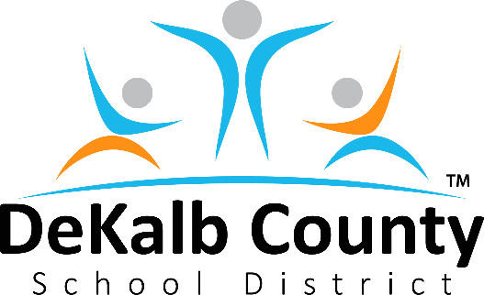
Mrs. Vickie B. Turner, Board Chair
Mr. Diijon DaCosta, Vice Chair
Mrs. Anna Hill
Mr. Marshall D. Orson
Mrs. Deirdre P. Pierce
Mrs. Allyson Gevertz
Dr. Joyce Morley

Mrs. Cheryl Watson-Harris, Superintendent

Dear DeKalb County School District Families:

I hope that you are continuing to stay safe, healthy, and warm. Thank you for your flexibility as we finalize our plans for the reopening of our schools. I know this year has been unlike any other and I admire the resilience and flexibility of our families and employees. I am proud of how well we have all worked together during these challenging times. Thank you for attending our virtual town hall meetings and providing your voice, insight, and passion for our district and its families.

Today, we will announce our plan to safely reopen schools. In Phase Two and Phase Three, cohorts of students will participate in hybrid, in-person learning based on their choice to attend school. Pre-kindergarten, kindergarten, first grade, second grade, sixth grade, and ninth-grade students will begin in-person learning on Tuesday, March 9, 2021. Grade levels third, fourth, fifth, seventh, eighth, tenth, eleventh, and twelfth will start on Monday, March 15, 2021, during Phase Three.

We acknowledge that, while each school within the DeKalb County School District is unique, we have a collective commitment to protect the health and safety of our staff, students, visitors, and their families. As we plan to reopen schools, it will take the cooperation and commitment from our entire district to continue to be successful and safe while also mitigating the risk of COVID-19.

I’m certain the questions that come to mind include what a day in the classroom looks like and what to expect. Some of these videos can be found on our YouTube page at https://www.youtube.com/c/DeKalbSchools/videos. Attached you will also find more information on how we are keeping DCSD safe and how we can all work together for a successful transition. Please continue to visit our Reopening webpage for up-to-date information on https://www.dekalbschoolsga.org/school-reopening/ .

While many of us would like nothing more than to return to “normal”, we must remember to keep safety first in all decisions, especially when returning to the classroom. It is important for all of us to remember that this is an ongoing process. The reopening of our schools is a collaborative effort of many, and we will only be successful together. It is essential that we regularly review, practice, and revise our plans as we progress to ensure the highest level of support and response during reopening.

Stay tuned as we provide updates and resources to successfully prepare for each school day upon our return! Thank you for your commitment.

Sincerely,
Mrs. Cheryl Watson-Harris

