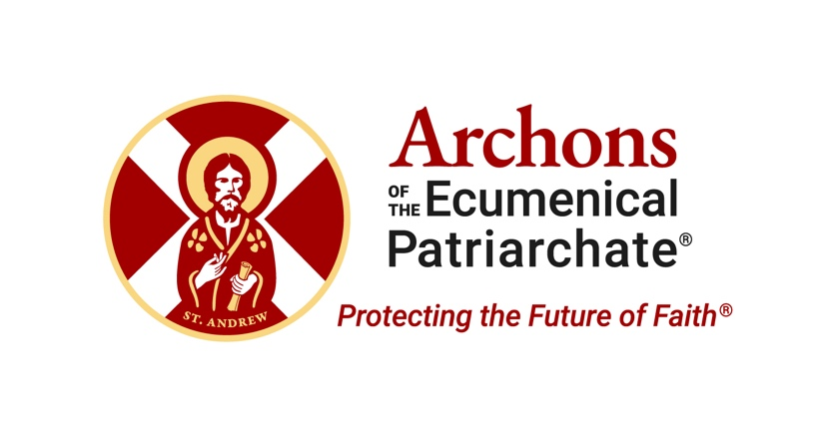
The Sacred Center of Our Holy Orthodox Faith Is Under Threat

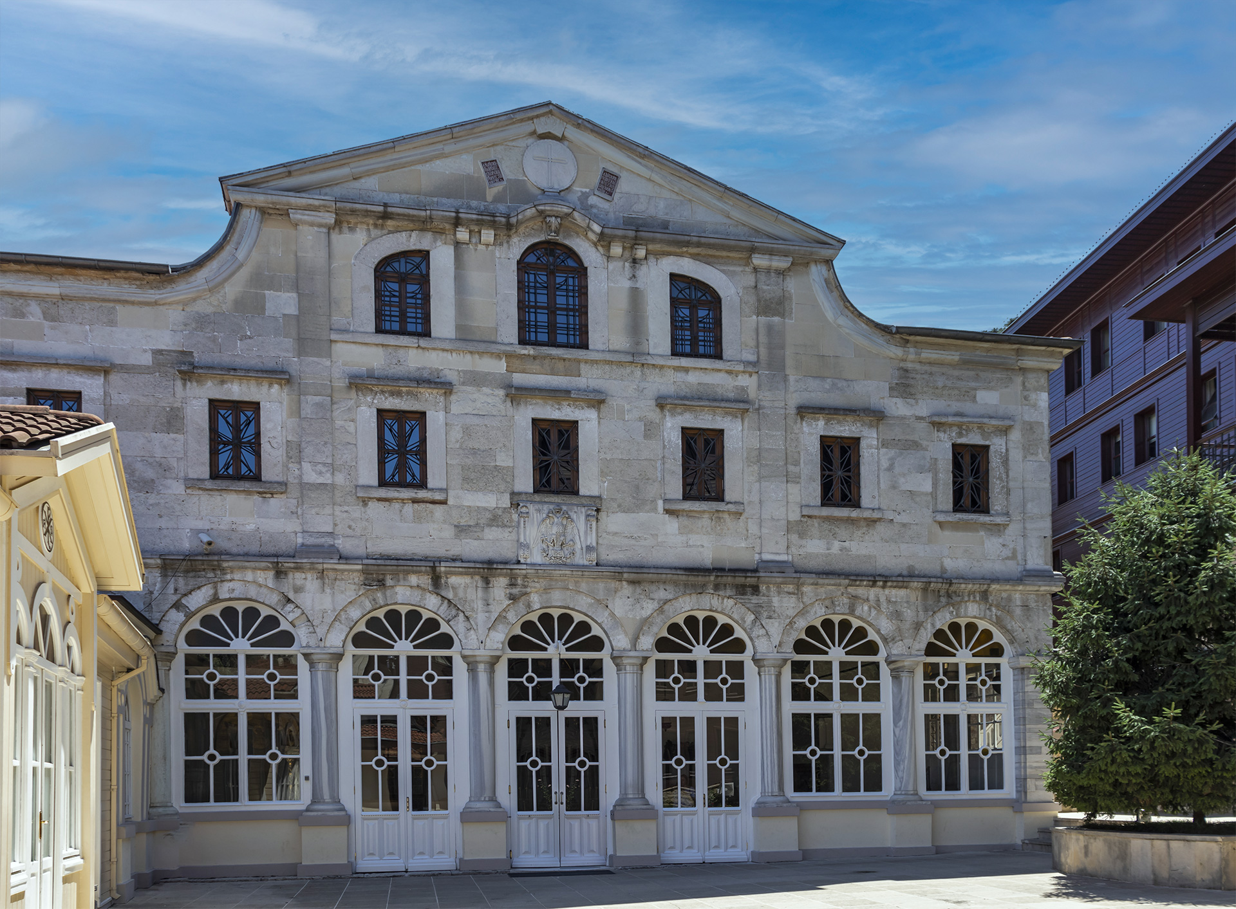
The Ecumenical Patriarchate of Constantinople (today’s Istanbul) is the sacred center of our Holy Orthodox Faith. According to ancient canons of the Ecumenical Councils that, under the guidance of the Holy Spirit, articulated the principal elements of our Faith, the Ecumenical Patriarch is the first bishop of the Church, charged with responsibility for the whole Church.
Today, the Ecumenical Patriarchate is the see of His All-Holiness Ecumenical Patriarch Bartholomew, the longest-serving and one of the most consequential Ecumenical Patriarchs in the history of our Church.

However, the Turkish government is presenting the Ecumenical Patriarchate with daily challenges and difficulties that could ultimately destroy its ability to perform its sacred global mission. Amid those challenges and difficulties, the Archons of the Ecumenical Patriarchate are dedicated to protecting and defending our Holy Mother Church of Constantinople.

The Ecumenical Patriarchate is under attack by the Turkish government in five key ways.

1. First and foremost, the Ecumenical Patriarchate has no legal identity or rights in Turkey. In the eyes of the Turkish government, the Ecumenical Patriarchate simply does not exist.

2. The Turkish government interferes with the election of the Ecumenical Patriarch by requiring that he must be a Turkish citizen, and maintains the right to approve who is selected. This is clearly interference with the Apostolic succession of the Church’s leadership.

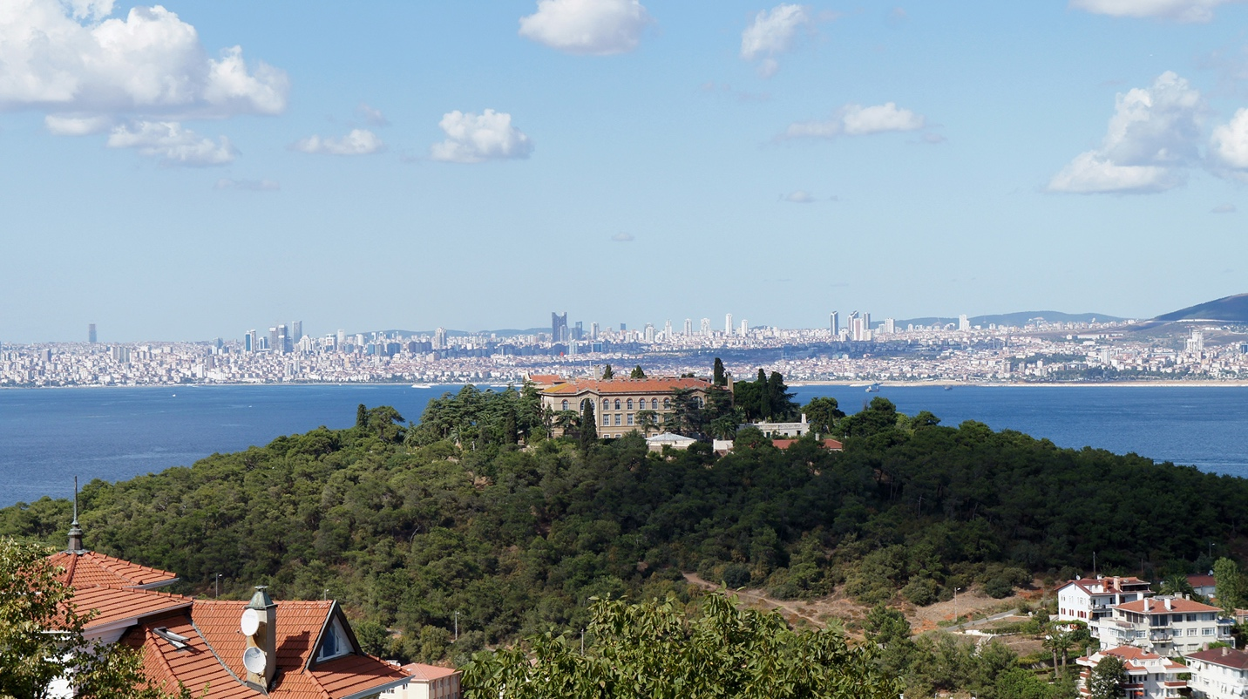

3. We can no longer train our clergy in Turkey because they closed our beloved Halki Seminary in 1971, where we had trained more than 1000 clergymen (including over 300 bishops and even a few Ecumenical Patriarchs) for 127 years. Today, Halki remains closed. As a result, those who want to become clergymen must be sent elsewhere out of the country.

The result is that we are experiencing a gradual asphyxiation of the Holy Mother Church in Turkey. The Greek Orthodox population of Constantinople is now only 2,000 to 2,500 people, down from 300,000 at the beginning of the twentieth century. With all of this said, His All-Holiness Ecumenical Patriarch Bartholomew has said that there have been recent positive discussions that could possibly lead to the opening of the seminary. We remain cautiously optimistic.

4. The Ecumenical Patriarchate cannot own, inherit or pass along property. The Ecumenical Patriarchate does not even own our churches in Constantinople and its environs. In 1936, the Church owned 8,000 properties, including monasteries, churches, schools, hospitals, orphanages, homes for the aged, homes, and apartment buildings. Today, most have been confiscated, and we have less than 500 properties remaining.

Occasionally, the Turkish government allows the Ecumenical Patriarchate to regain control of one of these confiscated properties, but only under the most difficult of circumstances. One example is the fact that the Turkish government does not legally recognize the Girls and Boys Orphanage Foundation on the island of Prinkipos (which the Turks refer to as Buyukada), for which the Ecumenical Patriarchate has held a deed since 1902, as belonging to the Ecumenical Patriarchate. In this case, however, the European Court of Human Rights compelled the Turks to hand it over to the Ecumenical Patriarchate, but only in dilapidated condition.

The implications of this are as obvious as they are ominous. Numerous churches have been converted to mosques — most recently Hagia Sophia, which for almost a millennium was the foremost church in the entire Christian world, and the Chora Church in Constantinople. The remaining churches are vulnerable.

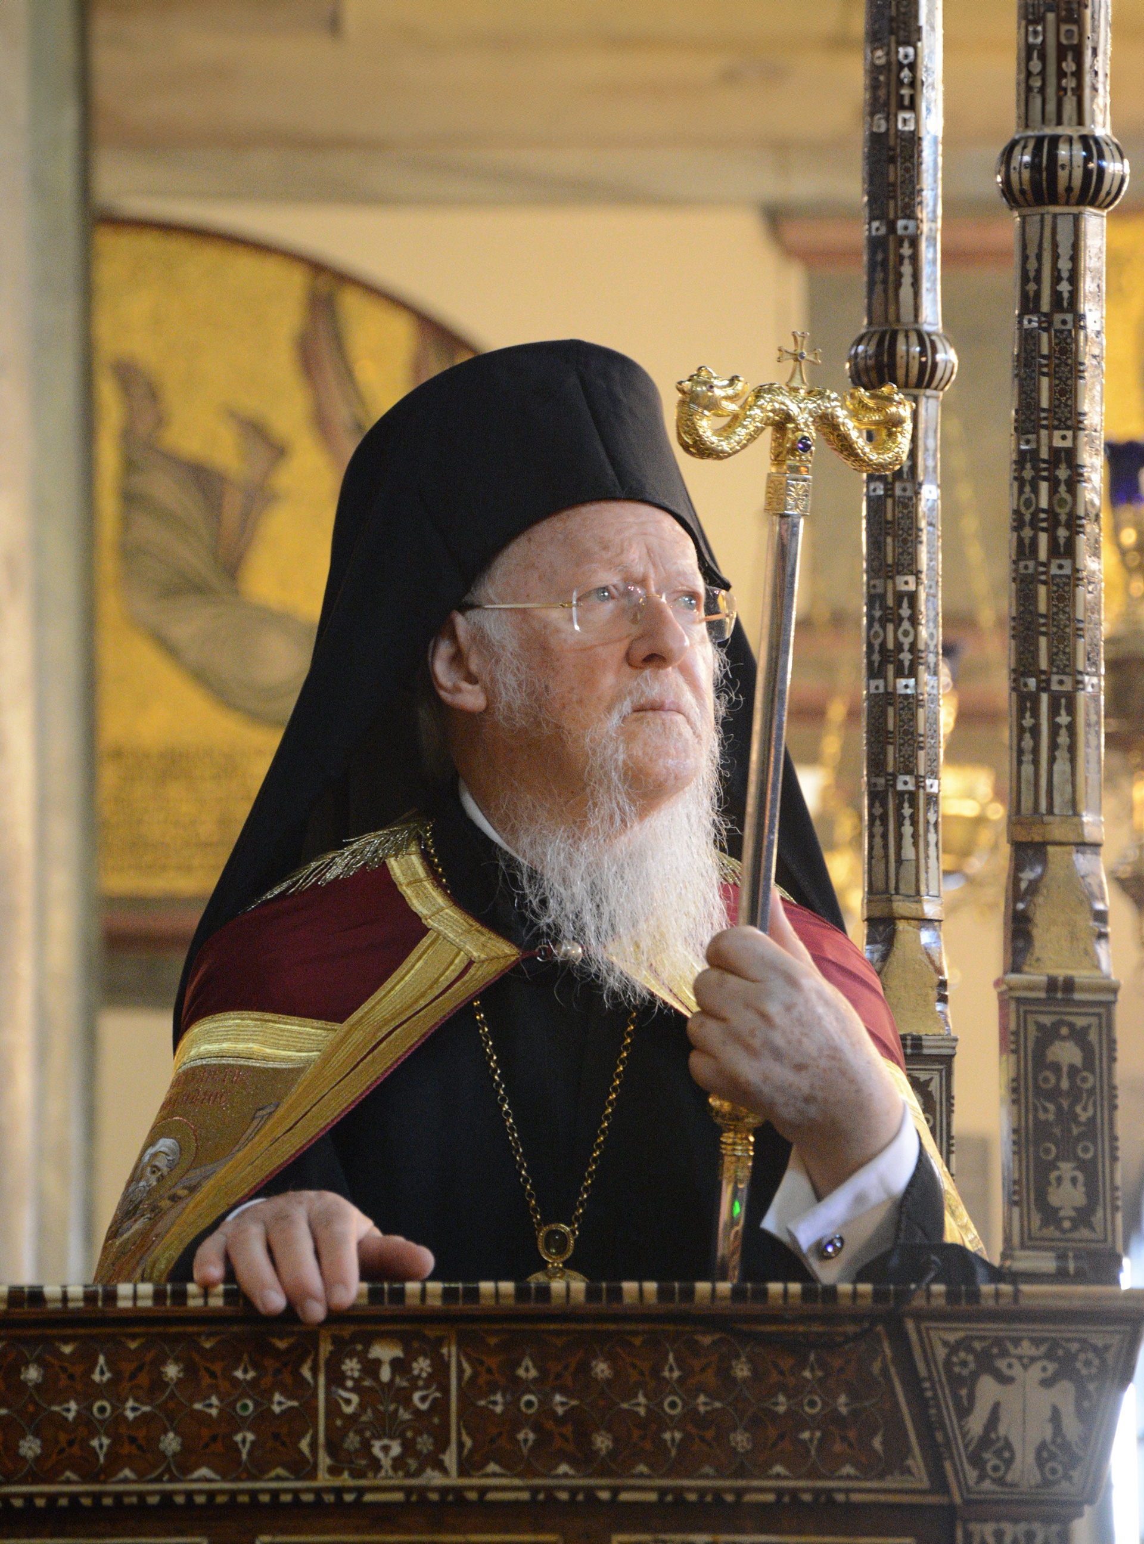
5. The Turkish Government does not recognize the “Ecumenical” status of the Patriarch and Patriarchate. Turkish authorities do not allow the use of the term or title “ecumenical” for any religious activity – even though this title has been used since the sixth century and recognized throughout the world. The Turkish government only refers to the Ecumenical Patriarch as the “Fener Patriarch,” referring to his headquarters in Constantinople, the Phanar.

Because of the Ecumenical Patriarchate’s lack of legal identity, its vulnerability to the decisions of the Turkish state is all-pervasive. If the international human rights organizations such as the European Court of Human Rights and the United Nations, among others, do not manage to compel the Turkish government to grant property rights to the Ecumenical Patriarchate, the spiritual center of the world’s 300 million Orthodox Christians remains essentially defenseless, and perilously close to extinction in its historical homeland.

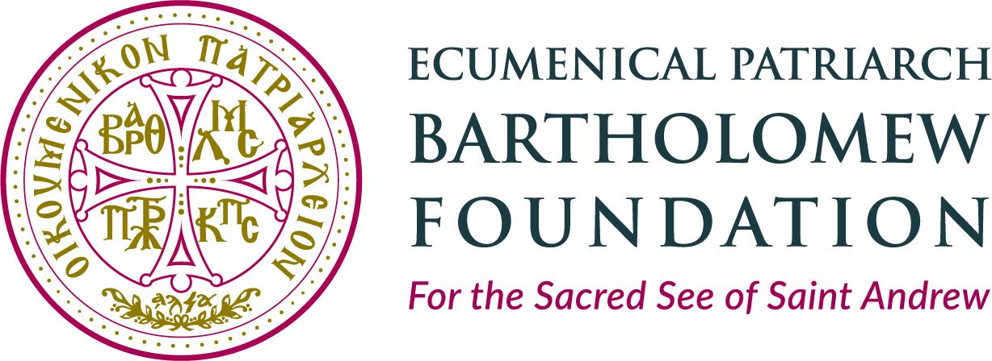
The Ecumenical Patriarchate needs financial support, so that it is less subject to the will of the Turkish government: the Ecumenical Patriarch Bartholomew Foundation, which the Archons founded several years ago, is dedicated to providing financial stability for the Ecumenical Patriarchate.

Please pray regularly for the Ecumenical Patriarchate and the Christians of Constantinople and prayerfully consider a donation to the Ecumenical Patriarch Bartholomew Foundation. The safety and survival of our Ecumenical Patriarchate, the sacred center of our Faith, is a priceless gift that surpasses virtually anything else we could pass on to our children and grandchildren.

