How to send a large video file via YouTube

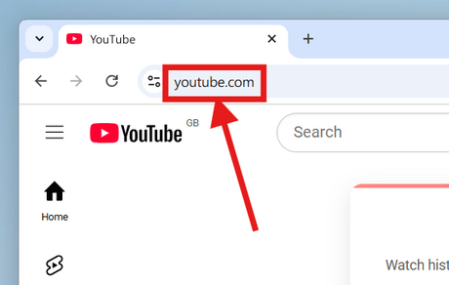

- Go to https://www.youtube.com in a web browser. You can upload a video directly from the YouTube web page.
- If you're not already signed in to your YouTube account, click Sign in at the top-right corner of the page to do so now. Select your YouTube account and enter your password or click Use another account and sign in with the email address and password associated with your YouTube account.

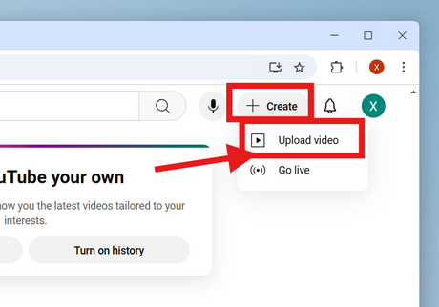
- Click the "Create" button with a plus (+) sign and click Upload Video. It's in the upper-right corner next to your profile image. This takes you to the YouTube Studio web page with an "Upload Video" window in the center of the page.

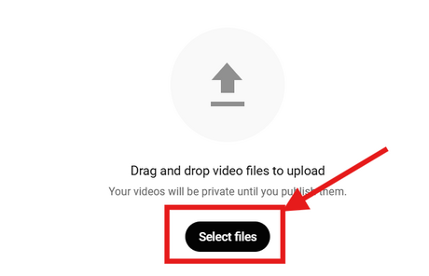
- Drag your video file to the arrow on the window. Alternatively, you can click the blue Select files button, navigate to the file on your computer, and then click Open. Either of these options will begin preparing the video for upload.
- You can upload videos up to 15 minutes in length by default. If you want to upload longer videos (up to 12 hours), you must verify your account first.
- YouTube supports uploaded video in the following formats: MOV, MPEG4, MP4, AVI, WMV, MPEGPS, FLV, 3GPP, WebM, DNxHR, ProRes, CineForm, HEVC (h265).[2]

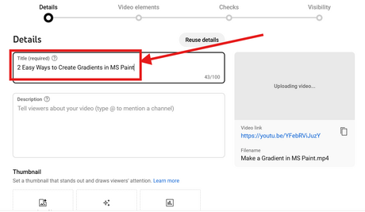

- Add a video title and description. The title is required, and the description is optional but recommended. The title can be up to 100 characters long. Use this space to create a catchy title that accurately reflects the video. Use the large box labeled "Description" to add a description for the video. Info in the description will appear below your video while viewing. You can use this space to add some unique information about the video, the creator, or other projects. Add keywords to this area to make your video appear in relevant searches.

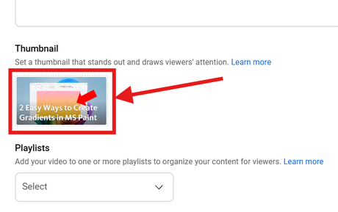

- Click a thumbnail you want to use. The video's thumbnail is the still photo that represents the video on your channel and in search results. Click one of the suggested thumbnails to use it as a thumbnail.
- Alternatively, you can click Upload Thumbnail and select your own image to use as a thumbnail. Click the image you want to use and click Open.
- You can change or edit your thumbnail whenever you want.

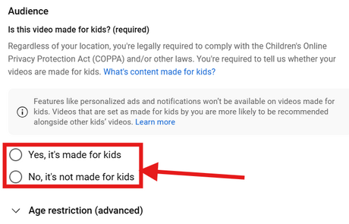
- Select if the video is made for kids or not. YouTube now requires you to mark any videos that are made for kids under the age of 13. If your video is made for kids, click the radio button next to "Yes, it's made for kids." If your video is not made for kids, click the radio button next to "No, it's not made for kids."
- Properly marking if your video is made for kids is required by law under the Children's Online Privacy Protection Act (COPPA). Improperly marking your video could cause YouTube to take action against your account or possibly get you fined by the FTC. See How to Comply with COPPA on YouTube for more information.
- Additionally, if your video is specifically made for viewers over the age of 18, you can set an age restriction for your video. To do so, click Age Restriction (advanced). Then click the checkbox next to "Yes, restrict my video to viewers over the age of 18."
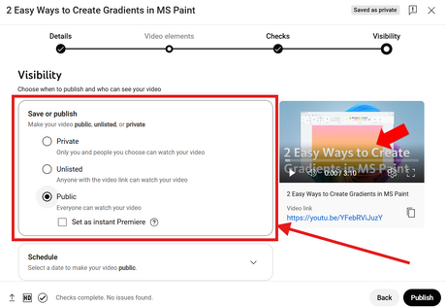

- Schedule a date to go public (optional). If you do not want the video to go public right away, you can schedule a time for it to go public. To schedule a time, click the radio button next to "Schedule". Then click the drop-down menu with the date and select the date you want it to go public. Then click the drop-down menu with the time and select the time you want it to go public.

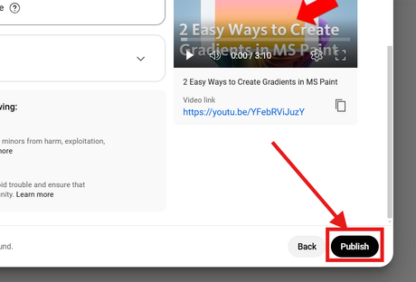
- Click the black Publish or Schedule button. It's at the bottom-right corner of the window. This will publish the video to your YouTube channel at the scheduled date and time, or after the video is finished processing.
- To edit the title and description at any time, go to https://studio.youtube.com/ and click Videos in the side panel to the left. Hover the mouse cursor over the video on this page, click the three-dot icon ⋮, and then click Edit title and description.
- You can change the visibility level of the video on this page by clicking the current level (e.g., Private) and selecting a different option. This is especially useful if you're uploading a video with HD quality so no one sees the lower-resolution version before it's finished processing.
- Once your video has been uploaded, you can embed it on your website or share it online.

