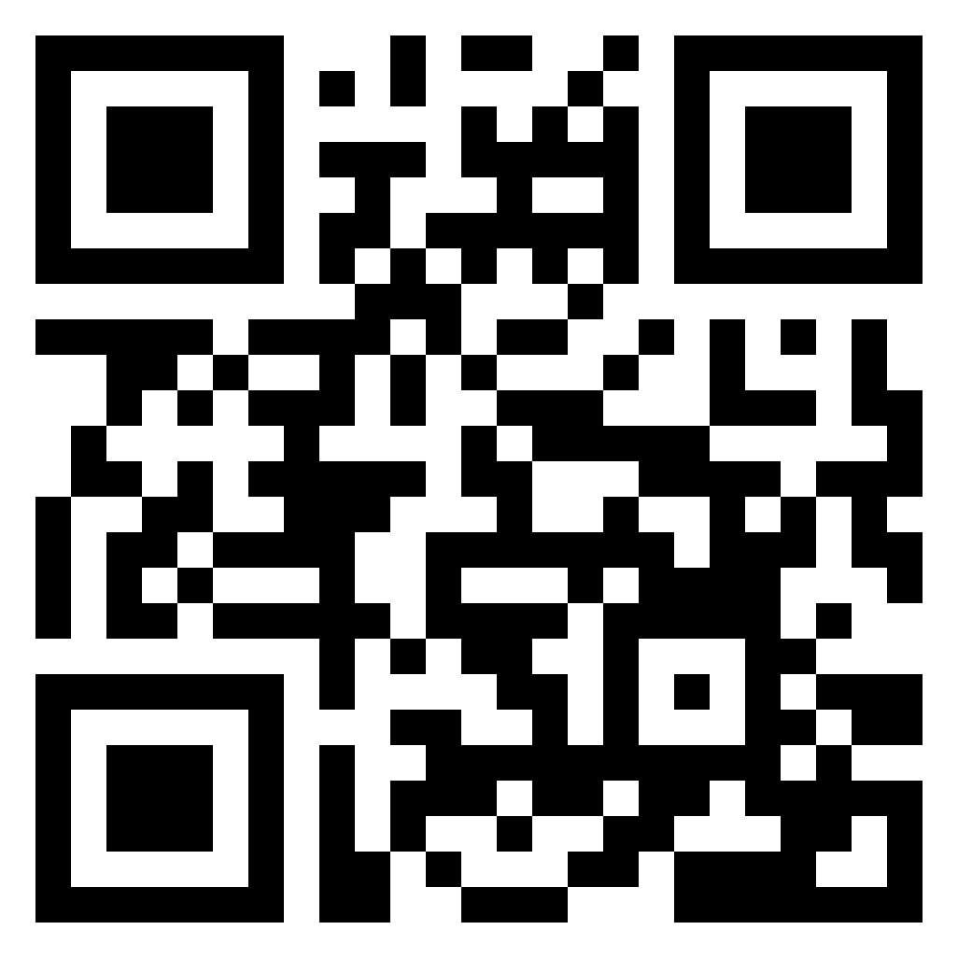

Point Your Camera and visit the
Simply Living Website
Check out our Vision and Mission and our Programs and Community Events

