VOSH/International’s Ghana Contact Lens Project
A Personal Perspective from Dr. Deepa Chandrasekaran
In 2000, my classmate Angela Ofeibea Amedo who was a Fulbright Scholar from Ghana, and I were chatting while I was doing my Master’s in Vision Science at the University of Alabama at Birmingham (UAB). I told her then that I was really interested in going to Ghana, and 19 years later, I received an email from the International Association of Contact Lens Educators (IACLE) that Volunteer Optometric Services for Humanity (VOSH)/International was seeking a volunteer to support their efforts in Ghana as part of their Ghana Contact Lens Project. Dr. Amedo was not there to receive us in Ghana, but a 19-year-old yearning was fulfilled.
My name is Deepa Chandrasekaran. I am an optometrist at the Vanderbilt Eye Institute in Nashville, Tennessee. I specialize in fitting contact lenses for different eye conditions. In November 2019, I got a great opportunity through a grant from VOSH/International to be able to lecture about specialty contact lenses and how to fit them, to the students and staff at the Kwame Nkrumah University of Science and Technology (KNUST), Department of Optometry and Visual Sciences in Kumasi, Ghana. I was also privileged to lecture to the optometrists as part of the Ghana Optometric Association meeting in Kumasi.
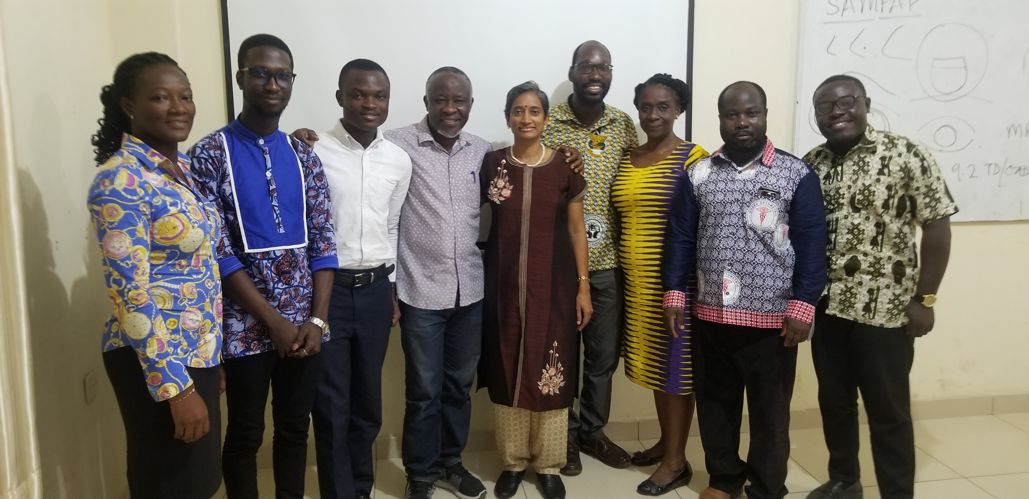
Picture 1. KNUST Optometry Faculty and Teaching Assistants (left to right) Ellen K Antwi-Adjei, Randolf Kwaw, Edward Blibo, Abdul-Kabir Mohammed, Deepa Chandrasekaran, Kwadwo Owusu Akuffo, Nana Yaa Koomson (Head of Department), Emmanuel Owusu, Emmanuel Owusu Poku
The family and I left for Accra, Ghana on November 15th. Little did we know how much we were going to learn about Ghana, the food, the hospitality and the culture. Even before we left, we had a magnanimous offer from the Provost of the College of Science and Technology at KNUST to fly us all from Accra to Kumasi (our initial plan was to fly in to Accra and then to be driven to Kumasi) as the university vehicle which was supposed to take us from Accra to Kumasi had broken down.
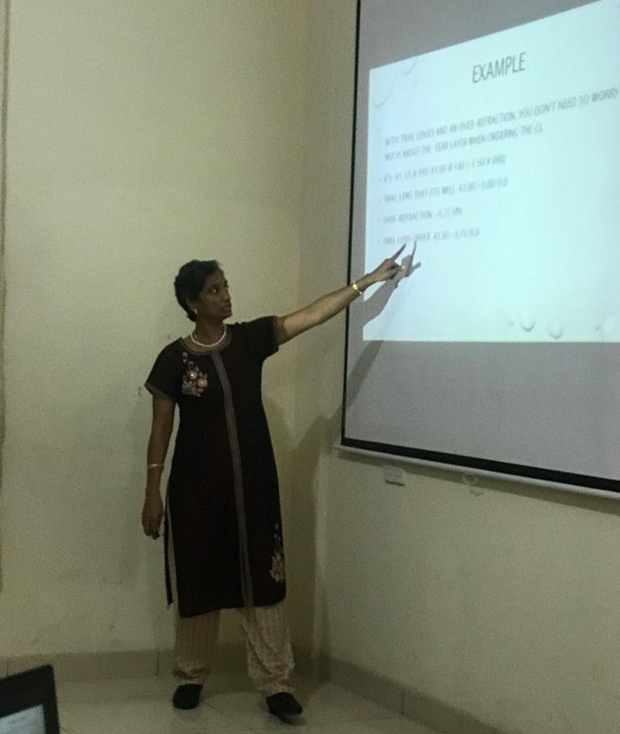
Dr. Emmanuel Kobia-Acquah, one of the faculty members at KNUST Department of Optometry and Visual Sciences, initiated the process and helped in coordinating my visit by collaborating with VOSH/International. The Head of the Department of Optometry, Dr. Nana Yaa Kwantwiwah Koomson, made all arrangements on-site (accommodation and local transportation in Kumasi and Accra). She had also arranged for my husband, Dr. Kalai Mugilan to give a couple of lectures to the university faculty and students about “Emotional Intelligence.” My lecture at KNUST was scheduled for 6 days from 9 am to 1 pm. For 5 days, I lectured for about 3 hours and spent the last hour doing practical with the students and staff. Dr. Emmanuel Owusu helped me in setting up the power point presentation and lining up students/patients for the practical session in their clinic. On the 6th day, I lectured to the optometrists as part of the Ghana Optometric Association meeting with instrumental help from Dr. Ellen Konadu Antwi-Adjei, another faculty member, who made all the arrangements to have this part of my session go as smoothly as possible. The optometrists also got a chance to fit a keratoconic patient with a gas permeable contact lens during their practical session.
Picture 2. Dr Deepa Chandrasekaran lecturing to KNUST Optometry faculty, teaching assistants and students
From the time we reached Kumasi, until we left for Accra, we were supported every step of the way. We had an assigned car and driver during the whole trip. Our driver turned out to be our tour guide and personal translator to the cultural norms. Our son and my husband were so intrigued by one of the major local languages spoken by the Ashanti people, Twi. We bought a book to learn more phrases and started trying to talk to the locals in Twi the best we could.
Overall, my trip to Ghana was not only professionally satisfying but also personally and emotionally refreshing. THANKS to IACLE, VOSH/International, & KNUST for making our trip to Ghana a memorable one!
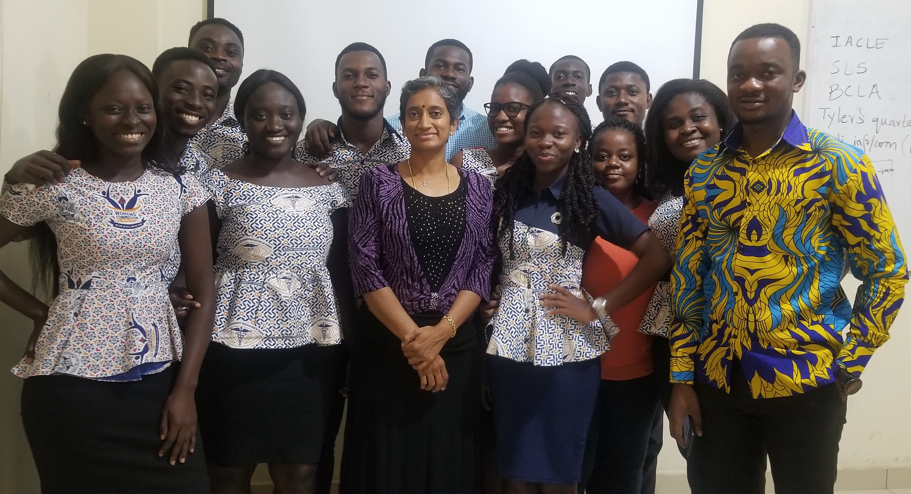
Picture 3. Dr Deepa Chandrasekaran and 4th year KNUST Optometry Students

Notes

In 2019 VOSH/International was awarded a XOVA (Excellence in Ophthalmology Vision Award) grant to implement a project at KNUST, Ghana to increase the knowledge of local eye care personnel on rigid gas permeable lenses (RGPs). This project will establish a lab and facilitate the visit of faculty to teach at the school of optometry, so they are able to offer RGP services to the local population on regular basis.

