Understanding Retinopathy of Prematurity (ROP) and Supporting Families

Retinopathy of Prematurity (ROP) is a potentially blinding eye condition that affects premature infants. It occurs when abnormal blood vessels grow in the retina, the light-sensitive tissue at the back of the eye. While many cases of ROP resolve on their own, some require treatment to prevent vision loss. Early detection and intervention are crucial, making education and awareness essential for parents, caregivers, and medical professionals. All children diagnosed with ROP, even if they didn’t need treatment, should continue to receive eye exams as recommended by their ophthalmologist and follow all recommended treatments. This monitoring is critical for detecting any other vision problems.

Dr. Paul Chan, a leading pediatric ROP specialist, explains the unpredictable nature of ROP monitoring:
“There’s no set number of exams that you’ll need. The exam findings on one exam will determine when the next exam is going to be. In addition to the visual function and the concerns we have regarding vision, we also just want to make sure that the active ROP does resolve appropriately.”

Learn more about risk factors for ROP, diagnosis, and treatment here.

Receiving a ROP diagnosis can be overwhelming, and families often struggle with navigating the medical landscape, long-term vision care, and emotional stress. This is where peer support becomes invaluable. Connecting with other parents and organizations that understand the journey can provide comfort, knowledge, and a sense of community.

Kelli Kelly, NICU parent and Founder and CEO of Hand to Hold, underscores the importance of peer support:
“I highly recommend that parents connect with support organizations like Hand to Hold to find that support and their community after they are at home, alone, caring for their baby.”

While many babies with ROP recover with or without treatment, some will experience vision challenges, including vision loss or blindness. Early intervention services can play a crucial role in helping children with vision loss reach their full potential. Early Intervention programs include a large range of services and can provide key functional vision assessments for understanding a child’s vision.

DeEtte Snyder, PhD, TVI, describes the use of functional vision assessments in understanding the vision of children with ROP:
“A functional vision assessment is a systematic look at how a child uses their vision in their world, and how they are accessing visual information, people, and things within their environment.”

ROP Resources

Check out ROP fact sheets, covering the following key topics:
- What is Retinopathy of Prematurity (ROP)?
- How is ROP Diagnosed and Treated?
- What Do I Need to Know About My Child’s ROP and Lifelong Vision Health?

Additionally, Prevent Blindness offers a video series featuring parents of children with ROP talking about their experiences and finding support, medical experts, therapists, Early Intervention professionals, nurses, and parent support organizations. These videos provide real-world insights into accessing early intervention programs and the importance of follow-up eye care after a NICU stay.

Check out ROP resources and all educational materials here.
Contact Prevent Blindness with questions at info@preventblindness.org.

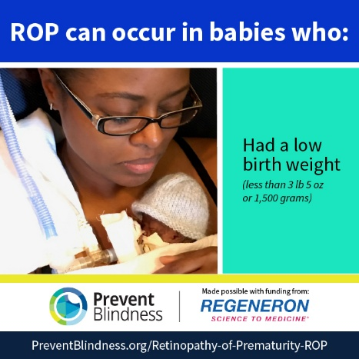

(Find more ROP social media graphics here.)

